Development of the Science Gateways Community Institute Workforce Development Documentation and Communication Site Pages

Lilshay Rogers
Elizabeth City State University
lilshay1999.lr@gmail.com
Reginald Kelley
Elizabeth City State University
reggiekelley43@gmail.com
Mentor: Jeff Wood
Elizabeth City State University
wood684@gmail.com

Abstract - The Center of Excellence in Remote Sensing Education and Research (CERSER) program on the campus of Elizabeth City State University is part of the Science Gateways Community Institute (SGCI) led by the San Diego Supercomputing Center (SDSC). SGCI was created to provide resources, expertise, community support, and education to the creators of gateways serving science and engineering research and education. SGCI is one of two Scientific Software Innovation Institutes funded by the National Science Foundation (NSF). In 2016, SGCI was created to provide a resource that would bring together gateway creators from a wide variety of fields of research providing technologies and strategies so that designers can focus on development needed by their specific user communities.
SGCI is divided into five sections: Incubator, Extended Developer Support, Scientific Software Collaborative, Community Engagement & Exchange, and Workforce Development. Dr. Linda Hayden, the CERSER Principal Investigator, leads the Workforce Development Section. The Workforce Development goals are to increase the development pipeline of science gateway young professionals and educators with an emphasis on increasing involvement of students from underrepresented groups.
Documentation and communication with Workforce Development participants have been divided between during the first years of this project between the web site maintained by CERSER and the site utilized by the SGCI team. The goal of this year’s undergraduate research project was to consolidate these pages with the SGCI site where the server now has a dedicated space to construct this set of pages. Utilizing HTML and graphics packages, the team developed content within the Liferay Content Management System utilized by SGCI.
Keywords: SGCI, Science Gateways Community Institute, Liferay, Workforce Development, HTML, CSS, Linda Hayden

Introduction

SGCI
Science Gateways Community Institute (SGCI) was founded in 2016 in reaction to a large-scale survey that identified the hardships that gateway developers faced at the time. The National Science Foundation funds its flagship software in two phases, implementation, and conceptualization. SGCI chose to utilize their award to work both the conceptualization and implementation phases. In doing so, they were able to build strong working relationships and a shared understanding of the institute’s components in Figure 1. [12] [15]
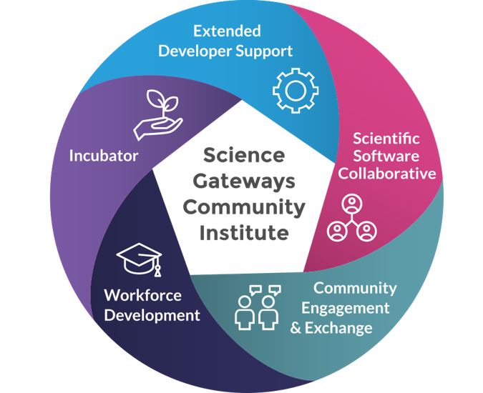
- SGCI Components
SGCI first started by setting up the component known as the incubator. Evidence from the survey showed there was a need for accommodation with areas outside of running gateways and technical tasks such as project management, cybersecurity, and sustainability planning.
The second component of the Science Gateways Community Institute is Extended Developer Support (EDS), which was created after the highly successful Extended Collaborative Support Services. EDS is designed with the intent of helping new gateways to come into existence and to add major new capabilities needed for growth and maintainability to existing gateways.
The Scientific Software Collaborative (SSC) component was designed to offer help to those who need assistance in their gateway building efforts. This includes the selection of technologies and the integration of new features and capabilities. The objective of the SSC is to promote science gateways, provide less complicated development, and expand the capabilities of science gateways. The SSC provides solutions that facilitate the following: discovery of gateways for those looking to use production gateways, hosting environments for gateway developers who need to develop, test, and create alpha releases of their gateway before moving on to their own platforms, discovery of gateway-related software, and assistance for those looking to build gateways.
The Community Engagement and Exchange (CEE) component supports the heart of the gateways community as a way for people to join with, support, and learn from each other. This is achieved by organizing events and resources specifically targeted toward the unique needs and interest of the gateway community. In addition, CEE supports the Institute as a whole by engaging new participants and clients through promotion, questionnaires, written material, and social media. Other CEE’s efforts focus on the development and maintenance of a website including important content creation to support the sharing of resources, news, information, and SGCI services and events.
The Workforce Development component was created to build the nation’s capacity to produce the workforce needed to overcome the difficult challenges of working in uncharted territory. The Institute’s primary approach to addressing this goal is through engagement and integration of research and education. First, the branch identifies several talented young people through partnerships with various organizations. Next, they connect them to the science gateway community through directed experiences. They then move on to the execution phase, which is derived from lessons learned and guided by a skills development report that consists of non-technical, basic technical, and advanced technical subject areas. Non-technical is comprised of communication skills, ethics, and internship practices. Basic technical skills consist of basic software engineering and system administration. Advanced technical skills include distributed systems, cluster/cloud computing, and cybersecurity.

SGCI Workforce Development
Workforce development is the key to every organization's growth. It is essential for organizations that want to acquire a top-tier workforce. Workforce development is considered an interconnected set of solutions to meet employment needs. Any changes to attitude, culture, or other positive development of employees that will greatly influence an organization's future success. The objective of workforce development is to prepare employees or workers with the specific skills needed for their job or the job they are trying to acquire. [10]
Dr. Linda Hayden leads the SGCI Workforce Development team. Dr. Hayden is the head of Elizabeth City State University’s Center of Excellence in Remote Sensing Education and Research (CERSER) program. She and her workforce development team have worked to create opportunities for students. Any students willing to get connected with SGCI and its workforce development team will be given many opportunities to hone their skills for the specific job they are searching for. Students are encouraged to apply for recommended internships at SGCI, partner, and client sites. Invitations are also sent out for conferences, which provide networking opportunities for students. These contacts provide entry into research, academic, and employment openings. [11]

Software and Languages

Content Management Systems
A Content Management System (CMS) is a software that allows its users to create, manipulate, organize, and publish content. CMS software packages allow users to edit and develop material for the web according to their requirements. An advantage of CMS is that it does not limit development of content to one user as it allows many users to work on content together simultaneously. [2]
A content developer’s data is saved on a database and displayed on a presentation layer based on templates that were created by the developer. This creates a safe place for the data that is easily manipulated and can be accessed very quickly. A CMS should contain four basic features, which include content creation, storage, workflow management, and publishing. Also being able to assign privileges to users and be able to be pushed and updated instantly. There are two basic components that make up a CMS software the first being a content management application (CMA), which is the graphical user interface (GUI). The CMA makes it easy for users of all levels to easily add, modify, and remove content from a website. Second is the content delivery application (CDA). This is the backend of the CMS that compiles and updates information to the website.
Content management systems are not limited to high level developers. They are meant to be used by many skill levels. The software should be so easy any user can pick up a mouse and create their designed web content. There are many different content management systems such as: Liferay, Joomla, Drupal, and WordPress. [4]

Liferay
Liferay is an open source software company founded in 2004. The company started with its Liferay Portal in 2000, which was created by its chief software architect Brian Chan. Liferay Portal was a solution to the enterprise portal problem for non-profit organizations. Although the software is a great help to organizations and people, the focus will be on Liferay Web Content Management System. [1] [6]
For our research, we used the web content management system to create Workforce Development pages for SGCI. We converted images and transferred information from our workforce development page on the NIA web server to the SGCI Workforce Development page. The software allowed us to create responsive web pages that resize to fit various screen sizes. [5] [7]

HTML
Hypertext Markup Language (HTML) was first developed by the computer scientist and engineer, Tim Berners-Lee in the year 1993 using an Internet-based hypertext system. Each HTML page contains a series of connections to other pages known as hyperlinks. A hyperlink is a graphic, icon, or text that links another file or object. [3] [14]
HTML allows for users to create and structure paragraphs, headings, links, and block quotes for web pages used on the World Wide Web. The HTML language consists of a sequence of elements called tags. By utilizing tags that have attributes, the language is able to define the design and layout of elements on a web page. HTML also provides the elemental structure of a page in which Cascading Style Sheets (CSS) are also employed to change the appearance of the page.

CSS
Cascading Style Sheets (CSS) was first introduced in the year 1996 by World Wide Web Consortium Schools. CSS is used to design and implement style elements such as color, fonts, and layouts onto an HTML, XML, or SVG document. By utilizing CSS, users are able to develop more accessible/flexible content on web pages. CSS contains multiple rules that affect how a web page is displayed. These rules have a selector, which allows the user to select the elements they wish to apply changes to, and properties, which holds the values the user has set previously to update how a web page is displayed. [13]

Methodology

Goal
The goal of this project is to transfer science gateways workforce development content from the CERSER website to the science gateways official site. To do this, the team had to implement HTML code and place it within the content management system Liferay. This code was derived from pages previously developed on the CERSER website and rewritten to conform to responsive web design using DIV tags. The responsive design enables the pages to be utilized on various platforms ranging from desktop computers to cell phones. [8]

Determining Pages
The original selection of pages to be completed was determined during the initial phone conference held on January 10, 2019. Representatives at this meeting included Nancy Wilkins-Diehl (Director, SGCI), Katherine Lawrence (Associate Director, CEE), Linda Hayden (Associate Director, WD), David Montoya (Website Development, SSC Staff), Nayiri Mullinix (Community Engagement Coordinator), and Jeff Wood (WD Staff). During this conference an initial set of files was laid out as a starting target for the Workforce Development section. This outline is as follows:
Initial outline:
- Young Professionals Network
  - Young Professionals Network
    - Mentoring
    - Special Events
  - Events (Set up like Blog/News)
    - Young Professional of the Year Award
    - YPN Liaison/Spotlight/Webinars
    - Mentoring
    - Special Events
- Events Workshops
  - From CERSER menu
- Internships
  - About
  - Application
  - Current & Past Interns
- Coding Institute
  - Application
  - 2017
  - 2018
These files were initially set up by David Montoya at TACC with content blocks left blank. Later, additional pages were added and deleted as the team worked toward its goal.

Rewriting Pages to HTML Code
The first step in the transfer process involved learning HTML code using exercises from W3Schools. HTML items reviewed included tags, image placement, links, and styles. Next, the team completed a series of tutorials on Cascading Style Sheets (CSS). Liferay depends heavily on these style sheets to maintain a constant look and feel throughout the website.
The next step was analyzing a web page and rewriting it into HTML code. This was done utilizing Google Documents for the initial code development. Once the code was written, it was tested in W3Schools’ testing window. After the code was tested and reviewed it was then imported into the Lifeway content window under the source code editor. Minor flaws were seen once it was based into the component such as double apostrophes, unneeded spaces, and incorrect URLs.

HTML to CMS
After the team finish scripting the HTML code, the code was moved from the google documents into the Liferay content management system. This was accomplished by utilizing the edit window shown in Figure 2. Once this window is opened, the source button is selected allowing the HTML code to be edited for the content as shown in Figure 3. The code developed in Google Documents is then pasted into this window and the content is either “Saved as a Draft” or “Published.” The page is then reviewed to ensure that the pasted code is interpreted correctly by the browser. If edits are needed, then the edit window is reopened and the code accessed again. [9]
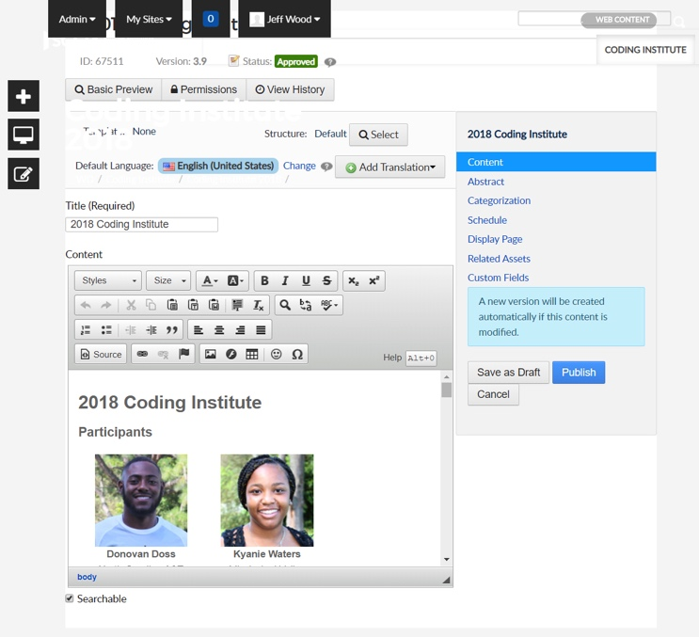
- Liferay Editor Window
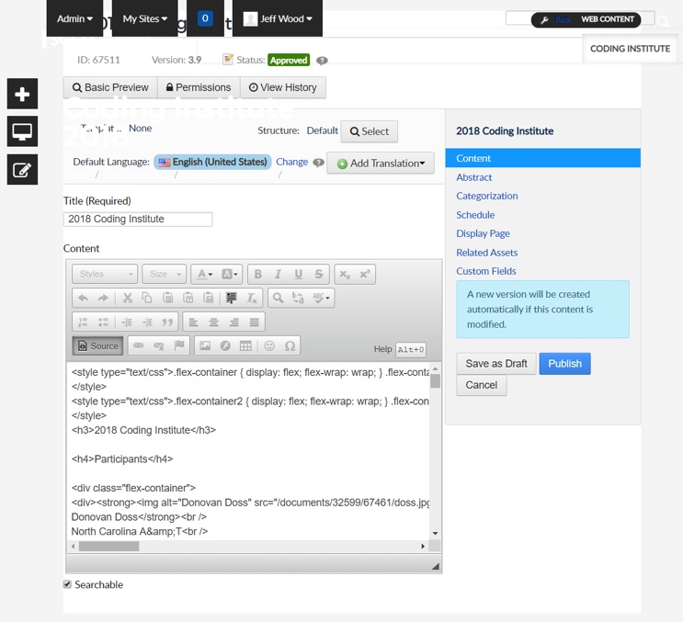
- Liferay Editor with Source Code Window

Other Assets
Content developed for these pages not only needed text, but also Portable Document Formats (PDF) and images. These resource files were uploaded to specific locations before being accessed by the developed code (Figure ##). PDF and image files were placed in multiple directories for better content management. These files addresses could be coded into the HTML or inserted through the WYSIWYG window.

Asset Manager
Another tool that Liferay contains is the Asset Manager, which allows developers to develop dynamic pages and content. Once entered, content can be categorized allowing developers/users to select content based on tags assigned to the content. This tool is customizable using templates implemented by the developer. This tool was used to start a library of SGCI interns based on the year that they took attended their internship. The library is currently being housed at:
https://sciencegateways.org/engage/internships/about-our-interns
and had to be ported manually to the Workforce Development page at:
https://sciencegateways.org/web/wd/current-and-past-interns
Now that the intern information has been entered, a new template must be developed to obtain the desired output. This will be added to the Future Works section.

Analysis
Implementation of pages in the new Workforce Development section of the SGCI site were completed utilizing the process discussed in the Methodology section. Gaining skills in HTML, CSS, and Liferay development were essential in completion of these pages. Further training is needed to implement higher level tasks in Liferay at this time.
Header images are not complete at this time as they must be implemented by David Montoya at TACC due to the permissions of the template. The team has begun gathering these images for when they can be placed into each file. The Interns page is also not complete due to further training needed to develop templates for the Asset Manager.
At this point pages exist in several states: not started, partially completed, and complete. The following list shows the state of the pages currently in the Workforce Development section:
Project completion outline:
- Home (Incomplete - Text/Images)
- Young Professionals Network (Complete)
  - Young Professionals Network (Complete)
  - YPN Liaison/Spotlight/Webinars (Complete)
  - Mentoring (On Hold)
  - Special Events (On Hold)
- Events (Incomplete - Images)
  - Upcoming Events (Incomplete - Blog Development [Montoya])
  - Past Events (Complete)
    - NOBBChE 14 (Incomplete - Images)
    - NOBBChE 15 (Incomplete - Images)
    - PEARC17 (Complete)
    - PEARC18 (Complete)
    - Hackathon 2018 (Complete)
- Internships (Incomplete - Images)
  - About (Complete)
  - Applications (Complete)
  - Current and Past Interns (Incomplete - Asset Management)
- Coding Institute (Complete)
  - Application (Complete)
  - 2017 (Complete)
  - 2018 (Complete)

Conclusion
While the inclusion of HTML into Liferay is very straight-forward, the development of the code and resources is time consuming and requires a learning period to develop the skills necessary to work with the CMS. The initial set of pages developed by the SGCI team was a good starting point to begin with and allowed the team to add and delete pages as needed.
Liferay is a straightforward CMS with flexibility to enable adaptation to the developer’s needs. Developers can search through various resources online to find assistance and inspiration to solve technical difficulties when they arise. As the CMS is utilized more, the capabilities of the content developers will increase allowing for better communication of the Workforce Development team to its customers.

Future Works
This project left much to be completed in the immediate future. Several of these tasks can be handled in-house, but several will need assistance of seasoned developers to complete.
The first task will be to add images to content where needed. This will entail selection of these images as well as formatting and production.
The next task will be completed with the assistance of David Montoya at TACC. He will be asked to set up a blog style page so that upcoming events can be inserted. This assistance has been offered during the initial phone conference so it is not a new request.
The home page text needs to be developed in conjunction with Dr. Hayden to ensure the correct message is delivered to customers. Once the text is added images can be added to enhance the page.
Now that the intern information has been added to the asset manager a new template needs to be developed to display the content in a catalog style with links to more detailed information. The layout goal can be viewed on the current SGCI site at:
https://sciencegateways.org/engage/internships/about-our-interns.
Each page in the site has a banner image at the top placed there by David Montoya. This must be done on his side of the production of Liferay. On our side the images must be selected and formatted to fit in the 1100x400 pixel format for the banner images.
Two pages initially suggested have no content: Mentoring and Special Events. It needs to be determined if these pages will move forward or be deleted from the Workforce Development section.

Acknowledgements
We would like to thank Dr. Linda B. Hayden for her support during this project and the Science Gateway Community Institute for funding of this project. A special thanks goes to Dr. David Montoya at TACC for his assistance with Liferay.
References
- Web Content Management - Liferay 6.1 - Liferay Developer Network. [Online]. Available: https://dev.liferay.com/discover/portal/-/knowledge_base/6-1/web-content-management. [Accessed: 28-Mar-2019].
- S. Balkhi, “What is a Content Management System?,” WPBeginner. [Online]. Available: https://www.wpbeginner.com/glossary/content-management-system-cms/. [Accessed: 28-Mar-2019].
- M. Bellis, “The History Behind What Helps Create Web Pages,” ThoughtCo, 27-Feb-2019. [Online]. Available: https://www.thoughtco.com/history-of-html-1991418. [Accessed: 28-Mar-2019].
- “Content Management System,” Optimizely. [Online]. Available: https://www.optimizely.com/optimization-glossary/content-management-system/. [Accessed: 28-Mar-2019].
- “HOW RESPONSIVE IS YOUR WEBSITE?,” Responsive Website Design Tester | Media Genesis. [Online]. Available: https://responsivedesignchecker.com/. [Accessed: 19-Feb-2019].
- “Liferay,” Wikipedia, 27-Feb-2019. [Online]. Available: https://en.wikipedia.org/wiki/Liferay. [Accessed: 28-Mar-2019].
- “Responsive Web Design - Introduction,” Responsive Web Design Introduction. [Online]. Available: https://www.w3schools.com/css/css_rwd_intro.asp. [Accessed: 19-Feb-2019].
- “Responsive Web Design – What It Is And How To Use It,” Smashing Magazine, 12-Jan-2011. [Online]. Available: https://www.smashingmagazine.com/2011/01/guidelines-for-responsive-web-design/. [Accessed: 19-Feb-2019].
- “Usage of content management systems,” W3Techs. [Online]. Available: https://w3techs.com/technologies/overview/content_management/all/. [Accessed: 28-Mar-2019].
- Wonolo Inc, “What is Workforce Development? Definition, Benefits & More,” Wonolo, 06-Jul-2018. [Online]. Available: https://www.wonolo.com/blog/what-is-workforce-development/. [Accessed: 28-Mar-2019].
- SGCI Young Professionals. [Online]. Available: http://nia.ecsu.edu/sgci/. [Accessed: 09-Apr-2019].
- Service Areas - Science Gateways Community Institute (SGCI). [Online]. Available: https://sciencegateways.org/about/service-areas. [Accessed: 09-Apr-2019].
- “What is CSS?,” What is CSS. [Online]. Available: https://www.w3schools.com/whatis/whatis_css.asp. [Accessed: 09-Apr-2019].
- “What is HTML?,” What is HTML. [Online]. Available: https://www.w3schools.com/whatis/whatis_html.asp. [Accessed: 09-Apr-2019].
- N. Wilkins-Diehr, M. Zentner, M. Pierce, M. Dahan, K. Lawrence, L. Hayden, and N. Mullinix, “The Science Gateways Community Institute at Two Years,” a53_Wilkins-Diehr.pdf, 18-Jan-2007. [Online]. Available: http://nia.ecsu.edu/sgci/documents/a53_Wilkins-Diehr.pdf. [Accessed: 09-Apr-2019].

