Design and Implementation of an Educational Web Based Application for Remote Sensing Concepts
Disaiah Bennett, Edsel Norwood Mentor: Derek Morris Jr.
lavontae.bennett@gmail.com, edselnorwood83@gmail.com, dmow4454@gmail.com
Elizabeth City State University

Abstract - Geographic Information Systems (GIS) and Remote Sensing is an industry with a high workforce demand and even higher environmental importance. There are many programs in which young adults are introduced to classes/careers that, otherwise may not come into contact with. It’s these types of programs that expose young adults to the open possibilities and career paths that lay ahead of them, and in doing so these young adults are given a chance to discover their passions, and plan the rest of their academic careers accordingly. It was for this reason that we felt that the training modules within the GAIA Crossroads textbook needed to be updated to take a more modern approach.
Keywords: JavaStript, HTML, CSS, Gaia, QGIS, Multispec

INTRODUCTION
The GAIA Crossroads program is an educational program that uses satellite imagery technology as a learning resource. The project was originally launched over two decades ago with a grant from Apple, who was then known as Apple Computer. The GAIA Crossroads program was formed with the intentions of bringing the imagery of the real world into the classroom, but overs the years the tutorials created for the Crossroads program have aged past their date of relevance. The tutorials within the GAIA Crossroads textbook contain outdated pieces of information and tips that are no longer compatible with the technology today, such as using images of outdated graphical user interface (GUI) and using outdated versions of software within the tutorials. These are some of the issues that are addressed within this research topic. The tutorials provided within the GAIA Crossroad textbook aims to give young students the tools and resources to create and manipulate satellite images from their local surroundings, while also providing educators with easy-to-use interactive tutorials. Students will be given the same tools used by scientists and are tasked to follow and experience the scientific process first-hand.

Geographical Imagery Systems (GIS)
GIS manages and analyze data, and can determine patterns, relationships, and situation that help users make intellectual decisions. GIS enhance the way people modify and approach geographic information such as maps. [2] People been using GIS maps for numerous of years. GIS maps helps users exploit their work and organization on the internet. Maps gives a basic setting since they are both creative and analytical. They sustain a general appearance, coherence, and structure to the world. Maps enable you to explore your information and to uncover and clarify patterns. “GIS allows students to collect and visualize authoritative data about the question of interest, adding their own data to the map before performing a wide range of analyses on the data in question.” [2]

Who uses GIS tools?
Geographical Imagery Systems (GIS) are used in hundreds of ways in today's world. Schools across the world use GIS in ways that enhance the learning environment, such as creating interactive maps that help students better understand subjects as math, environmental science, and history. The use of GIS related tools and resources so teachers can better help students improve “spatial analysis and critical-thinking skills”[9] that “prepare young minds to succeed in course work, further education, and life”[9]. GIS is also used in a wide range of fields such as health, government, and telecommunications.

Remote Sensing
Remote Sensing is the study of scanning the earth’s surface via satellite or high-altitude vehicle. “The technology of modern remote sensing began with the invention of the camera more than 150 years ago.”[13] By scanning the earth’s from high altitudes scientist are able to capture a larger amount of potential data in a single super-high resolution image. These scans are then used in various studies to obtain different pieces of data about the environment. Remote Sensing is a broad field that spans across dozens of professional fields, one such example is weather predictions and service when cameras on satellites and airplanes take images of large weather masses.

These sensors can be on satellites or mounted on airplane. Remote sensors can be either active or passive. Passive, or inactive, sensors react to outside jolts and record regular vitality that is reflected or radiated from the Earth's surface. The most well known wellspring of radiation distinguished by inactive sensors is reflected sunlight. Conversely, active, or dynamic, sensors utilize interior boosts to gather information about Earth. For instance, a laser-shaft remote detecting framework extends a laser onto the surface of Earth and measures the time that it takes for the laser to reflect back to its sensor [22].

Remote sensing utilizes cameras on satellites and planes to capture imagery of extensive regions of the Earth’s surface, allowing us to see considerably more of the Earth from an aerial perspective. Sonar systems on boats are used to collect information of deep sea depths without requiring deep sea excursions. Cameras on satellites are also employed in recording the temperature distribution in the sea [23].

Teaching with GIS and Remote Sensing/Geoscience

Teaching with GIS “allows geoscience students to work directly with data in the field and classroom and to develop and refine their spatial reasoning skills.” [6] By integrating GIS into geoscience courses, students are presented an opportunity to perceive the data being constructed and the content for “maps of recent earthquake events, geologic maps, and satellite imagery.” [6] process of developing skills in gateway development. [4]

SOFTWARE/LANGUAGES

Hypertext Markup Language HTML
Hypertext Markup Language (HTML) is the framework for labeling content documents to achieve font, color, graphic and hyperlink effects on Internet pages. HTML is used to make website pages. The Web browsers can read HTML records and create them into visible or audible web pages. The browsers do not show the HTML labels and scripts, but utilize them to interpret the substance of the page

HTML comprises of a series of short codes written into a content document by the cited author; these are the tags. The text is then spared as a HTML file and viewed through a program, similar to Internet Explorer or Netscape Navigator. This program reads the files and makes the translation text into an visible structure, ideally rendering the page as the author had planned. Writing your own HTML involves utilizing tags correctly to make your vision. You can utilize anything from a simple text-editor tool to an intense graphical manager to make HTML pages [16].

JavaScript
JavaScript is a cross-platform scripting program that provides web pages with interactivity on most browsers. Netscape originally developed JavaScript under the name Live Script. JavaScript is an object-oriented language with detailed scripting codes. As with other programming languages, JavaScript has certain key concepts and phrases that control the interaction with the web page. [14][15]. This project utilized JavaScript to manipulate the data in order that it could be visualized. Functions and events were used to interact with Google Maps and provide the data in the correct format.

Cascading Style Sheet
Cascading Style Sheets (CSS) is a style sheet language that is used for visual styling of web pages using HTML. It is used to separate presentation such as layout, fonts, and color from content. Using CSS improves flexibility for the user to control presentation characteristics. In CSS, there are rules that affect how a web page is displayed. These rules have a selector, which selects the elements you want to apply the changes to, and properties, which have values you set to update how an HTML page is displayed. Officially released in 1996 by Hakon Winus Lie, CSS was one of the first style sheet languages at the time. At the time web CSS required different style sheets from sources on the web which is what made it different from other style sheet languages at the time. As time went on and technology grew, a greater variety of stylistic capabilities were added to meet the demands of web developers. In the late 1990’s new internet browsers, such as Internet Explorer, were introduced and CSS had a hard time supporting the new applications. [17]

Multispec
MultiSpec is a processing system for analyzing and interacting with “Earth observational multispectral image data”[24]. Developed by Purdue Research Foundation, the overall objective is to act as an “aid to export the results of our research into devising good methods for analyzing such hyperspectral image data”[24].

QGIS
Gary Sherman developed Quantum Geographic Information System in early 2002. It became an incubator project of the Open Source Geospatial Foundation in 2007. The first version 1.0 was released in January 2009. In 2017, QGIS became available for several different operating systems including Mac OS X, Linux, Unix, and Microsoft Windows. A mobile version of QGIS began development for Android as of 2014. QGIS is maintained by a group of volunteer developers who release updates and bug fixes regularly. In 2012, developers finished translating QGIS into 48 different languages and the application has since been used internationally in both the academic and professional environments. Several companies offer support and feature development services[25].

METHODOLOGY

Introduction
When a user uses the web GIS it will allow the user to share data universally; in addition, GIS provide usage and access of their tools on smartphones and tablets. With the use of the web-based GIS tools, education established for individual classes are able to be provided for students in K-12. Preparing students for early college with the assistance of GIS, introduces the students to more STEM related areas of research, and provides a higher awareness of these subjects. The tools that have been applied have been shown to not only “enhance teacher awareness”, but also “allow them to best communicate and demonstrate geographical awareness and capabilities that even simple spatial analysis might bring about topics dealing with population, history, and other areas.” [1]

The Education Application team app works two ways. If teachers wanted to demonstrate to the students how the application function, the teacher can pull the application up on there projector. After, going through the demonstration, the teachers can then allow the students work through the lesson by via tablets, phones, or any technology they prefer.

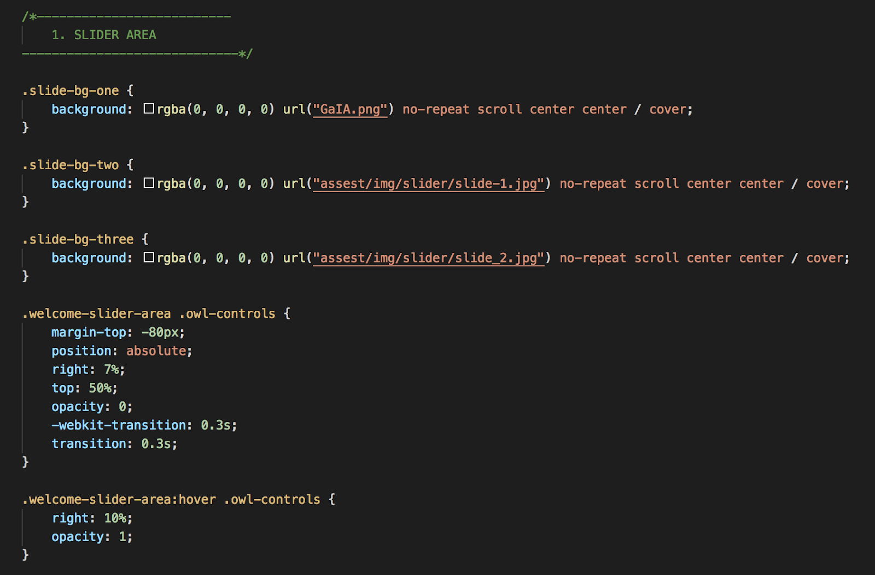
Fig 1.

Fig 2.

Overview
As mentioned before a website was created with lessons for the Gaia crossroad book. The above figure 1 shows the back in of the site. First, the team started with main page of the application. What you see is three functions were created for the slide show. Inside those function we created a background-color for each one. Then created a path for the image can show up on each side show page. The team also created dimensions so that the images can fit to the screen and etc. So we created margin, opacity, position, and transition. The margin is to create spaces around each picture. The positioning is just like aligning your element. For example we set our position to absolute. That means it will auto fit to the pages. Lastly, in this function we created a transition. When the image comes up on the page it show up for .3 seconds and then the image will transition to the next. In the last function we created a hover. Inside that there was a opacity. A opacity tells you how much transparent the element is, but by default the value is normally 1.

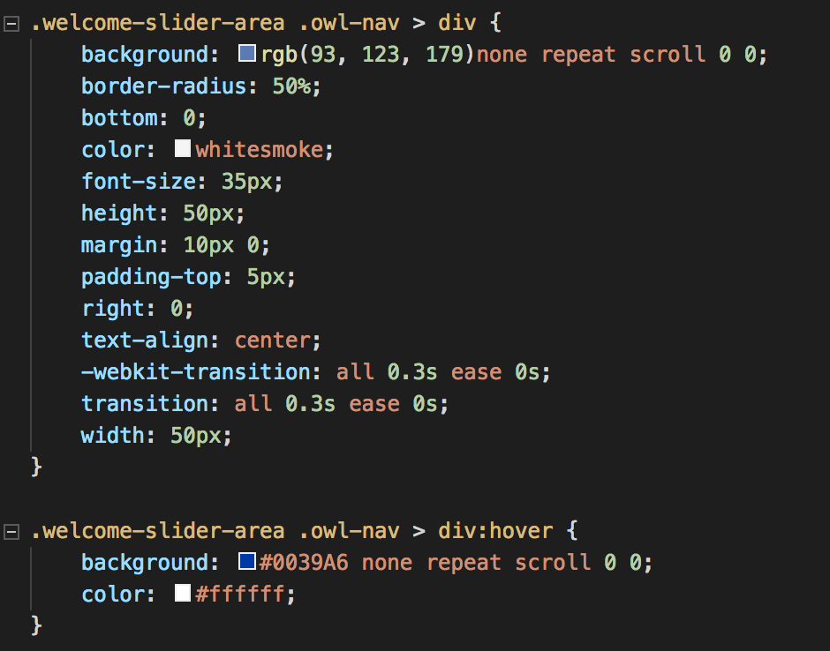

On the main page we have nav tabs. The tabs are arrows. If you wanted to control the images movement you can use the arrow tabs.So what you see in the figure 2 above is how we created the nav tabs. The nav is similar to the first figure 1 above but additional variables we added. Such as border-radius, it adjust the corner of the item, you can make a circular or elliptical corner. Then, we added height, it is the content of a object that accepts the length of any values. When using padding you can determine the length which is formed in pixels, point, center meters, and etc. Then it can be identified as percentage which can give you a specific with of the object. Lastly the width, it also gives you the content of the object but in portion inside and out of the object. Width works like text wrap in word, excel, and etc. As for the hover function we created colors for when you see it on the home page. You will then see the colors change when you hover over it. How it is going to work on GUI side is that you will see a white arrow but when you hover over the arrow you see a blue color for the background.

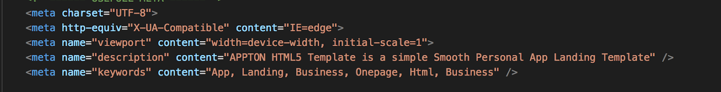

The <meta> tag is the brain of the webpage. The <meta> tag tells the instruction on how to control the page dimensions and scaling. When sites are are in use such as chrome, Google, education site, and etc; you need the tag <meta>. The <meta> tag gives information about the HTML document. The data do not shows the HTML on the GUI side of the page but will be a machine parsable. The <meta> tag is subject for keywords, author of the document, last modified and more. The content is a attribute that needs to defined or the attribute will give you a false error. If you do not have a name for the content you can use http-equiv. The http-equip gives the content a identification, that mean you will not get a error. The figure 3 above shows you how the <meta> tag was used in our web page.

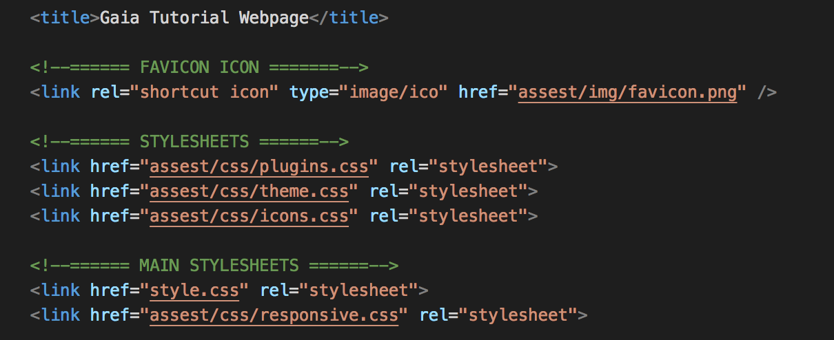

When searching the web you have names of the sites you going to in your tab bar. The tab bars are there for you can general idea of what you searched and keep you organized. Now, that is implemented by the <title> tag. The <title> tag also shows the name in the browser toolbar. Figure 4, shows the <link> tag and the attribute. The <link> tag gives you the path between document and external resources. The attribute that access the exact path is href. When writing code in html you are working with a lot of css. Most of the time inside your HTML file you are accessing the css. The next attribute is rel; which is our reference. The rel gives use the clarification of what is the type of source we are using. Rel reference the document of the style sheet.

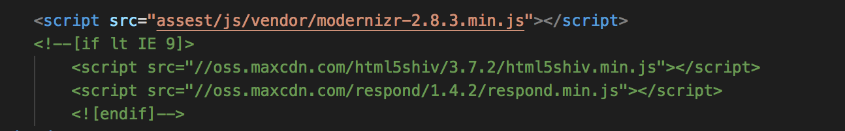

There are a difference between java and JavaScript. Most people assume they are the same but the languages works in different ways. Java and JavaScript are long lost cousin. Java has the ability to create application that can be used through virtual machine or the browser. Also java always needs to be compiled. JavaScript would not need to be compiled; JavaScript code is written in text. Which means, the code can only run on a browser. In the figure 5 we created a <script> (this is how you open and close a JavaScript tag) tag in HTML. Inside the <script> tag we created a attribute called src. The src attribute loads all the images on the browsers. The src makes sure the images stay in the spot of the webpage, otherwise, anybody that decides to see the image, it will break.

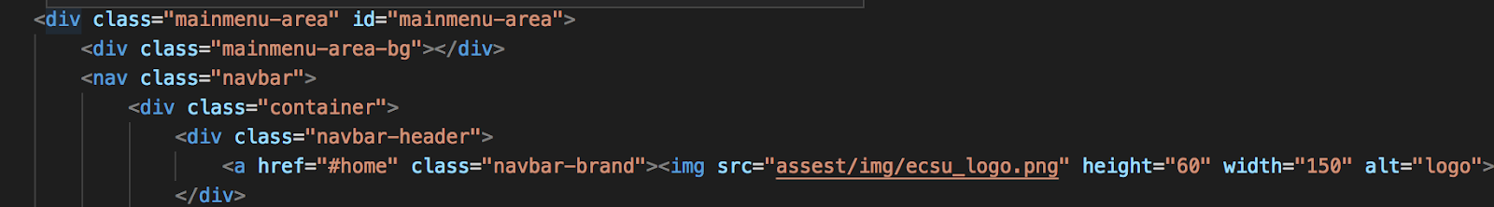

In figure 6, you see <div> <nav>, <a> tags with the attribute. The <div> tag can be hold in as a container in inside HTML to correspond with css or execute commands in JavaScript. When opening browsers such as chrome, Firefox, internet explorer, and etc.z; has a default line break. By using the <div> tag you can manually change the line break with the help of css. The <div> can identify a section or division in a html document. The class attribute like your uncle or aunt. A class can be identified as more then one class name. When you call a class in HTML it will point you to the style sheet you are looking activate. Also in use of JavaScript you can use the class to make changes in your HTML file of your choice.
The id attribute is almost the same as the class attribute. The id attribute looks for unique names, as in, it can only be identified with one character and can not any space characters. When a webpage or website is created you want to be organized. That's were the <nav> tag comes to play. The <nav> tag is links that directs information. Think of a <nav> tag like a book, when w page is turned, new information is presented. Likewise, with a <nav> tag, when a element is clicked on in the sites, it will go to a different page with more information with that specific site.
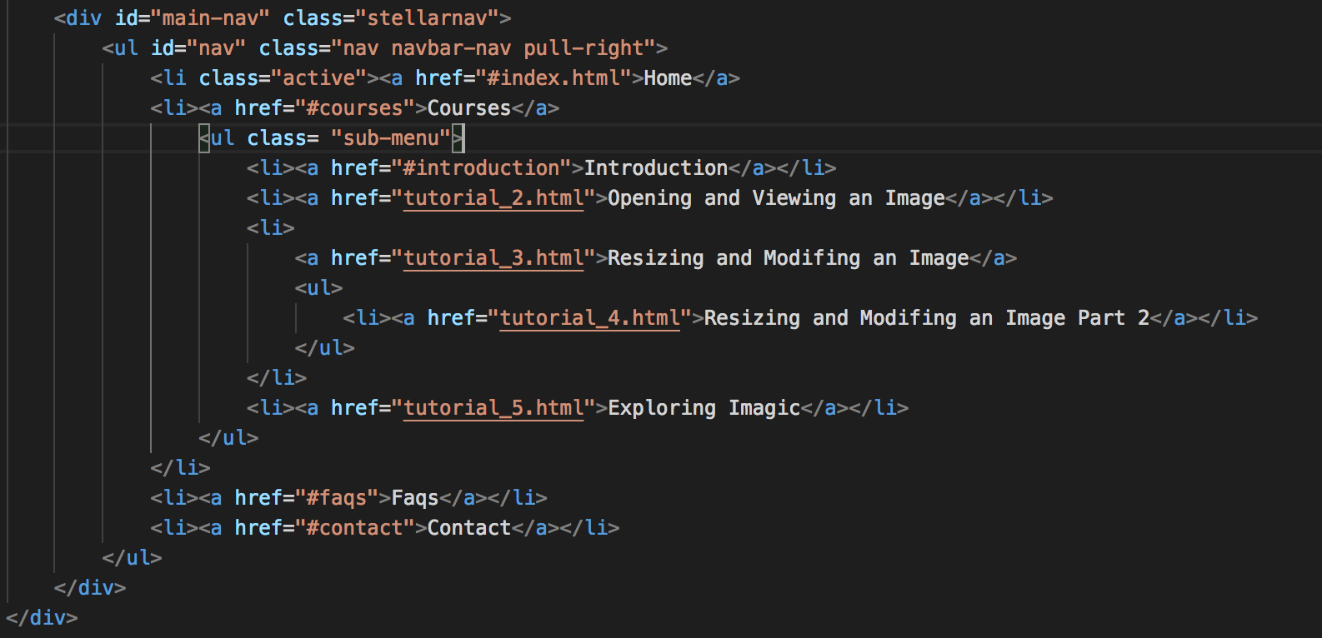

On the home page you will that there will be a nav bar create with specific navs. The is most concerning is the “course” nav. In figure 7, will show how the course nav will be called. For the course nav, there will be a drop down list. In order, to create this list there was two kinds of tags used, which are <ul>, and <li>. The <ul> and <li> tag are both list; both tags works like twins. Neither tags will not work on without implementing <ul> and the <li> tag. The <ul> tag access the unorder list but using the <ul> and <li> tag together will create a unordered or bullets list. For the site we created a few list; when hovering over the course you see lessons that will help with mapping.

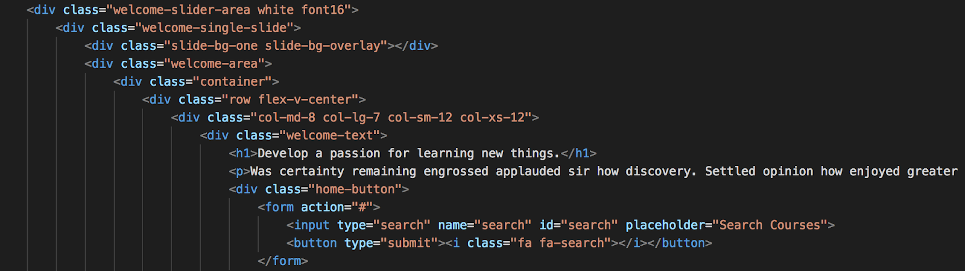

On the home page is a slide menu, on those slide menu are text and a search bar. For the text to display on the GUI side of the page; we used a header and paragraph tags. The tags were used to format the slides. The header tag will be the larger font on the slide. The header tag is used the same if you were operating Microsoft office. The only difference is that in office is point and click verse in HTML a built in tag is used (if you are trying to use header other then <h1> tag; just switch the number and the style header will display on the page. If getting confused how the tag works, just take a look at figure 8). In HTML the paragraph tag will start new line for you. There will be no need to start new lines when writing the <p> tag. Also the when the paragraph tag is executed the browsers will automatically add margin before and after. If the margins are not to your liking, you can create some settings in the css and call the css.

To create the search bar a <form> tag had to be created. This <form> tag will allow the users do a input, which means data is allowed to be inserted. Figure 8 shows the attribute used to create the input tag. The type is a attribute that shows the kind of input that is be used. A variable name has been declare, which help when a user submit data through the site ( it is like a reference or holding place). The placeholder helps the user, when in use of the search engine. The placeholder gives out hint when trying to use to search for elements. The placeholder works like Google, Firefox and etc. It tries to think for you and finish the sentence you type in the search engine. To execute the information the users input; a <button> tag is needed. The italic (<i>) tag is for the word in the search.

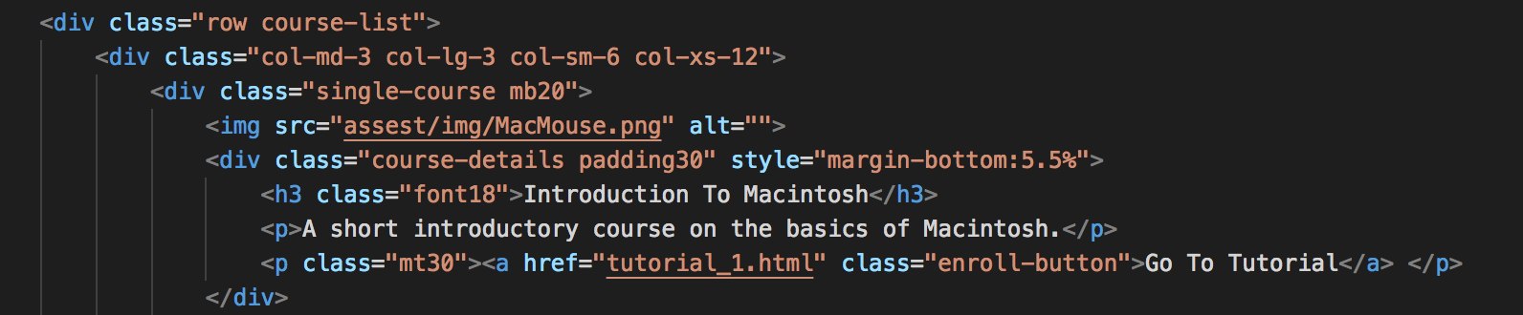

To make the site user friendly the first few lesson will be at the mid section of the home page. The lessons will loop through the page and will have a small description of what you going to work on before you click on the lesson.

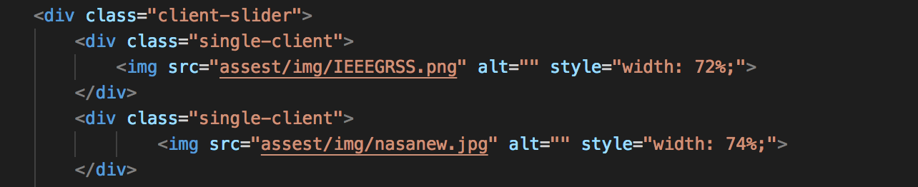

On the site we will have images that are linked of the sponsors we are partnered with. The alt attribute assists the images in the <img> tag. If the does not want to display on the screen the alt will find a different direction for the image to display on the screen. For instant, if you have a slow connection the alt attribute will redirect. There are many styles in the site, the style attribute can override the default and set the style to our preference.

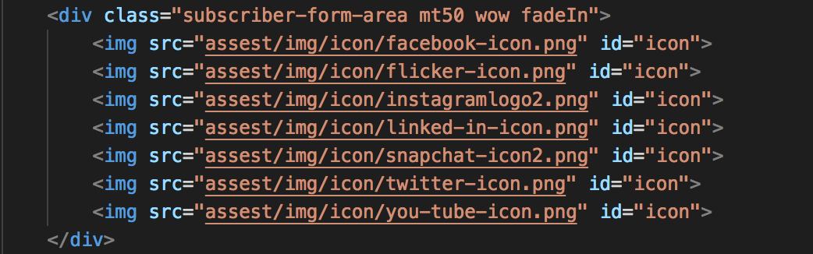

The bottom of the site will show you all the social media site that Center of Excellence for Remote Sensing Education and Research (CERSER) have created. If you wanted to see what were the upcoming events the social media accounts have them or see what the program have done the course of the year.

RESULTS
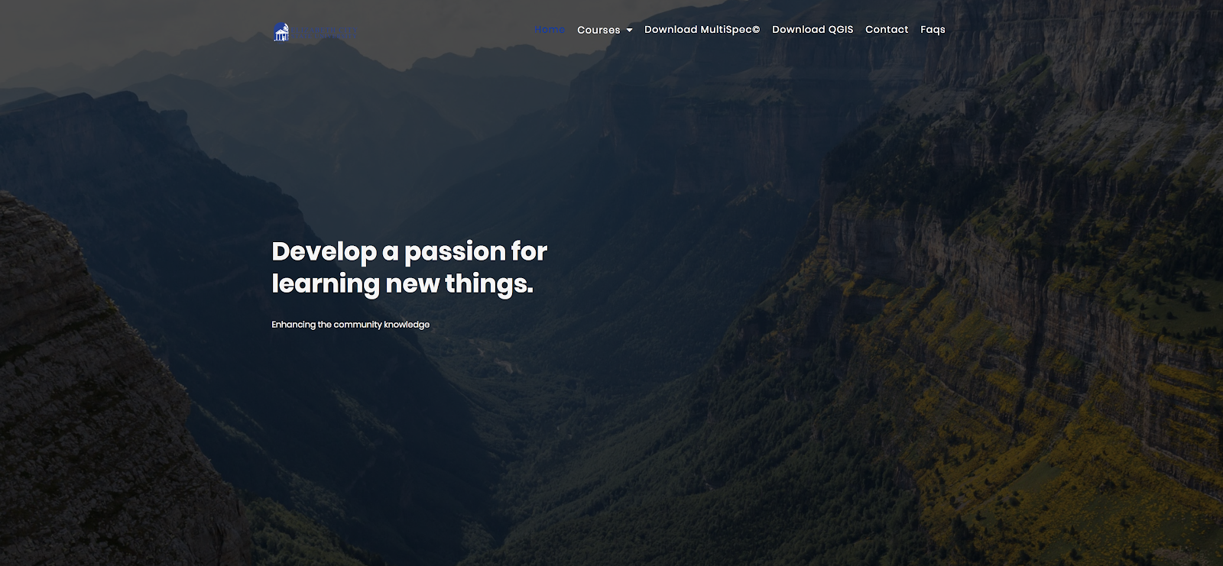

When opening the site, in figure 12 you will see this content. This home page will help navigate through the lessons. In the nav bar there will be options to choose from. Since you already on the home page, you see that home is blue when you hover over it; as the other tabs will do the same. If you can not find what you looking for, the search bar is there for your assistant. In this section of the home page there is a slide bar that moves about 5 seconds a part. Also, if you want to go to school page you can click on the Elizabeth City State University logo at the top right; that is our home page and you can find any other additional information.

There are many of lesson that you can work through, so as you scroll down the site there are few lessons that you start off with for easy access. The point of this slide bar, for it can be user friendly. The slide bar is in a infinity loop, which mean it will not stop moving through courses that is implemented.

There are sponsor that we are partnered with to make the project happen. They are placed at the bottom of the page to receive recognition. The logos are also in a infinite loop, which mean the slide bar on the home page will keep move unless the code is changed.
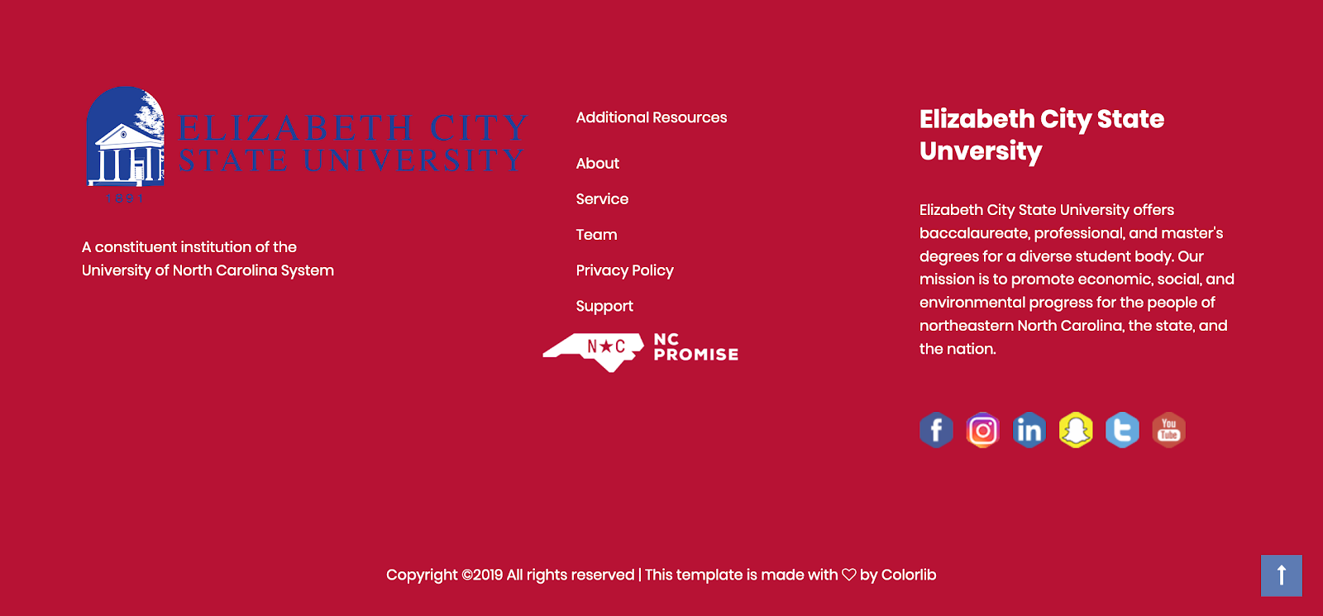

Figure 15 will display at the bottom of the home page. In the figure shown you will see the social media logo. If you want to look us up we be on these account. Also there is another ECSU logo you can click on to send you straight to ECSU home page.

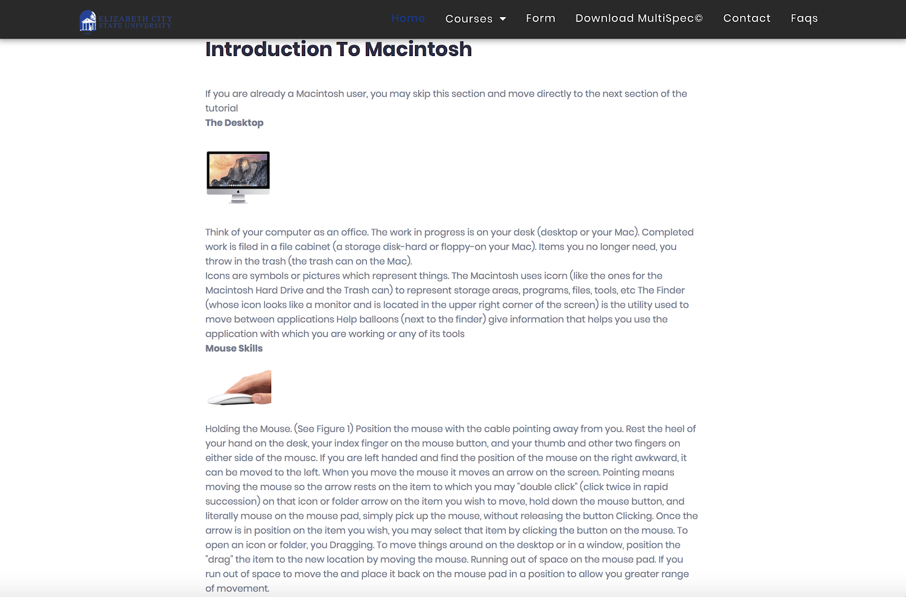

These lesson was base off using OS X system. Mac’s runs a little bit different then windows. The first lesson will show you how to operate a Macintosh system.

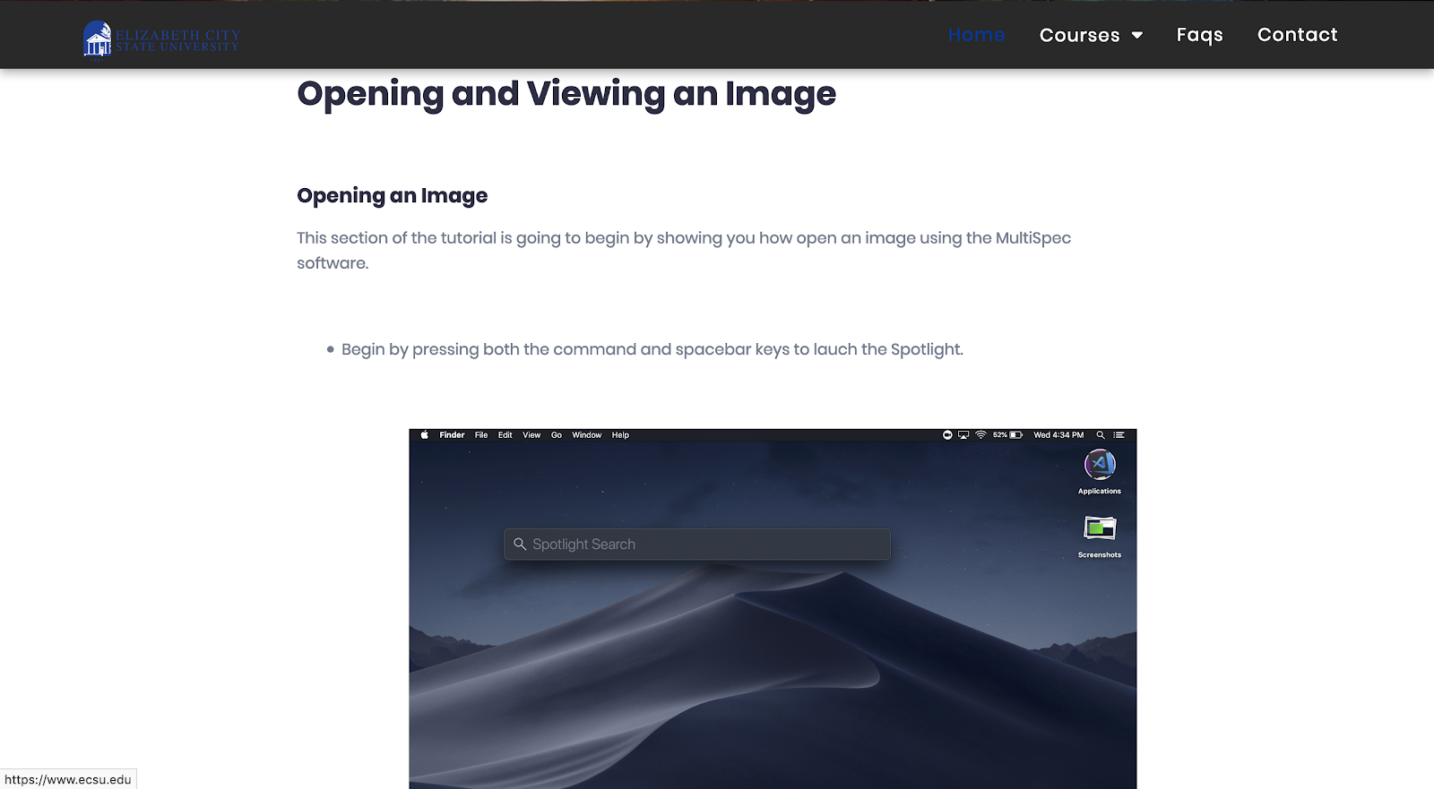

Each tutorial page consists of instructions for students and/or screenshots explaining the currently or previous action. Figure 17 contains a tutorial, which serves the purpose of teaching students how to open and view an image using MultiSpec.Students will be directed to open the MultiSpec program and select a specific image to open. This image will be provided via a download link on each individual tutorial webpage.
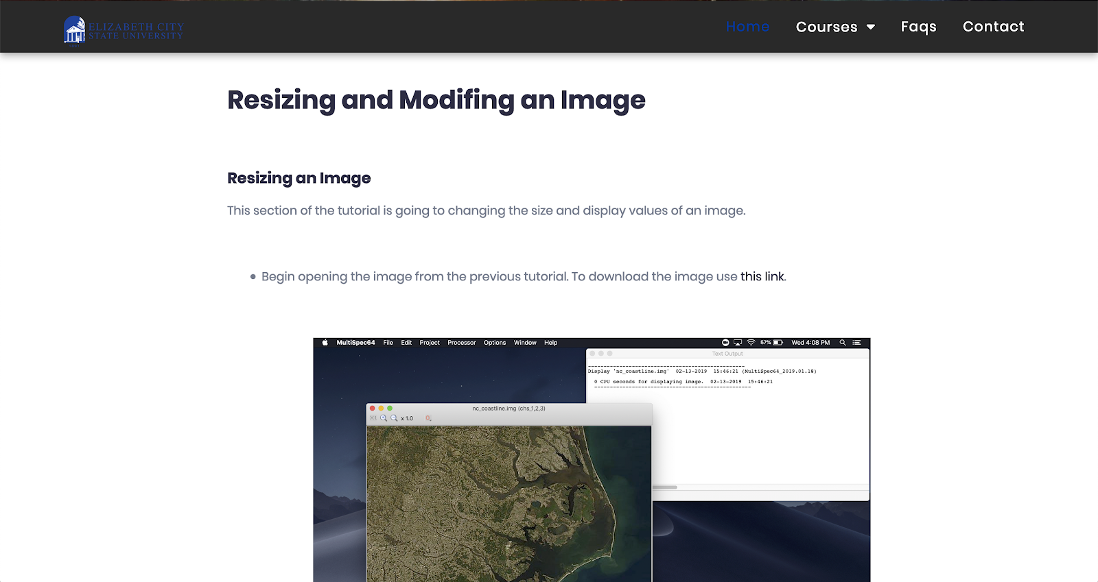

Figure 18 is a tutorial that has a two part section that provides students with the simple knowledge of modifying the size and color of an image in MultiSpec. It involves students modifying the start and end parameters for an image as well as alter the color channels of an image.

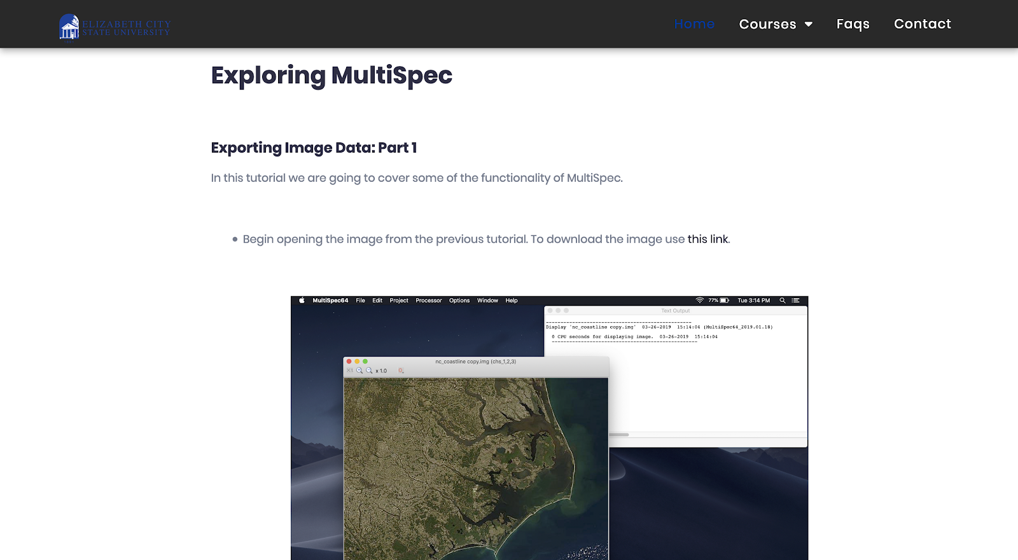

In this next page, figures 19 and 20 contains another two part section that focuses on exploring some of the different functions within MultiSpec such as histogram data, cluster data, and image statistics.
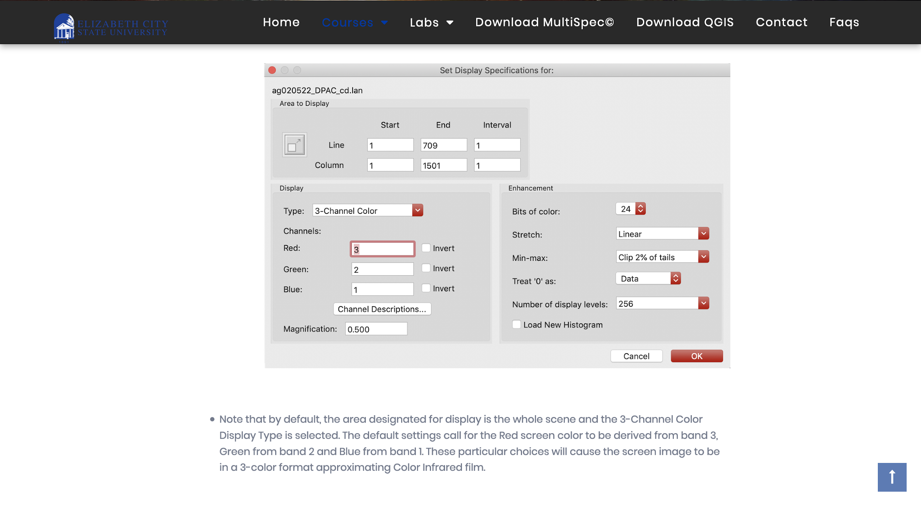
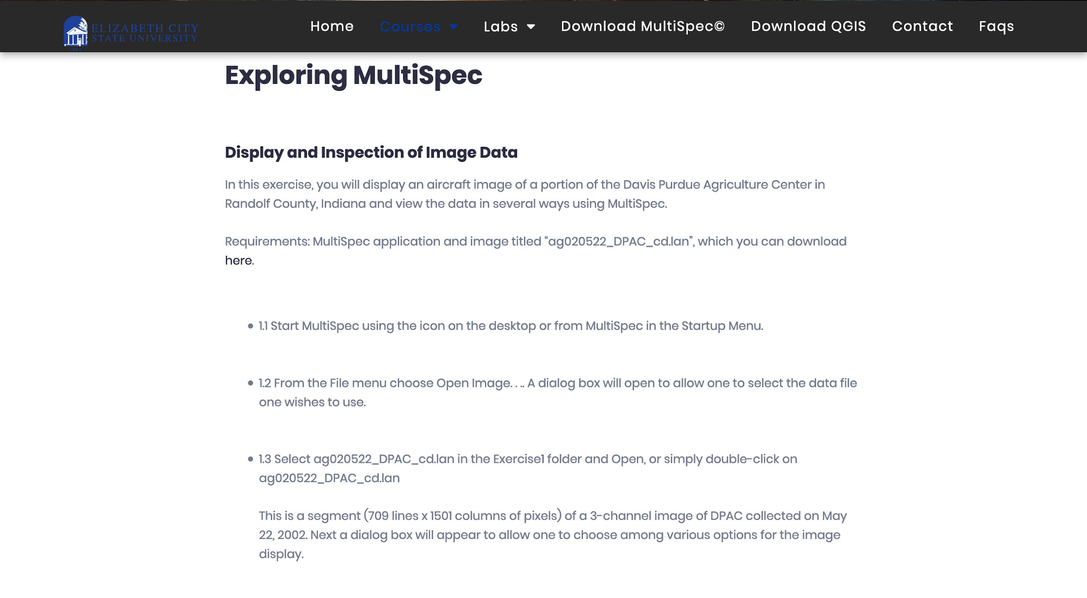
The two images above feature the tutorial on displaying and inspection image data. In this exercise, students will display a satellite image featuring a portion of the Davis Purdue Agriculture Center in Randolf County, Indiana From there the student with view the data in several different ways using the MultiSpec program.

CONCLUSION
In conclusion the group came up with the resulting website. The Cerser GAIA Tutorials website was built with the intentions of enabling teachers to better educate their students in the field of Geographical Information Systems (GIS). The tutorials contained within the Cerser GAIA Tutorials website are informative and use easy to understand instructions that resemble to an introductory-like structure. Plans of further improvements, optimization, and maintenance are scheduled for the future of the website.

FUTURE WORKS
There are many ways that the website can be improved to provide a more interactive experience for both students and teachers. In the future a database will be implemented to allow for both students and teachers to create an account and track progress. Teachers will be able to create a virtual “classroom” for their students, from which they can set a list of tutorials for students to complete and track a student's progress.

Each tutorial will be done in checkpoints; each checkpoint will consist of a set of tasks the student will need to complete. From there the student will be required to either; complete 2 or 3 questions proving that they understand what they've learned, or modify an image according to the tutorial, and then upload the modified image. The image will then be checked to validate if the student has properly modified it.

Feedback is not only taken from students but also teachers. All students and teachers that use Gaia Tutorial site are encouraged to submit feedback to better help us tailor the needs of both the student and teacher side of education.

ACKNOWLEDGEMENTS
We would like to thank Dr. Linda B. Hayden for her support during this project.

REFERENCES

- M. Altaweel, "Teaching GIS in Elementary School", GIS Lounge, 2019. [Online]. Available: https://www.gislounge.com/teaching-gis-elementary-school/.
- Esri.com, 2019. [Online]. Available: https://www.esri.com/library/ebooks/advancing-stem-education-with-gis.pdf.
- Publication", Ieeexplore.ieee.org, 2019. [Online]. Available: https://ieeexplore.ieee.org/document/6945948?tp=&arnumber=6945948&queryText%3Dms%20karen%20warrington=v.
- D. Butler and S. Bednarz, ""Mission Geography" and the use of satellite imagery in K-12 geographic education - A NASA - GENIP partnership", https://www.researchgate.net/, 2019. [Online]. Available: https://www.researchgate.net/publication/249044868_Mission_Geography_and_the_use_of_satellite_imagery_in_K-12_geographic_education_-_A_NASA_-_GENIP_partnership.
- "GIS and Remote Sensing", GIS and Remote Sensing, 2019. [Online]. Available: https://serc.carleton.edu/NAGTWorkshops/gis/index.html.
- "What is GIS? | Geographic Information System Mapping Technology", Esri.com, 2019. [Online]. Available: https://www.esri.com/en-us/what-is-gis/overview.
- "Geographic Information Systems (GIS)", Cityofec.com, 2019. [Online]. Available: https://www.cityofec.com/?SEC=5C759CFE-FBC1-46B3-80CB-ABB26AD42D1A.
- “What Is Remote Sensing and What Is It Used for?”, USGS, 2019, [Online]. Available: https://www.usgs.gov/faqs/what-remote-sensing-and-what-it-used?qt-news_science_products=7#qt-news_science_products.
- ”Remote Sensing”, earthobservatory.nasa.gov, 2019, [Online]. Available: https://earthobservatory.nasa.gov/features/RemoteSensing.
- Crockford, D. (2001). “JavaScript: The World's Most Misunderstood Programming Language.” [Online]. Available. http://javascript.crockford.com/javascript.html.
- Free, C. (2004). “JavaScript: An Evaluation of a Web-Related Technology - Description.” [Online]. Available.http://www.usca.edu/free/jscript/descrip.htm.
- Shannon, R., (2000-2015), “What is HTML.” [Online]. Available. http://www.yourhtmlsource.com/starthere/whatishtml.html.
- W3.org. (2018). Cascading Style Sheets, level 1. [online] Available at: https://www.w3.org/TR/1999/REC-CSS1- 19990111http://www.yourhtmlsource.com/starthere/whatishtml.html.
- Bakken, S., et al., Virginia Tech Digital Library and Archives, (2001-2015), “PHP Manual.” [Online]. Available.http://scholar.lib.vt.edu/manuals/php3.0.6/manual.html.
- Oceanservice.noaa.gov. (2019). What is remote sensing?. [online] Available at: https://oceanservice.noaa.gov/facts/remotesensing.html [Accessed 31 Mar. 2019].
- Usgs.gov. (2019). What is remote sensing and what is it used for?. [online] Available at:https://www.usgs.gov/faqs/what-remote-sensing-and-what-it-used-0?qt-news_science_products=7#qt-news_science_products [Accessed 31 Mar. 2019].
- Purdue.edu (2019). A Freeware Multispectral Image Data Analysis System. [online] Available at:https://engineering.purdue.edu/~biehl/MultiSpec/description.html [Accessed 31 Mar. 2019].
[18] QGIS.org (2019). A Gentle Introduction to GIS [online] Available at:https://docs.qgis.org/3.4/en/docs/gentle_gis_introduction/introducing_gis.html#overview

