Establishing paradigms for modifying and developing the Workforce Development section of the Science Gateways Community Institute Site
Alma Salisbury, Hagen Hodgkins, Sincere Ponton Mentor: Jeff Wood
salisburyalma@gmail.com, hagen.hodgkins@gmail.com, pontonsinceregse@gmail.com, wood684@gmail.com
Elizabeth City State University

Abstract - The Center of Excellence in Remote Sensing Education and Research (CERSER) program on the campus of Elizabeth City State University is currently partnering with the Science Gateways Community Institute (SGCI) which is led by the San Diego Supercomputing Center (SDSC). SGCI is divided into five sections to support members of the gateway community: Incubator, Extended Developer Support, Scientific Software Collaborative, Community Engagement & Exchange, and Workforce Development. Dr. Linda Hayden, the CERSER Principal Investigator, leads the Workforce Development Section. The Workforce Development goals are to increase the development pipeline of science gateway young professionals and educators with an emphasis on increasing involvement of students from underrepresented groups.
As science today grows increasingly computer based, it poses challenges and opportunities for researchers. Scientists and engineers are turning to gateways to allow them to analyze, share, and understand large volumes of data more effectively. The existence of science and engineering gateways and the sophisticated cyberinfrastructure tools together can significantly improve the productivity of researchers. Most importantly, science gateways can give uniform access to the cyberinfrastructure that enables cutting-edge science.
The goal of the science gateways team was to increase the interactivity of the SGCI Workforce Development section of the SGCI web site to attract potential members and publicize needed information. SGCI had recently converted to the web platform Liferay from WordPress which necessitated the need to learn a new platform and its capabilities. The pages on the SGCI server were not able to be accessed during this project due to design and team coordination efforts. The proposed modifications for this project were completed utilizing HTML, CSS, and graphical modeling.
Keywords: SGCI, Science Gateways Community Institute, Liferay, Workforce Development, HTML, CSS, Linda Hayden, Lexicon

INTRODUCTION

SGCI Workforce Development Site Enhancements
The CERSER program, in partnership with SGCI has collaborated to develop a website for the purposes of providing support services and information to those working on or with gateway projects.
The goal of the Workforce Development is to increase the pipeline of young professionals and educators working with gateways. To this end SGCI has converted from the web development platform WordPress to Liferay. This resulted in the need to train those working on web development to become familiar with the new system and its capabilities. Texas Academic Computing Center (TACC) is leading the website development and maintenance. Currently minor changes to the Workforce Development portion of the site are made through submissions to the University of Michigan.
The focus of the Science Gateways team, overseen by Dr. Hayden, was to establish a method of creating and modifying information on the SGCI Workforce Development site. The Science Gateways team attempted to obtain modification capabilities to the Workforce Development section of the website, but was unable to during this research period. In place of this, alterations to the SGCI Workforce Development section were suggested and designed by the Science Gateways team and were created using HTML, CSS, and graphical modeling.

Science Gateways Community Institute
The Science Gateways Community Institute (SGCI) is an organization that provides resources and expertise that is used by scientist and engineers that are focusing on gateway development. SGCI is funded through the National Science Foundation (NSF) and uses these funds through multiple domains. A gateway connects networks so devices on them can communicate. The different gateways connect scientist and engineers around the world. Because they are so attainable by researchers throughout the country, the gateways have become more productive for interactive use.
SGCI is divided into five separate groups: Incubator, Extended Developer Support, Scientific Software Collaborative, Community Engagement and Exchange, and Workforce Development. The Incubator is used to learn about important areas in a gateways lifecycle. An Extended Developer is used to offer support for potential projects. The Scientific Software Collaborative is used to promote gateways for teachers and students around the world. Community Engagement and Exchange includes an annual conference, monthly webinars, and information resources. Workforce Development is used to expand gateway knowledge for underrepresented minorities in STEM areas.
SGCI is partnered with seven academic institutions. These partnerships represent over a decade of collaboration on science gateways projects. The partnered institutions are; Elizabeth City State University, Indiana University, Purdue University, University of California-San Diego, University of Michigan, University of Notre Dame, University of Texas at Austin.
They also work with a number of organizations. These organizations offer services and resources that are complementary to SGCI’s goals: Boinc, Bridges, Cloudbuster, ESIP, Globus, Jetstream, OHSL, and XSEDE.
SGCI also funds a number of organizations which in turn work with them directly. These organizations are: The Association of Computer and Information Science/Engineering Departments at Minority Institutions (ADMI), BlueSky to BluePrint, Center for Research Computing, Trusted CI, Hubzero, The National Organization for the Professional Advancement of Black Chemists and Chemical Engineers (NOBCChE), and the Science Gateways Research Center (SGRC).

SGCI Workforce Development
SGCI uses Workforce Development to expand the knowledge for students and educators. They focus on the knowledge of minorities in science, technology, engineering and math (STEM) areas. SGCI is able to reach these groups of people using workshops and internships through financial support, the Young Professionals Network, and mentoring. With the help of these student focused programs, SGCI is able to sponsor coding workshops and organized lectures for students.

SGCI Young Professional Network
The SGCI Young Professionals Network is a group for individuals who are either just entering the Science Gateways arena or those researchers and educators who are experienced in gateway development. Advisors and resources are put in place to assist all groups in the development of gateways. SGCI draws from several organizations and institutions to provide assistance to young professionals and their technical advisors.
The Young Professionals of the Year Awards is for the purpose of recognizing young professionals that go above and beyond in the area of gateways studies. It acknowledges their achievements and advancement in the field of gateway development. The recipients of the award are selected each fall and receive it in a ceremony during the Gateways Conference. [1]

SGCI Internships
SGCI is offers several opportunities for students, both graduate and undergraduate, as well as young professionals to take part in internship programs. Those chosen to participate in the programs as interns will be placed at one of seven possible universities that have partnered themselves with SGCI. Also, additional sites or mentors can be recommended by SGCI client partners for interns to work with. Students that participate in an internship with SGCI will also be required to attend that year’s Gateways conference for which funding to attend will be provided to attending students. The gateways conference is a gathering for gateway creators and enthusiasts features hands-on tutorials, demos, keynotes, presentations, panels, posters, and plenty of opportunities to connect with colleagues. [2]
The 4-week program offered by SGCI is a workshop that will take place at ECSU. The workshop is intended to cover the essentials of gateway maintenance and design. As such the program will be constructed of a series of tutorials followed by practical application of the knowledge and skills gained through live coding exercises. [3]
The 8-week program offered by SGCI involves getting student researchers involved in gateway projects. In the interest of this SGCI has partnered with a number of universities that host ongoing gateway projects. Students are placed at universities and matched with a mentor who will introduce and help to guide the student researchers through the process of developing skills in gateway development. [4]

SOFTWARE/LANGUAGES

Content Management Systems
“A content management refers to the system and processes whereby information is created, managed, published, and archived.” [5] Content Management Systems (CMS) refers to the infrastructure for the process of curating content to take place. The utilization of a CMS allows for numerous contributors to provide content as well as collaborate throughout the lifecycle of the CMS.
The use of CMS has been on the rise as the exponential growth of content on the internet means it is no longer viable for the manual publishing and management of content. Information that is published online must be continuously reviewed and revised. One of the most visible examples of a content management system is Facebook. It allows people, groups, organizations, and businesses to publish, refine, and maintain a presence on the internet.

Liferay
Liferay is an open source platform which is utilized in the creation and management of extranet and internet content. The platform has been branded as a web application framework rather than as a content management system [6]. It is composed of a number of units known as portals and the framework uses a number of languages in its execution. Liferay offers a wide variety of features that users can employ to adjust and manage the way they display their content. [7]

Lexicon
Lexicon is a design language created with the aim of providing a common framework for building interfaces within the Liferay product ecosystem. Lexicon was developed by Liferay and is based on Atomic Design, a modular paradigm. With Lexicon the user is able to define the dimensions of a webpage via a grid system. This systems framework is based on an 8px module. This means that the dimensions of the elements and the distance between them will always be multiples of 8. This is used to create consistency between elements.
There are two versions of this 8-point grid system, one called the “Hard-Grid” method and another called the “Soft Grid” method. The Hard Grid method is mainly used for implementing elements in a grid defined in 8 point increments. The Soft Grid measures these 8 point increments between elements. This system is mainly used when you’re coding an interface as programming languages does not use a grid structure, making them irrelevant. A column system is used when arranging elements horizontally. Lexicon’s infrastructure allows for the implementation of special features such as links, alerts, and confirmation messages.

Hypertext Markup Language
Hypertext markup language (HTML) is the standard language used in the creation of web pages. It is an uncompiled coding language that can be edited from a text editor, this makes it highly accessible. The way that the web is traversed is through the use of hypertext. This is text which calls content from other areas or sends the user instead to different web pages. HTML is primarily composed of a series of elements or tags that most browsers are designed to recognize. These tags markup their contents to have them perform certain functions. It is the content of these markups that makes a website what it is as they control everything from the spacing on the web page to the images displayed.
Additionally the contents of the elements of an HTML file can be modified in a uniform or on a case by case basis by adding either inline code or a link to another file which contains style components.

Cascading Style Sheet
Cascading Style Sheets (CSS) is a stylesheet language that is used for visual styling of web pages using HTML. It is used to separate presentation such as layout, fonts, and color from content. Using CSS improves flexibility for the user to control presentation characteristics. In CSS, there are rules that affect how a web page is displayed. These rules have a selector, which selects the elements you want to apply the changes to, and properties, which have values you set to update how an HTML page is displayed.
Officially released in 1996 by Hakon Winus Lie, CSS was one of the first style sheet languages at the time. At the time web CSS required different style sheets from sources on the web which is what made it different from other style sheet languages at the time. As time went on and technology grew, a greater variety of stylistic capabilities were added to meet the demands of web developers. In the late 1990’s new internet browsers, such as Internet Explorer, were introduced and CSS had a hard time supporting the new applications. [8]

METHODOLOGY

Introduction
This research sought to establish a paradigm by which the Workforce Development sections of the SGCI website could be updated. This site was designed and is currently maintained by the Texas Advanced Computing Center (TACC) personnel. Minor modifications have been completed by personnel at the University of Michigan up to this point, but Elizabeth City State University has lacked a method of performing updates and modifications.
Unfortunately, due to design requirements of SGCI standards and software limitations, the team was not able to fulfill this task. In place of this goal the team proposed to analyze the current site and create or modify pages as necessary for future teams to add to the SGCI site when site access becomes available. While content was available for several pages, the team was required to research new material and create a survey to gather further information.

Overview
The team analyzed the SGCI site seeking first to create a flowchart and storybook of site pages. The opening page of the site contained over 70 links making this course of action too involved to complete. The team then chose to focus on what pages and links were needed for the Workforce Development section only. The flowchart in Figure 1 below illustrates the pages that are currently part of the Workforce Development section of the website in blue and pages or links that are needed in red.
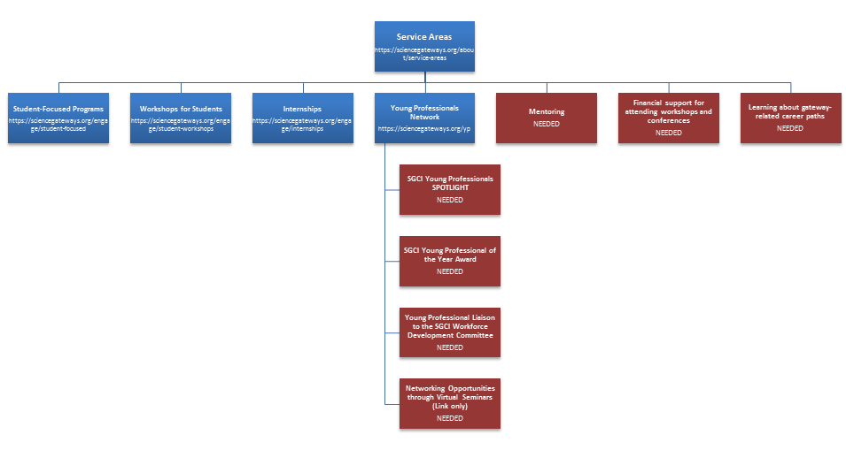
- Workforce Development flowchart
Under the SGCI page Service Areas (https://sciencegateways.org/about/service-areas) three needs were identified:
- Mentoring
- Financial support for attending workshops and conferences
- Learning about gateway-related career paths
Under the SGCI page Young Professionals Network (https://sciencegateways.org/yp) four areas were identified:
- SGCI Young Professionals SPOTLIGHT
- SGCI Young Professional of the Year Award
- Young Professional Liaison to the SGCI Workforce Development Committee
- Networking Opportunities through Virtual Seminars
While not all pages identified were created, the following areas were assembled or researched for future development.

Mentoring
When SGCI personnel were contacted regarding future interns and mentors, they requested that resources be gathered to assist new mentors and interns as to what they should expect and how to succeed. The Science Gateways Team gathered over 90 links to sites that sought to encourage and inform those involved with internships. This group was reduced to 17 intern resources and 8 mentor resources through elimination of pertinent information. Some were too specific to a certain career field while others contained information that was too general.
The resources were then documented by source name, source URL, and description with the information being entered into a table. The table was then converted to HTML format as in Figure 2 below.
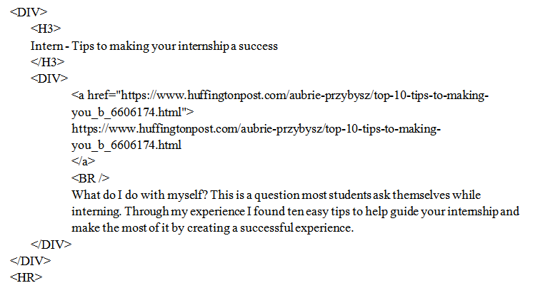
- HTML Code
Once this was completed, the team chose an SGCI page similar in construction to the intern/mentor resource list. The page contained multiple Cascading Stylesheet classes used to format the various “DIV” and “a” tags. These classes were added to the HTML code so that the developed code could be dropped into the SGCI pages and be implemented immediately. The code for these classes can be observed in Figure 3 below.
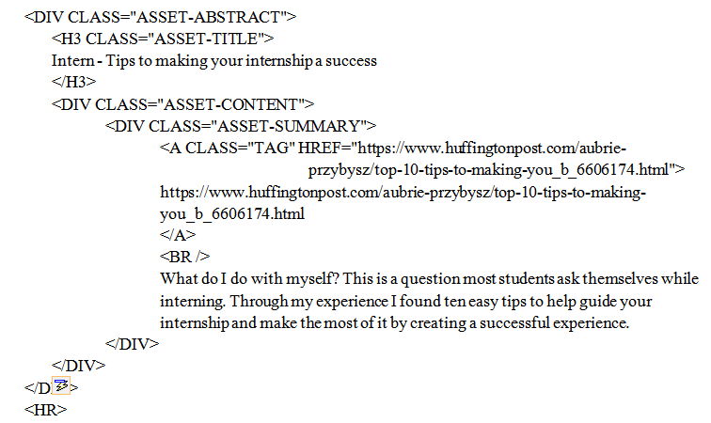
- HTML plus CSS Code
A graphical model of the code above is illustrated in Figure 4 below. The full mentor/intern resource list can be found in Appendix A.
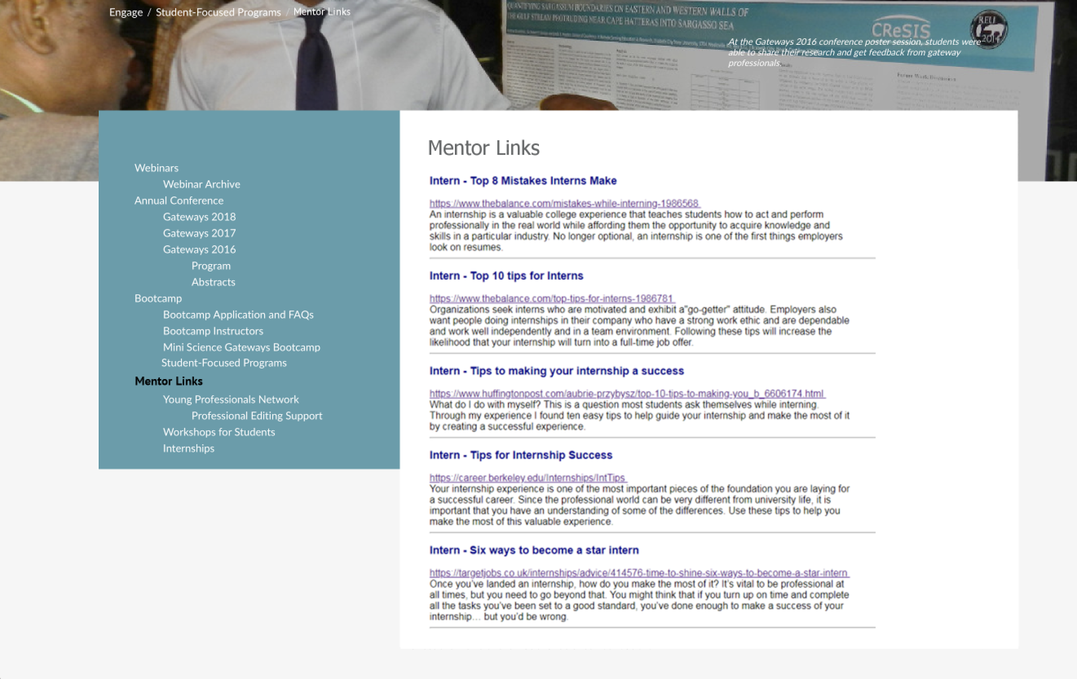
- Graphical Model of Links

Young Professionals of the Year
The Young Professionals of the Year award was presented to three individuals at the 12th Gateway Computing Environments Conference sponsored by the Science Gateways Community Institute (SGCI) which took place at the University of Michigan in Ann Arbor, Michigan. One of the parts of this award is “...a website highlight.” This portion of the award has not been completed yet. The team took biographical information along with photos to create a model for the page to be created on. Figure 5 below illustrates a portion of that modeled page.
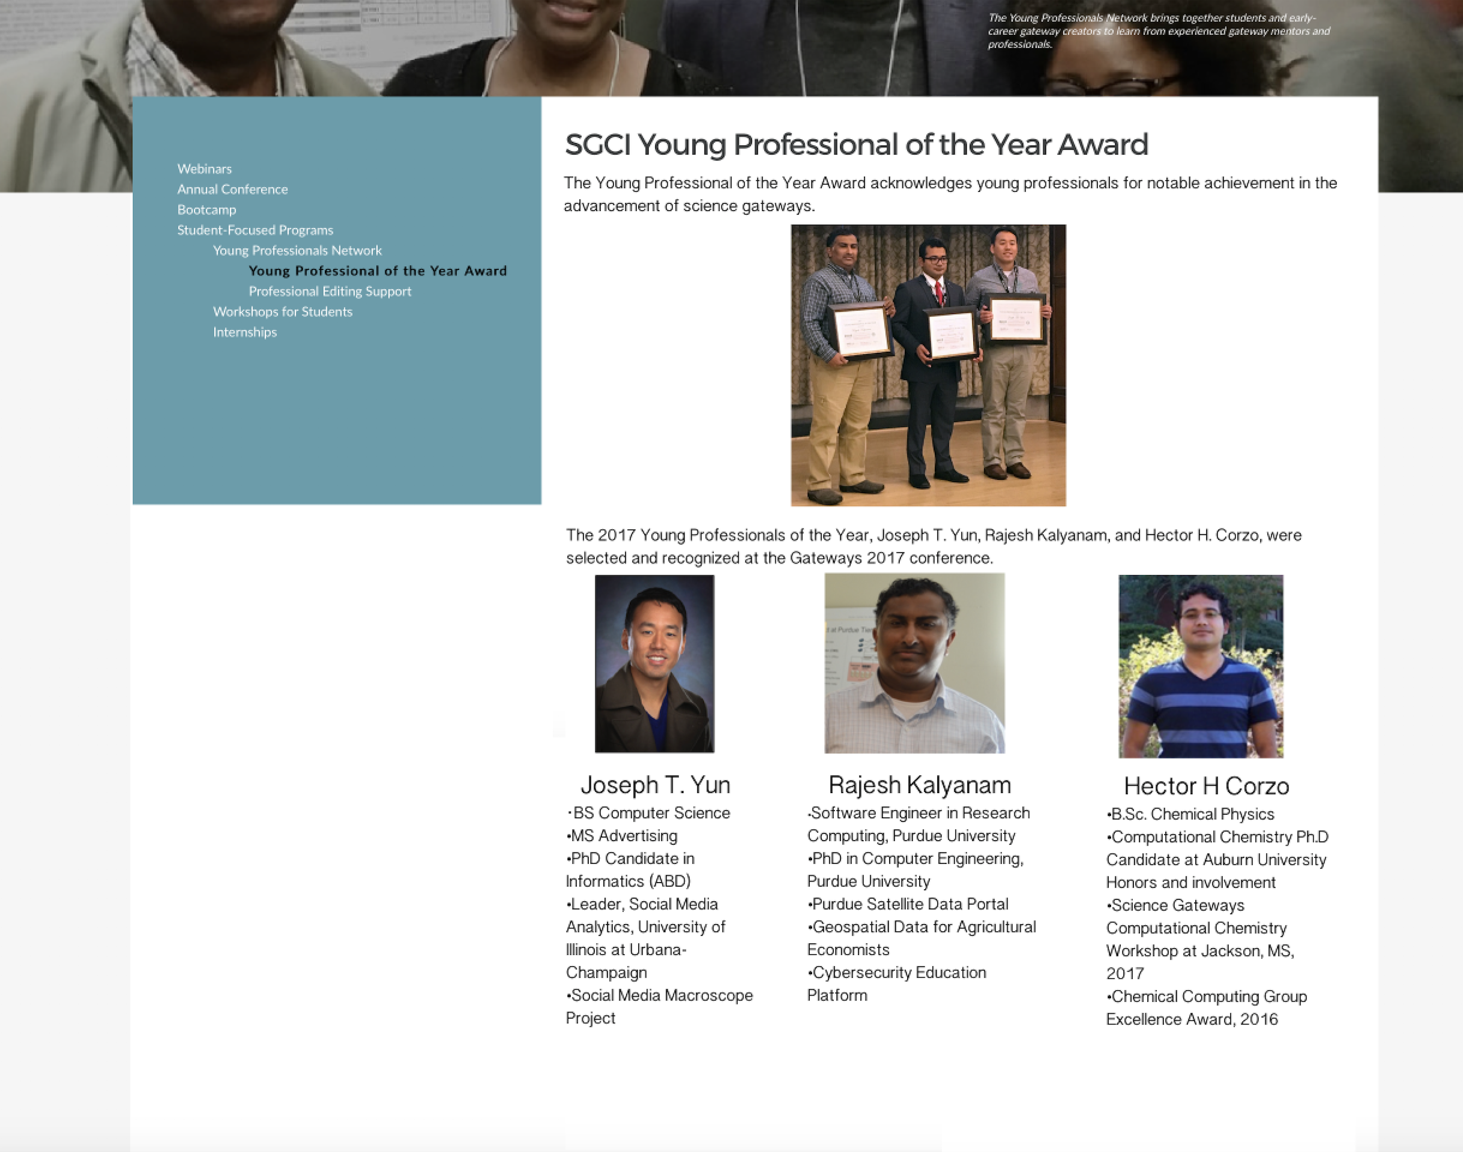
- SGCI Young Professional of the Year model

Gateway Career Paths
“Learning about Gateway Career Paths” was a difficult topic to cover as there are no set educational paths to enter the Science Gateway development field. After discussion with SGCI personnel who have a great amount of experience in this field, it was determined that the team needed to collect information from those who have entered the field either through degree programs or through certification and ad hoc instruction for particular projects.
Given this need the team developed a large set of questions and reduced the number to 14. These questions were divided into four sections:
- Introduction to Gateways
- Gateway Survey for Career Path Description
- Gateway Skills Development
- Future of Gateways
The survey questions were then implemented in a Google Docs survey form so that once a method of updating the site is developed, the form can be inserted and disseminated to a select group of individuals who are. A screenshot of the survey can be found below in Figure 6.
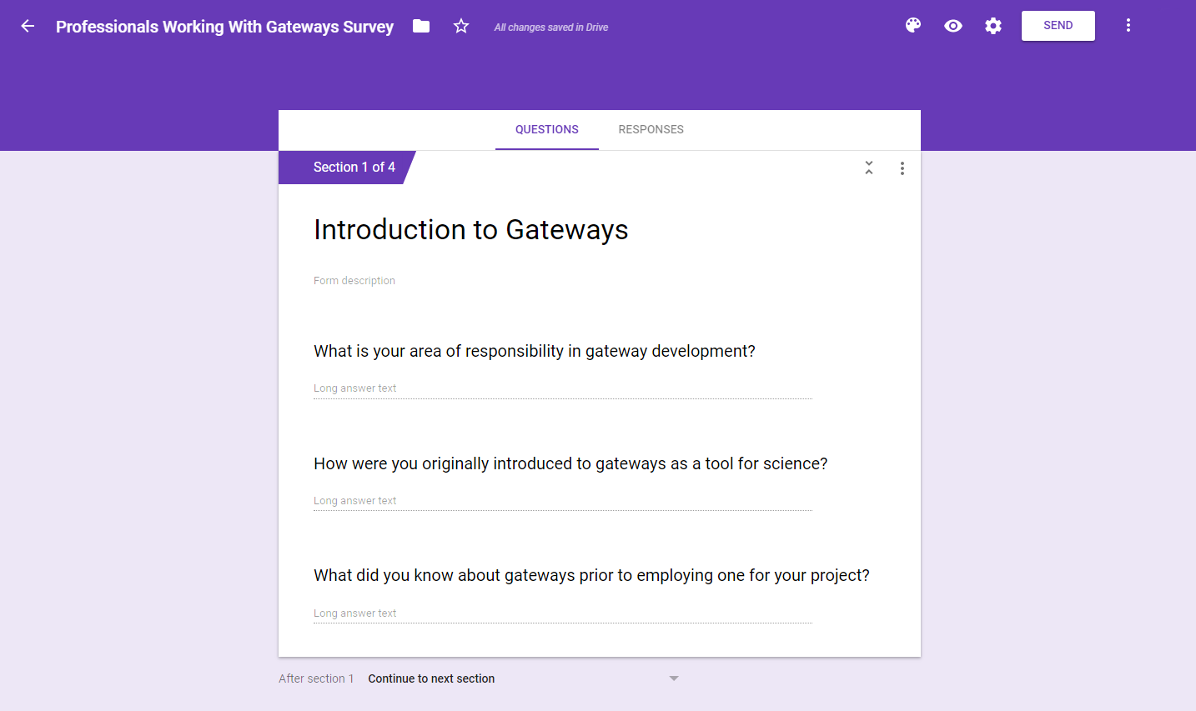
- Gateway Career Survey
The following is the list of questions submitted to SGCI personnel for review:
Introduction to Gateways
- What is your area of responsibility in gateway development?
- How were you originally introduced to gateways as a tool for science?
- What did you know about gateways prior to employing one for your project?
Gateway Survey for Career Path Description
- What did you learn from using and developing a gateway for your project?
- How did the use of gateway change your project?
- Would you use gateways in future projects?
- Did the use or development of a gateway improve the project?
- What do you think are the most important parts of a gateway?
- Which gateway project(s) are you most proud of?
Gateway Skills Development
- What path of study would you recommend to someone interested in gateway development?
- How much education is needed to become a gateway developer?
- What are your most valuable talents and skills in regards to gateways?
Future of Gateways
- Is there room for advancement and if so, what position would you ultimately like to have?
- What do current gateway developers see in the future for this field?

Financial Support
The Workforce Development service area supports individuals who present at conferences and attend workshops which contribute to the development of science gateways. The team developed a model for this page based on text supplied by Dr. Linda Hayden, the Workforce Development director. This model can be seen in Figure 7 below.
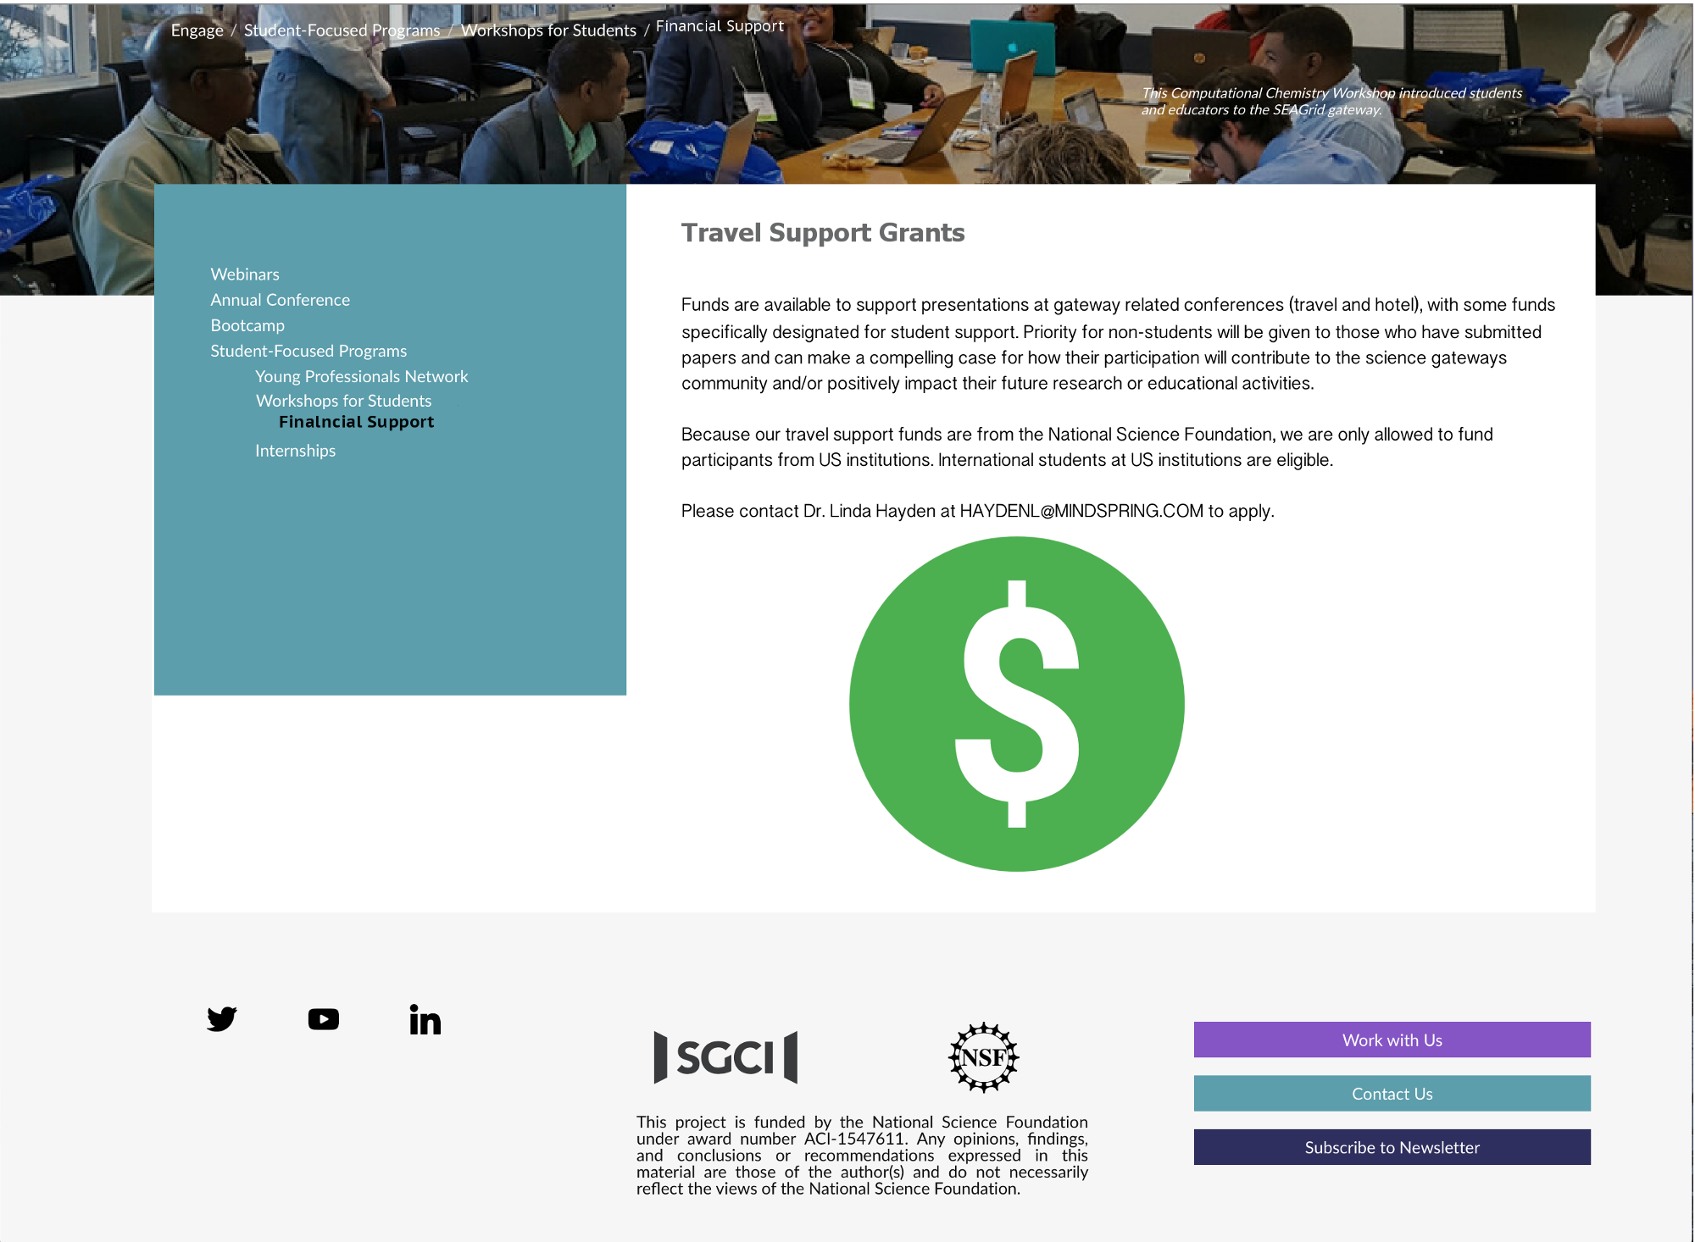
- Financial support model

ANALYSIS
The primary goal of this project was to establish a method of updating the Workforce Development section of the SGCI site. While the team was not able to reach this goal, the groundwork was laid with the SGCI staff for beginning the steps to updating and creating content on the SGCI site.
The Science Gateways team identified several pages for future development and addition to the SGCI site. The four pages created for this project included: “Gateway Career Paths”, “Young Professionals of the Year”, “Mentoring”, and “Financial Support.”
Where coding was not applicable, content was gathered and arranged as a model for TACC developers. In this case, text and images would be supplied for a page to be developed as in the “Young Professionals of the Year award” page in the methodology section.
In other cases it would be feasible to develop the content utilizing HTML and CSS so that formatting could be completed on the Workforce Development side and handed off to the developers. This would speed up the process of development and give the Workforce Development more control of the display of the content.
Both of these cases involve having TACC or the University of Michigan update and create the Workforce Development pages. While this would be a secondary choice when compared to having the ability to directly edit and create the pages, it would still be beneficial to the Workforce Development service in order to develop the needed pages and modifications.

CONCLUSION
Modeling of pages under development is a basic tenet in website creation. Whether through coding or graphical methods, storyboarding is necessary to build a coherent site. The team project produced models and HTML files for future pages to be added to the SGCI site once a method of updating has been established.
The Mentoring/Internship Resource page was assembled utilizing HTML and CSS coding. Basic DIV tags replaced the use of a table formatting and allowed the use of previously CSS classes developed by the TACC developers. Sample CSS styles were substituted for SGCI classes in order to view the assembled code in a browser. This process worked well for this type of page which was formatted as a listing with embedded HTML links.
The Young Professional of the Year and Financial Support pages were developed using graphical models rather than HTML to capture the essence of what the page would look like once changes had been implemented. This process of developing graphical models instead of HTML pages was agreed upon when it became clear that the team had no way to directly implement changes to the Workforce Development section of the website.
The Gateways Career Path page was primarily built around a survey intended for current gateways developers. The lack of a known career path based on the development of a gateway in and of itself lead the team to develop a large list of questions, which was then narrowed down to 14 key questions in order to determine the skills and knowledge needed to work on gateway projects.

FUTURE WORKS
There are several projects that can be implemented by future teams. The first is a simple link addition from the “Networking Opportunities through Virtual Seminars” bullet on the Young Professionals page. SGCI has initiated a monthly webinar that fulfills the original intent of this subsection.
Another page to develop should be the “Young Professionals Spotlight.” This page would highlight young professionals involved in science gateway development and education.
The survey for the Science Gateways Career Path should be implemented on a targeted audience. Results should be compiled and disseminated to students and educators to aid them in focusing their education and training on gateway development. This survey will most likely be implemented by the University of Michigan as they are currently connecting their Goggle Surveys to a database for collection of results.
In developing new pages, developers must also identify images for use as header images for the Workforce Development web pages. The dimensions of the images need to be identified by contacting the designers at TACC. The images can then be identified in the ECSU NIA photo library which contains images of SGCI conferences and workshops.
The highest priority will be continuing to work toward a working paradigm for updating the SGCI Workforce Development web pages. This may be in the form of supplying changes and new pages to a designer at TACC after a review by the SGCI staff or directly accessing the Workforce Development section of the site. Future coordination with SGCI will take place in the spring of 2018 and will involve not only the practical methods of updating, but ensuring that the updates are in line with the website direction.

ACKNOWLEDGEMENTS
We would like to thank Dr. Linda B. Hayden for her support during this project and the Science Gateway Community Institute for funding of this project.

REFERENCES
- Sciencegateways.org. (2018). Young Professionals Network - Science Gateways Community Institute (SGCI). [online] Available at: https://sciencegateways.org/yp [Accessed 23 Apr. 2018].
- Sciencegateways.org. (2018). Welcome - Science Gateways Community Institute (SGCI). [online] Available at: https://sciencegateways.org/gateways2018 [Accessed 23 Apr. 2018].
- Sciencegateways.org. (2018). Workshops for Students - Science Gateways Community Institute (SGCI). [online] Available at: https://sciencegateways.org/engage/student-workshops [Accessed 23 Apr. 2018].
- Anon, (2018). [online] Available at: https://sciencegateways.org/engage/student-workshopshttps://sciencegateways.org/engage/internships [Accessed 23 Apr. 2018].
- Web.csulb.edu. (2018). [online] Available at: http://web.csulb.edu/committees/webcomm/hannonhill/Hannon_Hill_Content_Management_White_Paper.pdf [Accessed 23 Apr. 2018].
- Anon, (2018). [online] Available at: https://www.quora.com/What-is-Liferay [Accessed 23 Apr. 2018].
- Evontech.com. (2018). What is Liferay?. [online] Available at: http://www.evontech.com/what-we-are-saying/entry/what-is-liferay.html [Accessed 23 Apr. 2018].
- W3.org. (2018). Cascading Style Sheets, level 1. [online] Available at: https://www.w3.org/TR/1999/REC-CSS1-19990111 [Accessed 23 Apr. 2018].

Appendix A: Mentor/Intern Resources

Students
Top 8 Mistakes Interns Make
https://www.thebalance.com/mistakes-while-interning-1986568
An internship is a valuable college experience that teaches students how to act and perform professionally in the real world while affording them the opportunity to acquire knowledge and skills in a particular industry. No longer optional, an internship is one of the first things employers look on resumes.
Top 10 tips for Interns
https://www.thebalance.com/top-tips-for-interns-1986781
Organizations seek interns who are motivated and exhibit a "go-getter" attitude. Employers also want people doing internships in their company who have a strong work ethic and are dependable and work well independently and in a team environment. Following these tips will increase the likelihood that your internship will turn into a full-time job offer.
Tips to making your internship a success
https://www.huffingtonpost.com/aubrie-przybysz/top-10-tips-to-making-you_b_6606174.html
What do I do with myself? This is a question most students ask themselves while interning. Through my experience I found ten easy tips to help guide your internship and make the most of it by creating a successful experience.
Tips for Internship Success
https://career.berkeley.edu/Internships/IntTips
Your internship experience is one of the most important pieces of the foundation you are laying for a successful career. Since the professional world can be very different from university life, it is important that you have an understanding of some of the differences. Use these tips to help you make the most of this valuable experience.
Six ways to become a star intern
https://targetjobs.co.uk/internships/advice/414576-time-to-shine-six-ways-to-become-a-star-intern
Once you’ve landed an internship, how do you make the most of it? It’s vital to be professional at all times, but you need to go beyond that. You might think that if you turn up on time and complete all the tasks you’ve been set to a good standard, you’ve done enough to make a success of your internship… but you’d be wrong.
Making Your Summer Research Internship a Good One
http://www.sciencemag.org/careers/2008/12/making-your-summer-research-internship-good-one
Getting past the frustration--and in the process learning how real research differs from science learned in the classroom--is what undergraduate research internships are all about.
Internship Do’s and Don’ts for College Students
https://www.livecareer.com/career/advice/jobs/internship-dos-donts
The value of one or more internships to college students cannot be overstated. Internships have simply become a must for all college students. Internships help you better understand your field, help cement (or at times change) your career goals, and give you the experience employers demand — even of college graduates.
How To Be The Best Intern EVER
https://internsdc.com/internship-advice/how-to-be-the-best-intern-ever/
To really impress, you guys should go the extra mile over the next few weeks because you never know what doors it may open in the future. May be your boss will be so impressed they’ll offer you a job, or give you an amazing reference when you need it.
Ask the Intern: How to Master Workplace Etiquette
https://www.theinterngroup.com/our-blog/ask-the-intern-how-to-behave-at-work/
While you want to enjoy yourself as much as possible, there are a few basic office etiquette rules by which to abide. Here are a few of my top tips on how to behave at work.
8 Essential College Internship Tips
https://www.collegexpress.com/articles-and-advice/career-search/articles/internships-co-ops/8-essential-college-internship-tips/
Everything you need to know about college internships could honestly be a 10-part mini-series. There's so much to keep in mind! But since they don't have binge-watchable Netflix series for job search advice, here's the next best thing: the top eight tips for finding and crushing your internships.
50 internship tips for students
https://blog.timesunion.com/careers/50-internship-tips-for-students/1607/
Other than your education, the single most important means of transitioning from student to professional is an internship. This is a collaborative work experience with professionals in your field of interest where the emphasis is on learning rather than earning.
18 things we wish we’d known as Interns
http://www.businessinsider.com/advice-for-interns-2013-6
A good internship can lead to a job, great references, and valuable experience. A bad internship can turn out to be a waste of time and money for everyone involved. So how do you ensure that you have the right kind of internship? A lot of it comes down to the attitude and approach taken by the intern.
10 tips for your summer internships
https://www.cnbc.com/2015/05/01/10-tips-for-your-summer-internship-commentary.html
Summer is just around the corner. And that means summer vacations and for many students ... that also means your first summer job or internship. Here are tips for how to make the most out of your summer internship. Who knows ... this could be the first step to landing your dream job out of school.
10 steps to turning your internship into a job
https://www.careerbuilder.com/advice/10-steps-to-turning-your-internship-into-a-job
Whether you're on the verge of graduating from college or have a few more credits to go, getting an internship is one of the smartest moves you can make as an undergrad. If you go about it the right way (and if the timing is right), your internship may lead to a full-time job offer down the line.
10 Tips to make the most of an Internship
https://www.careereducation.columbia.edu/resources/10-tips-make-most-internship
An internship is an excellent opportunity to try out a career field, build skills, and potentially become employed at a company full-time after graduation. Here are 10 tips to make the most of the experience:
10 Things They Don't Tell You about Your First Internship
https://money.usnews.com/money/careers/articles/2013/07/18/10-things-they-dont-tell-you-about-your-first-internship
For anyone who might start their first internship sometime soon, consider this list the dossier on what you need to know.
10 Qualities of a Successful Intern
http://www.internships.com/eyeoftheintern/uncategorized/successful-intern-tips/
For the past two summers, I have done an Internship with AT&T Services downtown St. Louis, Mo. To say that I have learned a lot would be an understatement. I want to give you some helpful advice on how you can absolutely thrive during your internship. Of course there’s more than 10, but the following are the top 10 things every intern must do:

Mentors
Top Qualities of a Good Professional Mentor
https://www.thebalance.com/top-qualities-of-a-good-mentor-1986991
A good mentoring relationship provides new employees as well as interns with someone that will share their professional knowledge and expertise in the field. A good mentor is available to answer any questions relevant to the job. Good mentor-mentee relationships are a two-way street; consequently, if you want a good relationship with your mentor, become a good mentee. This requires a genuine interest in your mentor and a willingness to do what it takes to become successful as an intern or new employee in the field.
Ten Ways to Become a Great Mentor
https://knowledge.insead.edu/blog/insead-blog/ten-ways-to-become-a-great-mentor-3994
Mentoring is a much used and abused word. Becoming a great mentor is by no means a goal or a destination, but a journey that has a starting point and a constantly changing endpoint. To be effective at different stages of this journey, a mentor needs to keep his or her mind open, constantly adding value, helping the relationship evolve and playing different roles at different stages.
Mentoring University Students
https://niu.edu/mentor/why/mentorstudents.pdf
Cusanovich and Gilliland state that a “mentoring relationship involves professors acting as close, trusted, and experienced colleagues and guides. It is recognized that part of what is learned in graduate school is not cognitive, it is socialization to the values, practices, and attitudes of a discipline and university, it transforms the student into a colleague.”
Mentoring Basics - A Mentor’s Guide to Success
https://www.bc.edu/content/dam/files/centers/cwf/individuals/pdf/MentorGuide.pdf
Prepare for mentoring by learning more about mentoring and the qualities and activities of a mentor. Learn why technical women need mentors, and how to find a promising protégée. Find out how you benefit from the mentoring relationship, and learn basic Do’s and Don’ts of mentoring.
Learn How to Be an Effective Mentor
https://alis.alberta.ca/succeed-at-work/explore-ways-to-improve-your-work/learn-how-to-be-an-effective-mentor/
Are you successful in your career? Do you like the idea of helping someone else achieve career success? Then check out what it takes to be an effective mentor.
How to Be a Good Mentor
https://www.monster.ca/career-advice/article/tips-on-how-to-become-a-mentor
Mentoring is about helping another person learn through a one-to-one relationship. It’s a common practice for transferring knowledge and promoting best practices at work. As well it is an effective way to develop new leaders.
How To Be An Effective Supervisor and Mentor of Student Interns
https://www.isd742.org/cms/lib/MN01909691/Centricity/domain/570/cte%20docs/Mentor%20Handbook.pdf
After you interview and accept a student intern, you should set up your own one-on-one orientation to familiarize the student intern with the new surroundings and to establish the rules, regulations, and office protocol she/he is expected to follow. At this meeting, you can begin to establish rapport which will help both of you resolve difficult situations if and when they arise.
7 Ways to Be a Great Intern Mentor
http://employerblog.looksharp.com/7-ways-to-be-a-great-intern-mentor/
Having decided to hire an intern, you now have the difficult job of getting them settled in at your company as fast as possible. After all, their time with you is limited. So how do you put your intern at ease and make them feel at home?

