Measuring Shoreline Loss: Salmon Creek Case Study

Austin Ivins
Elizabeth City State University
CERSER
Elizabeth City, NC
arivins623@students.ecsu.edu
Derek Morris
Elizabeth City State University
CERSER
Elizabeth City, NC
dmow4454@gmail.com
Reggie Kelly
Elizabeth City State University
CERSER
Elizabeth City, NC
rjkelly826@students.ecsu.edu
Clay Swindell
Elizabeth City State University
CERSER
Elizabeth City, NC
swindell.clay@gmail.com

Abstract - The effects of sea-level rise are measurable in historic maps and modern aerial imagery. Today, scientists are actively studying these changes along the coast of North Carolina through a variety of multidisciplinary approaches. New technologies such as Unmanned Aerial Systems (U.A.S) are helping provide researchers with a cost effective and site-specific platform for collecting remotely sensed data. In the past, multispectral imagery was acquired through expensive satellite and aerial platforms. Today, these data can be obtained through the use of small inexpensive drones equipped with imaging systems that provide current and detailed data sets for very specific locations.
The goal of this project is to identify how much of the shoreline along Salmon Creek in Bertie County, NC has eroded away over the last several hundred years. It is hoped that this information will help better understand what it may have looked like in the late 1500’s when English explorers first mapped the area. To measure changes since the 16th century we first analyzed the earliest known depiction of the creek made when English explorers intending to settle the region mapped the area. The map produced from these expeditions is both surprisingly accurate and detailed in its representation of the creek. This is made more obvious when it is directly compared with modern 20th century aerial imagery.
To further assess changes since the 16th century, the project turned to the existing expertise at the Center of Excellence in Remote Sensing Education and Research (CERSER) in acquiring and analyzing imagery with U.A.S. CERSER researchers use these new technologies on a variety of problems from creating 3D elevation and model datasets, to detailed analysis of photo-mosaic imagery to locate archaeological sites.
The results of this project demonstrate how dramatic changes to the 16th century shoreline of Salmon Creek are and show that once exposed to a significant rise in sea level, shoreline migration and impacts are permanent.
Finally, it is hoped that this project will further aid in the creation of specialized technologies and methodologies for future studies of shoreline loss at CERSER.
Keywords - Sea-Level Rise, Aerial Imagery, DJI Phantom 2 Vision+, drone, UAS, Archaeology

Introduction
Scientists are actively studying the dramatic changes along the coast of North Carolina through a variety of multidisciplinary approaches. One such approach relies on a technology becoming more prevalent in scientific research. U.A.S. have emerged from once expensive and unconventional tools to inexpensive yet complex research systems.. Their accessibility and capabilities offer advantages in obtaining aerial imagery, elevation data, and structural elevation models that have many applications including uses in humanitarian response, environmental studies, remote sensing research, and archaeological studies.

Objective
The goal of this research was to use an UAS combined with historic maps and satellite imagery to measure the effects of sea level rise along the coastline of Salmon Creek in Bertie County, North Carolina. To achieve this objective, an UAS platform equipped with a visible light camera to was used to capture a series of images along the northern shoreline of Salmon Creek. Shoreline presence and orientation from this imagery was then compared to historic maps and satellite imagery to allow for observations of shoreline changes. The intention is identify how much of the coastline has eroded away over the last several hundred years in order to better understand what it may have looked like in the early 1500’s.
What makes this study unique is the intention to use localized datasets acquired through U.A.S to generate more precise measurements of how this transition zone behaves and how it has changed in recent years.
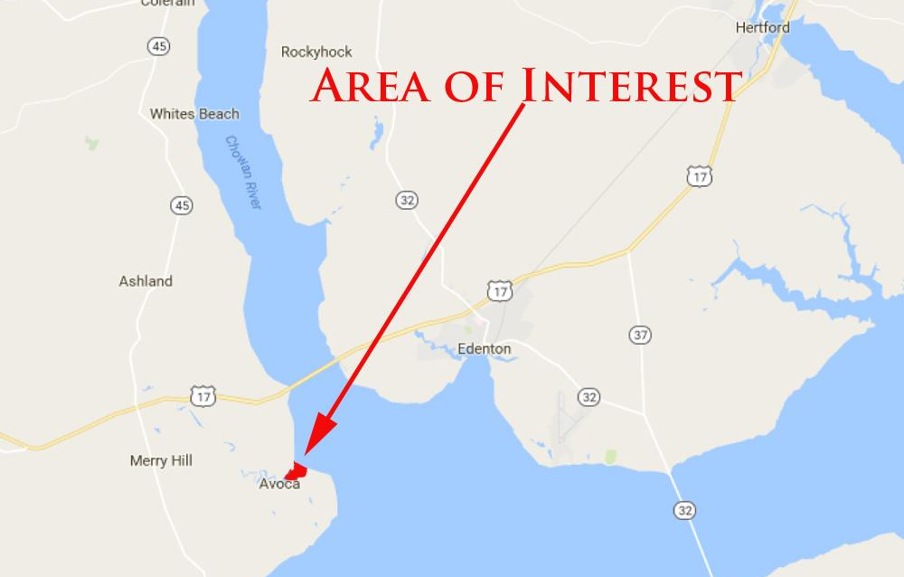
- Area of Interest (AOI), [2]

Area of Interest
The Area of Interest (A.O.I.) is located at the western end of the Albemarle Sound near the conflux of the Roanoke and Chowan Rivers (Fig. 1). Between these two major drainages is a drainage named Salmon Creek. People have used Salmon Creek for millennia but the first time it is drawn is in the late 16th century by English explorers (Fig. 1).

Equipment
The primary piece of equipment used to conduct this research was the DJI Phantom 2 Vision+ UAS with a built-in Naza-M V2 Flight Control System and integrated gimbal and camera [1]. The Phantom 2 Vision+ is a two-pound remote-controlled quad copter that contains four rotating wings capable of stable flight and taking high-resolution pictures and video.

Methodology
The team used a DJI Phantom 2 Vision in order to create an image of the Salmon Creek shoreline. The drone is equipped with a mounted camera. Using an app named Pix4D to control the path of the drone wirelessly to take images of the designated area. Pix4D allows the user to draw an outline of the path that they want the drone to take, and controls the drone during the whole process. Controlling the altitude of the drone to make sure it does not come into contact with any trees during the photography of the site.
The fieldwork portion of the project began during the spring of 2017; this project demonstrated how dramatic the changes to the coastline within the transition zone and showed that once exposed to a significant rise in sea level the migration and impacts are permanent. The transition zone is measurable by comparing images from previous years and also allows for future predictions of impacts from rising sea levels. Once arriving at the site the team connected to the drone using the Pix4D app, on an android device. Once connected the course for the drone was set using a grid to pick the method of the imagery. After mapping the course the drone was sent on several trips, in order to photograph every part of Salmon Creek possible.

Flight Plan
Pix4d Android application was utilized on a Samsung J7 for the creation of four flight plans. The parameters for the flights taken were 125 x 89 meters, which is large enough to cover the area of interest (Figure 1). A total of four aerial image flights were taken, with the longest flight time recording at 12 minutes. There were a total of 171 pictures taking during the four on-site flights. This overlap is necessary for the creation of the larger mosaic.
Despite the UAS ability to fly missions on its own, it is still necessary to plot the linear transects prior to flight. It is also important to plot out the mission onsite as obstacles such as trees and power lines pose a threat to successful flight operation. Prior to flying, the team chose a location free of obstructions for takeoff and oriented the transect grid over the AOI. There was a respectable location for the DJI Phantom 2 to take off and be clear of obstructions. Once transects were mapped, the UAS automatically flew at a constant elevation of 50 meters along the route taking aerial images at every point mapped until completion. This resulted in 171 overlapping images that would later be used to produce a larger mosaic image. The benefit of this automation was that the team did not have to manually fly the UAS.

Aerial Imagery
To acquire images dating back to the 1950’s earth explorer was used to download aerial photo single frame images taken from aircraft. Using latitude and longitude coordinates to establish an area of interest images were selected from each decade continuing from the 1950 through 2016. Due to various abnormalities, images could not be collected in exactly 10-year increments. Cloud cover, poor focus, and images taken at night could not be used to accurately identify changes in the river’s shoreline features. From the years 1975 to the early 1990’s there is a gap in aerial photography. After year 1990 Landsat 7 and 8 were used to collect the remaining images, using geostationary satellites and high-resolution cameras to observe changes in the shoreline.
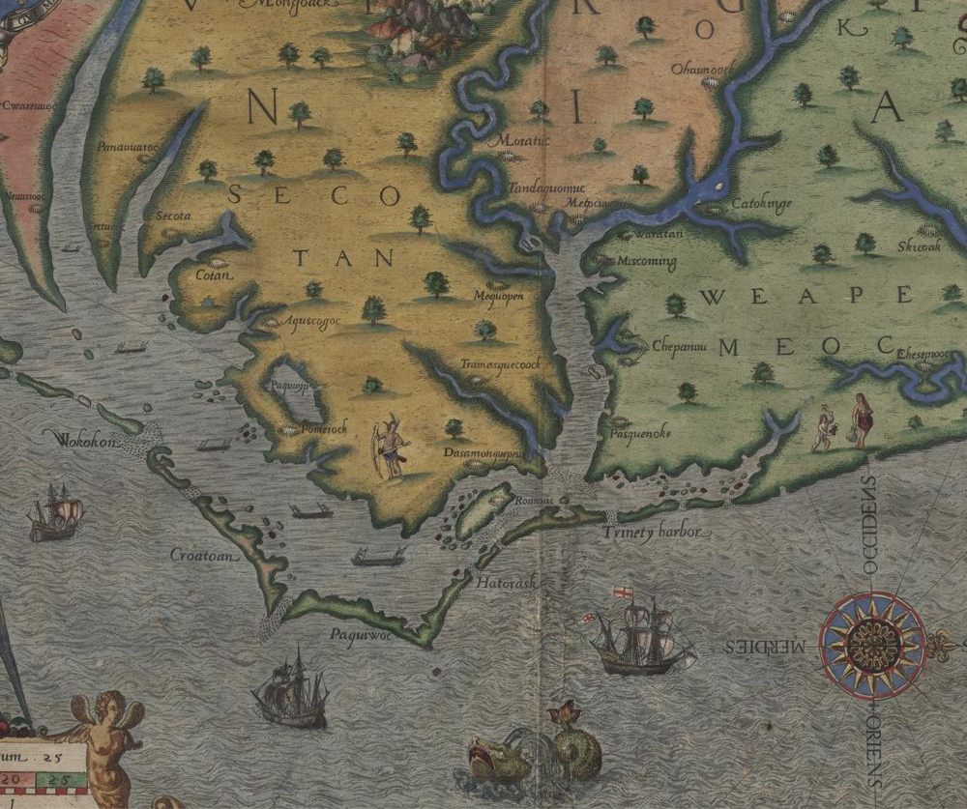
- DeBry Wood Engraving, ca. 1585

Image/Image Processing
In order to process the images captured by the DJI Phantom’s visible light camera, the team generated a photo mosaic as an effective way of analyzing the field data collectively. The term photo mosaic refers to one complete image that is formulated by the piecing together of multiple images. The images taken during the flight along the transects were composed into a photo mosaic using the image processing software Pix4D, which converts a multitude of images into "geo-referenced 2D mosaics and 3D models", useful for mapping and modeling [3]. A 64-bit trial version of Pix4D Mapper (Discovery Version) for Microsoft Windows. The 171 images collected and stored as JPEG on SD cards provided with the DJI Phantom were transferred to an 8 GB flash drive. From that point forward, the images were inserted into the Pix4D Mapper application project folder. Then the software took the individual images taken along the transects determined the overlap between each image by searching for commonalities, and then composed the images collectively into a photo mosaic of Salmon Creek. Two hours were taken to fully process the 171 images from the four trips to create the photo mosaic (Fig. 3). Once images were collected they were imported into image editing software, the AOI selected, and the shorelines traced for comparison (Fig. 4).
- Aerial Image of Salmon Creek North Shore, 2017

Results
A shoreline is defined as the intersection of the land with the water surface. The shoreline shown on charts represents the line of contact between the land and a selected water elevation. In areas affected by tidal fluctuations, this line of contact is the mean high water line. In confined coastal waters of diminished tidal influence, the mean water level line may be used [4]. Therefore, shoreline loss is defined as the migration of this line over time towards land. This movement results in either the inundation of the landform or in more severe cases landform truncation (Fig. 4).
At first the differences in shoreline location over the centuries seems to change little. However there are clear differences in the mappings of salmon creek from 1584, which were based on the most advanced technology of the time. First, while the accuracy of the 1585 shoreline is stylized it is obvious that the map maker spent time depicting it correctly. Compared to the current images generated from aerial photography and LandSat satellite imagery we can see many of the same features including the bay and spur on the south side of the creek and the hook of land on the north (Fig. 4). These features remain constant over the centuries into the present. As of 2017 the hook remains prominent. What has changed is the width of the entrance to the creek. In the 16th century this feature is drawn as a narrow entrance. This appears closer to how the entrance is depicted in the coastal survey maps from 1860 and 1911. The soundings at or around 4 ft. match closely the 1584 DeBry depiction. This suggests that by the 1860s inundation of the Albemarle Sound and surrounding rivers was well underway. The most severe loss of land appears to be along the western edge of the landform that extends north. This erosion west combined with the tip of land on the south side is enlarging the entrance to the creek.
From this research we can conclude that the entrance to Salmon Creek during the 16th Century was much smaller opening up to a large sheltered bay. Today this entrance has expanded considerably.
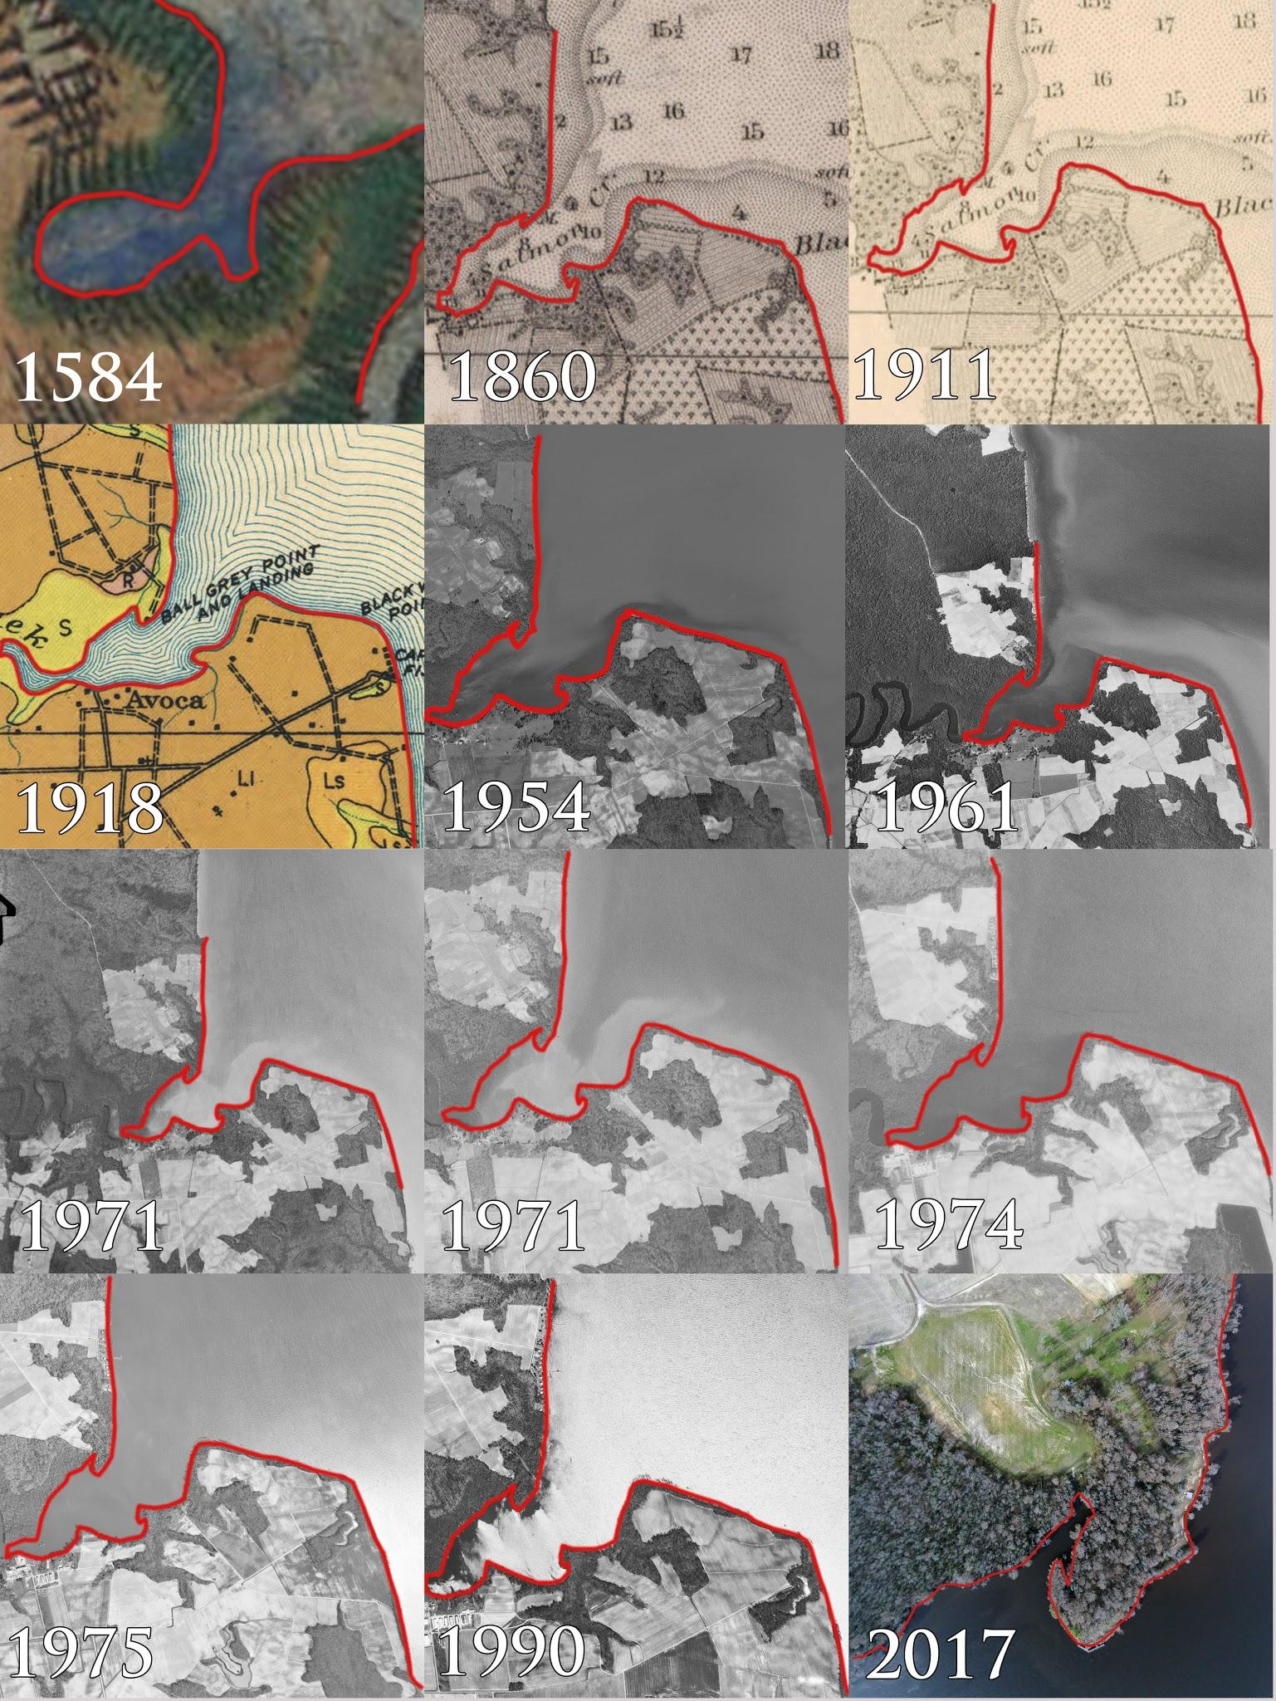
- Salmon Creek shoreline from 1584 to the present.

Conclusions
This research was successful in achieving the primary objective that was to test, develop, and acquire the needed technology to make use of the images taken through the U.A.S. platform, and to use aerial photography and satellite imagery to combine them in order to identify changes in the Salmon Creek shoreline. By evaluating the Salmon Creek site in Bertie County, North Carolina with the DJI Phantom 2 Vision+, 171 images were captured and stitched together to compare and contrast with the aerial photography and satellite imagery. Ultimately, the CERSER program at Elizabeth City State University can benefit from this research by applying U.A.S. technology and the methodology produced from this research to aid further remote sensing research.

Acknowledgments
The team would like to recognize Dr. Linda Hayden for her continued efforts in the CERSER organization and Mr. Clay Swindell for his consult on various UAS methods and practices.

References
- Phantom 2 Vision+ User Manual, V1.6, DJI Co., Los Angeles, CA, 2016, pp. 5-12.
- Digital Globe, USDA Farm Service Agency Map Data (2016). Google Maps [Online]. Available: https://www.google.com/maps
- Pix4D Co. (2016). Pix4D: simply powerful [Online]. Available: https://pix4d.com/
- [4] NOAA Glossary [Online] https://shoreline.noaa.gov/glossary.html

