Continuation of Analyzing Long-Term Drought Effects on Land Surface Temperature and Vegetation Using NOAA Satellite Data

Ademola Adedeji, Kevin Benton, Hagan Hodgkins, Tori Wilbon
Center of Excellence in Remote Sensing Education and Research
Elizabeth City State University
Elizabeth City, North Carolina 27909
demola001@gmail.com, kevinbenton1996@gmail.com, Hagen.Hodgkins@gmail.com, toriwilbon@gmail.com
Andrew Brumfield
Center of Excellence in Remote Sensing Education and Research
Elizabeth City State University
Elizabeth City, North Carolina 27909
arbrumfield12ecsu@gmail.com

Abstract - According to the State Climate Office of North Carolina, since 2007 the northern coastal plain of North Carolina has been experiencing a long-term summer drought. The team’s objective was to analyze how long-term drought in summer months’ affected vegetation and land surface temperature in the Pasquotank, Perquimans, Camden and Gates county areas. The team collected imagery data through the SeaSpace TeraScan system in order to produce land surface temperature (LST) and normalized difference vegetation index (NDVI) products. The data products were averaged into monthly and yearly composites so that the team could use TeraVision to depict the differences of values for the products.

Keywords –Land Surface Temperature, TeraScan, Vegetation, TeraVision, USGS

- INTRODUCTION
TeraScan is a combination of hardware and software designed for automated reception of data from meteorological/environmental satellites and for processing the data into images and data overlays. Images and overlays are of a special format called TeraScan Data Format (TDF) and can be displayed with the TeraScan GUI TeraVision. These data files can be used to produce images in various formats. Different types of satellite data can be received from both the hardware and software that is installed on the computer. These satellite data types include: X Band Data from Polar Orbiting Satellites, L/S Band Data from Polar Orbiting Satellites, and L Band Data from Geostationary Satellites. Droughts clog wells and fills them with water from the rain, which is harmful to grassland, farmland, and vegetation production. Without NOAA satellites droughts could be hard to see and manage.

A. TeraVision
TeraVision is a Graphical User Interface (GUI) that is a part of TeraScan, in which the user to include annotations, overlays, and image enhancement of different parts of the image [1] can manipulate the images, in the form of TDF. Infrared of land surface temperature using TeraVision the team’s objective was to analyze how long-term drought in summer months’ affected vegetation and land surface temperature in the Pasquotank, Perquimans, Camden and Gates county areas. The team chose to focus on the summer month of June. Satellite data can have data degradation at the near and far edges. Therefore the team only downloaded daytime orbits with a minimum elevation of 55 degrees. NDVI During the “configproc” a series of conversions took place to convert TXT files into TXT files and TDF files into PTS files. A TDF file is the original satellite data format, TDF is a common data format, and TDF is a TeraScan Data Format. After the file was converted into a TDF file, a calculation with the different channels was applied to create both Land-Surface Temperature (LST) and Normalized Difference Vegetation Index (NDVI) products. LST used level-2 and level-3 data in an algorithm designed specifically for the MODIS instruments. The NDVI equation was equal to the quantity of the infrared channel minus the near-red channel divided by the quantity of the infrared plus the near-red channels [3]. This equation made the product “greener” to differentiate the differences in dense vegetation and low vegetation. The PDSI drought since 2007

B. Polar Orbit
Polar-orbiting satellites provide a more global view of Earth; circling at near-polar inclination (the angle between the equatorial plane and the satellite orbital plane a true polar orbit has an inclination of 90 degrees). Orbiting at an altitude of 700 to 800 km, these satellites cover best the parts of the world's most difficult to cover in-situ. The National Oceanic and Atmospheric Association (NOAA) is the satellite we use for our project. NOAA has multiple satellite but we focus on various ones, which are NOAA-15, 18,19. NOAA-15 was launched May 13, 1998 with a period of 101 minutes. NOAA-18 was launched May 20, 2005 with a period of 102 minutes. NOAA-19 was launched February 6, 2009 with a period of 102 minutes. They orbit over the earth and they use a whiskbroom technique to collect imagery information. Then when the satellite passes over our ground station satellite transmits the information to receiving station. From 2002 until now, SeaSpace has provided equipment to Elizabeth City State University, in the form of an east coast training site and data center, which continues to foster established research collaboration. The equipment gained from SeaSpace Corporation thus far includes two 5.0m Geostationary L-Band antennas, and a one 1.5m L-band antenna, with the associated acquisition and processing servers. In September of 2014, a new acquisition was made by Elizabeth City for new SeaSpace hardware and software for Dixon Patterson Hall on Elizabeth City State University’s Campus. Dixon Patterson Hall, which houses the new acquisition of Hardware and Software, had to be prepared and documented before SeaSpace subcontractors could arrive and install new software and hardware, purchased by Elizabeth City State University. Therefore, there needed to be proper documentation of past installation of equipment in the recent years. The monitoring systems provided SeaSpace attaches a visualization station with a 24 and 42-inch widescreen monitor to each of the visualization stations. This hardware specification is also for all of the Visualization stations in room 228 and room 229 [6]. The monitoring systems will be able to do what the Visualizations stations do, but will be able to display the information on a 24 and 42-inch screen.

C. TREX
The TeraScan Rapid Environmental Extreme (TREX) is processing computer provided by SeaSpace. The TREX processing computer is a Dell R720E, 16 core E5 2667 3.30 GHz, with 128GB RAM, a 12x1.2 TB 10K SAS HDD, with a Dual PS [6].

D. TeraVault
The TeraScan TeraVault is provided by SeaSpace Corporation. The TeraVault has 60 TB (RAW) of storage. Accompanying the TeraVault specifications includes: a 4U, 2 controllers each with X4 1 Gigibit NIC+ 1 mgmtctller, 60 Drive Bays, X20 3 TB disks, C20 connector, Dual PS, and a Rapid controller [6]. The TeraVault will hold the raw data incoming from the TREX software, which is collecting the whole, pass data sets [6].

E. UPS Assy
SeaSpace Corporation provides the Uninterruptible Power Source (UPS) Assy. The UPS Assy houses a 1500 VA, 220VAC, and 2U Rack mount. There are a total of two UPS machines, with four possible racks/outlets. One of the racks will be for the GOES East connection, and one for the GOES West connection. The TREX and the TeraVault already have a UPS [6].

- METHODOLOGY

A. Point files
From the United States Geological Survey biomes were selected from counties in the Northeastern North Carolina, which are Perquimans, Pasquotank, Camden and Gates counties. The locations selected were of specific biomes such as grasslands, farmlands, swamps and forest. Numerous points for each biome were selected within each of these counties. These point files, created by the previous research team needed to be reformatted to coordinates and names, before the research continued to the next step.
The point files contain the points of interest for this project. The files were saved on the “T-rex”. The files were located within the following directory: [ ~/Desktop/ecsuure2016/ ]. To correct point files the team copied the coordinates located in the .txt files provided from the previous team to a .csv file type. making sure to format the coordinates and name of each location as coordinates first and name of the location.

B. Data Collection
To connect to the Terascan Rapid Environment Extreme (TREX) the command line interface was used to establish a remote connection via the ssh command. Inside TREX is the Teravault which houses the archived data of previous years. The team made monthly documents of all of the listed passes from NOAA Satellites. The Weather Underground [14] archive of Elizabeth City was used to eliminate satellite pass times when clouds obstruct the satellite's field of view of the ground. This was done because products LST and NDVI would not be produced when clouds appear. Conversion of the times between our local and GMT time by removing these passes that did not meet the requirements the team found that remaining passes were far more likely to yield useful data. Used T-Rex to restore archived data between May to August in the years of 2015 and 2016. The team then navigated to the Teravault directory and collected the names of the passes from these months. The pass names were then copied to a document with which the team could color code them based on

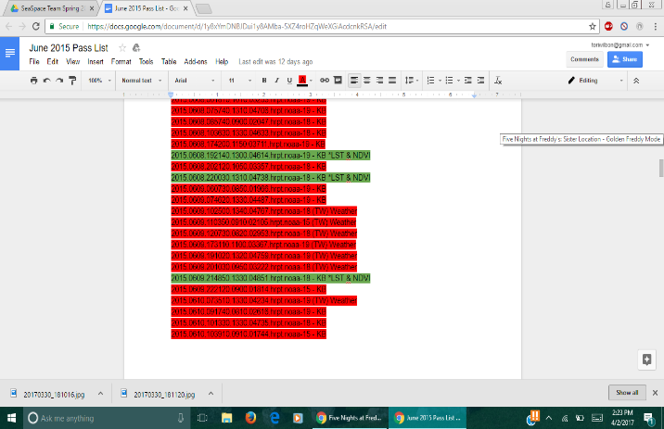

By using Terascan (a customized remote sensing data analysis software), we connected to already existing satellite data that was gathered from the NOAA/AVHRR systems over a few months. The description of the seasonal dynamics of the various locations examined were portrayed by the transformed AVHRR data. The detailed techniques for processing and analyzing the data are outlined below.

B. Restoring Passes

The data comes from the National Oceanic and Atmospheric Administration (NOAA) satellites 15, 18 and 19. The months May, June, July and August of the years 2015 and 2016 were used in this project. There were two requirements that needed to be met to use the data. First the weather must be clear at that time for the data to proceed being used. Second after restoring the pass and running the ingest command the file must be seen in both the land surface temperature (LST) and Normalized Difference Vegetation Index (NDVI) folders. Wunderground.com, a weather history website, was used to search if the weather was clear. If both of the requirements were met the data was moved into the Area of Interest directory which was in the 2017 year directory. There was a time difference between the time recording in the pass file name and the time records on the weather underground website. This is because the passes are recorded using GMT (Greenwich Mean Time) time and the weather underground website recorded using local time, in this case EST (eastern Standard Time). This resulted in a 4 hour difference in the two that had to be reconciled in order to keep ensure the team could accurately filter the passes by weather.

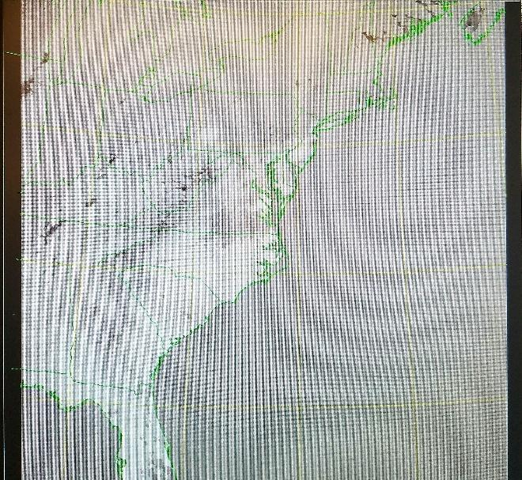

Fig. 1. LST image from TView

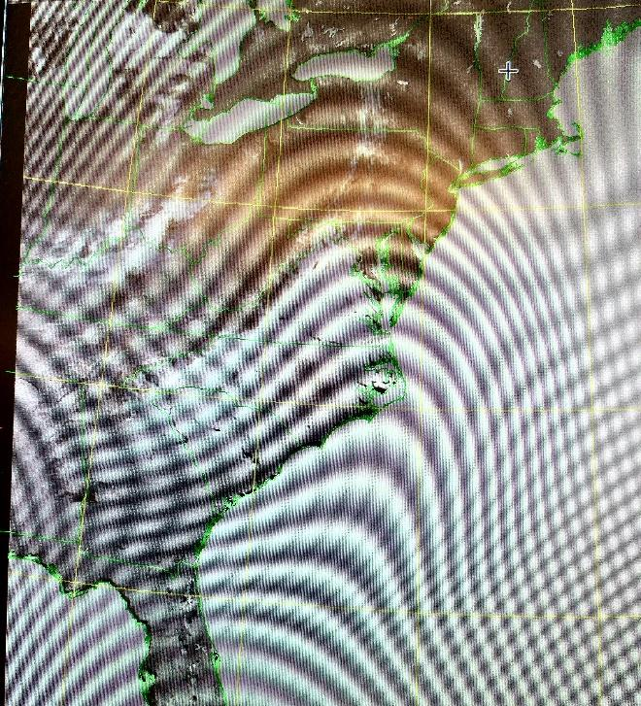

Fig. 2. NDVI image from TView

C. Sample & Expasc
After the restoring of the passes the data was output in LST and NDVI format. The team needed the data formatted in a point file format and text file. The point file is to display the image into TeraVision and the text file is for the python program. To reformat the data the team used the command sample to combine the trusted data format (TDF), NENC.tdf, and the NDVI and LST files. Using the sample command gave the team a point file. Next the expasc command was used to output a text file. The point file from the sample command was inputted into the expasc command and the output was the text file of the point file.
Both the sample and expasc tool had to be performed on each NDVI and LST file that was stored in the Area of Interest (AOI) directory. Then the text files were moved to the data directory to be used for the python program. The team was able to complete May in 2015 and 2016.

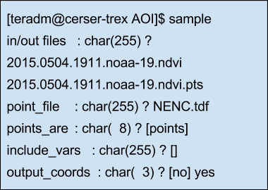
Fig. 3. Sample Command
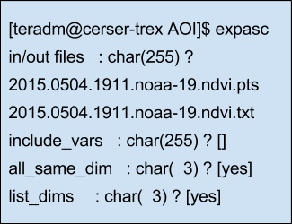
Fig. 4. Expasc Command

- RESULT & CONCLUSION
The results of the project is all the data for LST and NDVI have been searched and any data that was not clear to be used was removed. Then the LST and NDVI was restored and moved to the Area of Interest directory. Lastly the month of May for 2015 and 2016 was completely done with the sample and expasc command.
.

- FUTURE WORK
Future work is to continue converting the 2015 and 2016 monthly data to point files and text files. Then create a Python program to use the LST text file data, NDVI text file data and the county point files to automatically create a linear and nonlinear regression. This program should be able to separate the counties in the point files for the linear and nonlinear regression.

- REFERENCE
[1] OSCAR (Observing Systems Capability Analysis and Review Tool) “Satellite: GOES-15”Internet:http://www.wmosat.info/oscar/satellites/view/151,n.d.[April 3, 2015]
[2]TeraScan Help. “TOVS” Internet:http://cerservis11/terascan/thelp/man7/tovs.html, n.d. [April 5, 2015]
[3]NOAA Office of Satellite and Product Operations.“Polar-orbiting Operational Environmental Satellites
(POES)”Internet:http://www.ospo.noaa.gov/Operations/POES/index.html,n.d.[April 5, 2015]
[4]TeraScan Help. “AVCloud” Internet:http://cerservis11/terascan/thelp/man1/avcloud.htm, n.d. [April 5,2015]
[5]TeraScan Help. “DCS” Internet:http://cerservis11/terascan/thelp/man7/dcs.html, n.d. [April 5, 2015]
[6]NOAA Satellite and Information Service. “Comparison of GOES and POES SST Against In-Situ SST Validations for NOAA CoastWatch regions” Internet:http://www.star.nesdis.noaa.gov/sod/mecb/goes_validation/test/val_coast.php, n.d. [April 5, 2015]
[7]TeraScan Help. “AVHRR” Internet:http://cerservis11/terascan/thelp/man7/avhrr.html, n.d. [April 5, 2015]
[8]TeraScan Help. “HRPT_Fog” Internet:http://cerservis11/TeraScan/thelp/man1/hrpt_fog.html, n.d. [April 5,2015]
[9]NOAA SATELLITES. (n.d.). Retrieved July 27, 2016, from http://www.n2yo.com/satellites/?c=4
[10]“GVAR configprocs” Internet:http://ecsugoeseast/terascan/thelp/batch_processing/GVAR_configprocs.html, n.d. [April 3,2015]
[11][Satellite Orbits. (n.d.). Retrieved July 27, 2016, from http://scool.larc.nasa.gov/orbits.html
[12]“GVAR”Internet:http://marine.rutgers.ed~lojanen/terascan/html/man7/gvar.html,n.d. [April 3, 2015]
[13]TeraScan Help. “TeraMaster” Internet:http://cerservis11/terascan/thelp/terapgs/teramast.html, n.d. [April
3,2015
[14]Wunderground. “Elizabeth City” Internet: https://www.wunderground.com/history/airport/KECG/2016/7/1/DailyHistory.html?req_city=Elizabeth+City&req_state=NC&req_statename=North+Carolina&reqdb.zip=27909&reqdb.magic=1&reqdb.wmo=99999, n.d. [January 26, 2017]
[15] Holness Cornelius, Morris Derek, Brumfield Andrew, “Analyzing Long Term Drought Effects on Land Surface Temperature and Vegetation Using NOAA Satellite Data”., in press

