Enhancing Interactivity and engagement to the Science Gateway Community Institute Workforce Development Site
Disaiah Bennett, Tatyana Matthews, Jefferson Ridgeway IV, Jeffrey Wood
lavontae.bennett@gmail.com, matthews.tatyana17@gmail.com, jdridgeway4@gmail.com, wood684@gmail.com
Elizabeth City State University

Abstract - The Center of Excellence in Remote Sensing Education and Research (CERSER) on the campus of Elizabeth City State University is a founding member of SGCI led by San Diego Supercomputing Center and the Science Gateways Community Institute (SGCI). One of the five areas of SGCI is the Workforce Development led by Dr. Linda Hayden. Workforce Development aims to nurture the next generation of gateway users and developers and engage the potential of students from underrepresented groups.
As science today grows increasingly computer based, it poses challenges and opportunities for researchers. Scientists and engineers are turning to gateways to allow them to analyze, share, and understand large volumes of data more effectively. The existence of science and engineering gateways and the sophisticated cyberinfrastructure (CI) tools together can significantly improve the productivity of researchers. Most importantly, science gateways can give uniform access to the cyberinfrastructure that enables cutting-edge science.
The goal of the web development team was to increase the interactivity of the SGCI Young Professionals site to attract potential members and disseminate information. This was completed utilizing WordPress Widgets to provide graphical and interactive components. Bootstrap components (HTML, CSS, and JavaScript) were also researched for their inclusion into the current WordPress Content Management System (CMS) and the future Liferay CMS.
Keywords- SGCI, Science Gateways Community Institute, Bootstrap, HTML, CSS, JavaScript, WordPress, Liferay, widgets, components

INTRODUCTION

SGCI Workforce Development Site Enhancements
The Science Gateway Community Institute (SGCI) Workforce Development Team was tasked with attracting professionals, faculty, and students to participate in conferences, workshops, and internships. Dr. Linda Hayden is the lead on this component of SGCI. One of the main communication devices is the web site at:
http://sciencegateways.org/services/workforce-development.
This team undertook the project of enhancing the visual presentation and interaction of the site in order to provide an inviting presence to visitors.

Science Gateway
"A Science Gateway is a development from cyberinfrastructure (CI)" [14]. Perceived as a gateway, it correlates as a bridge to digital databases and applications that connect diverse communities and individuals. "As a connector, the Science Gateway allows data and applications that are stored on clouds or hubs to be more accessible to either science or engineering community with a common definite objective" [14]. Becoming more attainable to researchers in widespread areas, the CI's modules become productive for interactive use. Science gateways are an effective way of allowing researchers to collaborate, discover new approaches, organize, analyze structures, and increase engagement.

Science Gateway Community Institute
The institute has been divided into five areas: Incubator, Extended Developer Support, Scientific Software Collaborative, Community Engagement and Exchange, and Workforce Development.

SGCI Workforce Development
SGCI Workforce Development is "tasked with guiding underrepresented trainees to acquire undeveloped skills" [17]. This is accomplished by utilizing internships for young developers that are eager to establish an expertise of gateway technologies. By generating internship experiences for the students, undergraduates are able to assemble together and mature as scientists. In addition, "Science, Technology, Engineering, and Mathematics (STEM) professors are incorporating gateways into organized lectures for their courses" [17]. The implementations targeted for this process are initiating the SGCI Young Professionals Network, constructing training at Elizabeth City State University (ECSU), universal accessibility for training, establishing SGCI partnerships, and associating gateways to applicable syllabuses.

SGCI Young Professional Network
"SGCI Young Professionals Network is a body for inexperienced and mature instructors that are beginning to understand and use science gateways" [9]. Advisors that contribute assistance to SGCI function as workforce development committee members and organizers for the young professionals' activities. The Young Professionals Network aims to inspire novice researchers to generate input into plans to diversify professional expansion. Involving new students, SGCI "produces webinars to connect with gateway specialists to broaden the network" [9]. By sharing performances, developers are motivated to assimilate data and widen their perceptions. "Young Professionals that exceed expectations are awarded the SGCI Young Professionals of the Year Award" [9].

SGCI Internships
In the summer of 2017, SGCI aims to conduct three internship opportunities for recruits at the graduate and undergraduate levels. For each individual program, "SGCI partnering locations will serve as the overseer" [8]. Scholars that are underrepresented in minority groups, women, and first-generation students are exceedingly influenced to apply. Included in the internship experiences, SGCI offers funding for traveling assistance, housing, and earnings. However, to apply for these summer internships, the student must be a permanent native or local in the United States. The three internships that are being offered by SGCI are the Science and Engineering Application Grid (SEAGrid), a four-week program on gateway development and an eight-week program on gateway projects. SEAGrid "authorizes developers to smoothly use software that utilizes cloud computing" [8]. The four and eight-week internship programs will serve as workshops to develop undergraduate skills.

SOFTWARE

Content Management Systems
Software packages that were researched during this project included the Content Management Systems (CMS) WordPress.org and Liferay. A CMS is defined as a "web-based application that provides capabilities for multiple users with different permission levels to manage (all or section of) content, data or information of a website, project, or internet/intranet application" [15]. SGCI currently uses the CMS Wordpress.org and will soon migrate to the Liferay CMS. Utilizing a CMS rather than creating a static or dynamic website is much easier to manage for multiple collaborators.

WordPress
WordPress is a "publishing platform that makes it easy for anyone to publish online, and proudly powers millions of websites" [16]. The publishing platform comes in two different packages: WordPress.com and WordPress.org. While the platform is the same for the two packages, the utilization is completely different for each package. In WordPress.com, a user is not able to modify PHP and Cascading Style Sheet (CSS) code, but is only allowed to pick a "theme". A "theme" for WordPress "controls the general look and feel of [the] site including things like page layout, widget locations, and default font and color choices" [12]. However, in WordPress.org, a user can install custom themes or build their own with PHP and CSS. For this project, and in compatibility with SGCI, it was better to use WordPress.org due to its flexibility.

Liferay
Liferay is also another CMS that is used by businesses, individuals, and universities all over the world. Developing a website via Liferay, will include using Liferay Portal. Liferay Portal seeks to "offer developers a complete platform for building web apps, mobile apps, and web services quickly, using features and frameworks designed for rapid development, good performance, and ease of use" [5]. Through understanding the proposed functionality of the two CMS', Liferay and WordPress, it was a goal of this project to research the use of Bootstrap to add more interactivity to the CMS platforms.

Bootstrap and Responsive Web Design
Bootstrap "is the most popular HTML, CSS, and JS framework for developing responsive, mobile first projects on the web" [19]. Responsive web design is the "approach that suggests that design and development should respond to the user's behavior and environment based on screen size, platform and orientation" [21]. Based on statistics from StatCounter in 2016, 51% of global internet usage utilized smartphones and the remaining 49% searched the internet using a desktop PC [6]. In understanding this statistic, it can be seen that responsive web design is extremely important, both for the present and the future.
Bootstrap was chosen based on the ease of use, open source, and responsive features. Within the Bootstrap framework, there are objects that are called components. These components can represent anything from "iconography, dropdowns, input groups, navigation, alerts, and much more" [20]. Within WordPress and Liferay, components have different names. In WordPress, in order to have a similar "component" that would be present in Bootstrap, a plugin is needed. A plugin in WordPress is "a piece of software containing a group of functions that can be added to a WordPress website [and] they can extend functionality or add new features to your WordPress websites" [2]. A module in Liferay is similar to a plugin in WordPress in that it provides components via a module. A module is "simply a group of Java classes, a MANIFEST.MF file, and additional optional resources packaged together as a JAR file" [7]. A module can contain one or more components [7].

METHODOLOGY
In the research conducted by the team, it became evident there was a computing difference between WordPress.com and WordPress.org. In using WordPress.org, it was easier for the team to incorporate the bootstrap components in
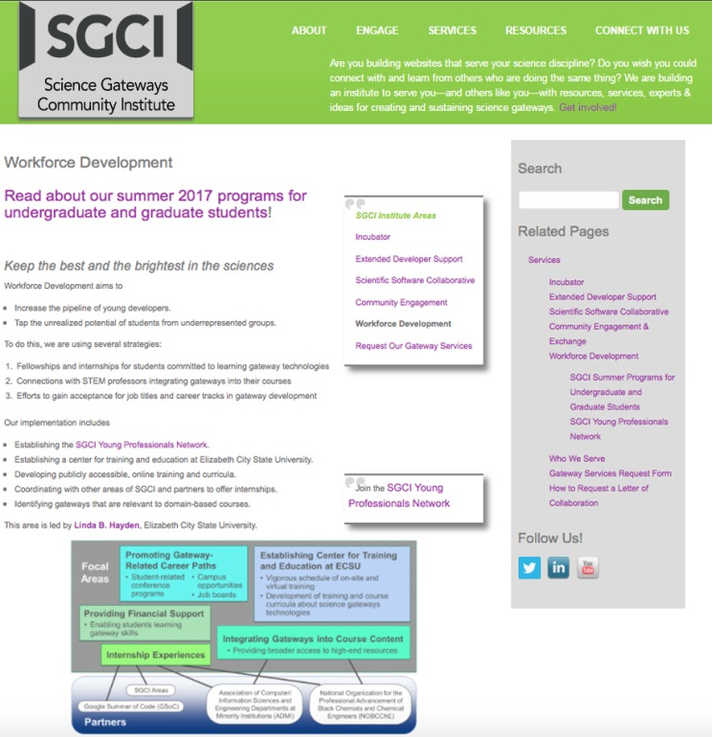
- Original SGCI Workforce Development Layout
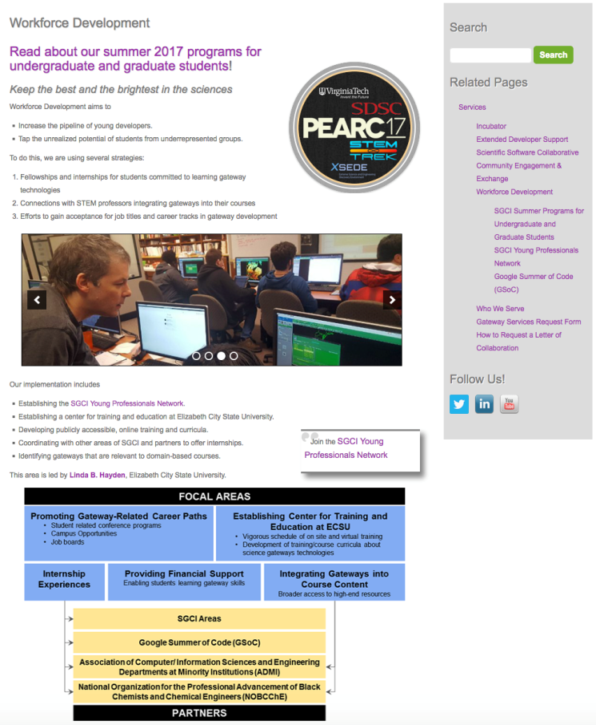
- Updated SGCI Workforce Development Layout
WordPress.org due to the allowance of modification via code and/or "shortcodes" which are used to utilize plugins in WordPress.org posts. The team then researched how to deploy a WordPress.org post using a bootstrap component.

WordPress.org
In order to implement components from bootstrap, it was important to first develop a bootstrap theme. The first step is to then set up a server via either MAMP (for Macintosh operating systems), LAMP (for Linux operating systems), or WAMP (for Windows operating systems). The AMP represents, Apache, MySQL, and PHP. MAMP/LAMP/WAMP can be used as "local servers that are used while developing PHP sites. Using these servers, programmers can test a website locally before they upload it to the main server" [13]. MAMP was used for this research due to team members using a Macintosh operating system. One has to then download WordPress.org in order to install WordPress.org on their PC/laptop. Furthermore, the team members followed the tutorial provided by LyraThemes entitled, "How to develop a WordPress Theme Using Bootstrap (Part 1)" [3]. After setting up the MAMP server, the team had to download Bootstrap and place the Bootstrap CSS, JavaScript(JS), and font directories within the WordPress directory. After MAMP was properly configured and activated, the team members were able to see a live Bootstrap, responsive design WordPress blog post.
Due to SGCI not utilizing a Bootstrap theme for WordPress.org, another method of implementing Bootstrap-like components in a WordPress theme was explored. It became apparent to the team to utilize the numerous plugins that have been developed in order to enhance WordPress. Of all of the plugins that were researched, the plugin Soliloquy was used based on its ease of use and its previous installation provided by SGCI. Soliloquy is defined on the plugin website "as the best responsive image slider for WordPress…[and]...will always look great on all devices (mobile, tablet, laptop, and desktop)" [11]. Soliloquy has to first be downloaded and activated. The user is then able to start using the plugin that will produce the widget for users interacting with the site. After activation within WordPress, the team members had to add images related to SGCI's purpose and add relevant text that would bring attention to what SGCI has to offer to users. Next, the adding of the slider itself was required in order that users can view images from different areas of SGCI's Workforce Development. The term created a category and placed images within the category that represented each of the links on the SGCI Young Professional's Page. A small text description of each of the links was added and connected to the subsequent pages. In order for WordPress.org to process the addition of new plugins to a post, it offers the use of shortcodes. Shortcode is "a WordPress-specific code that lets you do nifty things with very little effort. Shortcodes can embed files or create objects that would normally require lots of complicated, ugly code in just one line" [10]. An example of a shortcode that implements a button would be [button type="twitter"] [18]. A shortcode for Soliloquy was used after setting up the slider.

Image Hover
Alongside the Soliloquy plugin, the team members also searched for a plugin that would replace the textual links on the SGCI Young Professional's Network website and make it more inviting for users. The plugin found by the team was Image Hover Effects Pro. Image Hover Effects Pro allows the user "to add 40+ hover effects to images with captions" [4]. The team then used an image that highlighted the importance of Practice & Experience in Advanced Research Computing (PEARC), and link to the PEARC website once the user hovers over the image as shown in Fig. 2. This plugin was selected to be utilized based on its ease of use, functionality, and attention-grabbing animation with images. The installation and activation of the plugin is the same as Soliloquy. A shortcode within the WordPress post to observe the changes that were made by the Image Hover Effects Pro plugin.

Diagram
Lastly, the team redesigned the diagram seen in Figure 3 on SGCI's Young Professional Workforce Development homepage. The diagram originally included content that was difficult to understand. The team decided that this diagram needed to be redesigned to communicate clearly the focal areas and partners who are within the SGCI Young Professional's Network. This redesign initiative took the previous diagram and made the boxes for focal area wider placing them underneath the focal area title. The boxes associated with partners were selected to be placed on top of the partner title box and made the same length in order to distinguish between the boxes related to partner and focal area. The team was able to successfully recreate the diagram as seen in Figure 4 in a method that would communicate effectively with the users of the site.
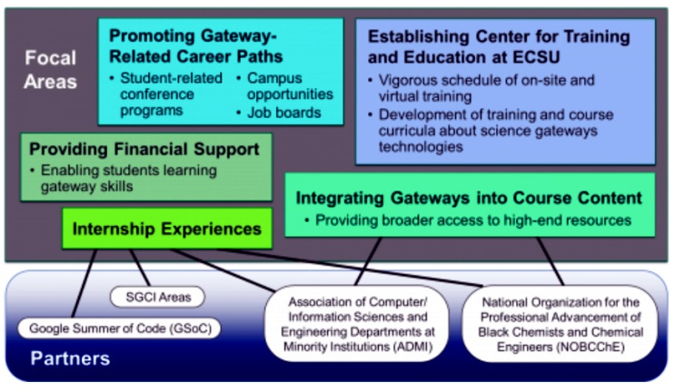
- Original Focal Areas/Partners Diagram
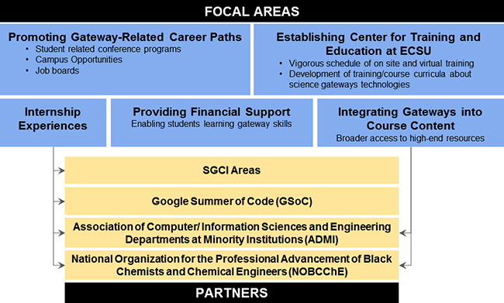
- Revised Focal Areas/Partners Diagram

ANALYSIS
Implementation of the Bootstrap components was beyond the capability of this project as the WordPress theme was not based on a Bootstrap theme. Other methods of achieving the goal of enhancing the SGCI site were found in the utilization of WordPress widgets. There were many widgets available on the web for free and for purchase. This team used two widgets as a starting point to elevate the appearance of the site.
The first of these, Soliloquy, was previously loaded onto the SGCI site which made its use straightforward. The images were assembled and the options for the widget were reviewed followed by the implementation. The use of the two widgets during this project were routine with a great amount of versatility.
The second widget, Image Hover Effects Pro, was purchased due to the need to provide a link to a new tab or window. The free version of this widget did not provide this capability. The base image was developed, imported and the options selected.
The revision of the Focal Areas/Partners diagram was accomplished using the PowerPoint and Photoshop applications. Multiple versions were created in order to match the size allocated by the current site and to ensure the readability of the text within the diagram.

CONCLUSION
The research has shown that in order for the implementation of bootstrap components in WordPress.org to be used Bootstrap themes must be installed. As the team did not have the authority to change the site to a Bootstrap theme, the project was forced to utilize WordPress widgets for the enhancement. This worked well, but did not advance the use of the Bootstrap components.
The research into the future CMS platform, Liferay, yielded a great amount of information regarding the integration of bootstrap components. Liferay can be developed as a responsive site able to be viewed on various platforms (desktop, pad, phone). Once the migration from WordPress to Liferay has been completed, the new pages will be evaluated to determine if any enhancements are needed.

FUTURE WORKS
Liferay, the future SGCI platform is equivalent to the sites current WordPress platform. In order to make the transition to Liferay, research must be conducted in order to identify those Liferay components that are equivalent to WordPress widgets. For example, the equivalent of Soliloquy in WordPress is a Slider in Liferay. These components are necessary for enhancing content within Liferay's editing platform, called Liferay Portal. As previously stated, Liferay Portal is a web application in which developers can build web apps, mobile apps, and web services quickly [5].
It is important to include components that encourage students to interact with the SGCI site. Several examples of these elements are blogs, video and photo libraries, survey and polls, and tutorials. It is suggested that future research investigate how to implement these interactive components in order to enhance the site's connection with students.
Another potential feature would utilize a social media network, such as Facebook Groups as a method for students, faculty, and professionals to network outside of the SGCI site. The Facebook group would be closed, exclusively open to those affiliated with the Science Gateway Community Institute Young Professionals network. For any students, faculty, or professional that visits the Young Professional page, the individual would be invited to join the Facebook Group through an embedded Facebook page feature. A selected moderator will be needed to guide Facebook conversations in order that they be beneficial to both students, faculty, and professionals.
Bootstrap is powerful web development tool because of its simple interactive components and responsiveness. Because of its capabilities it is recommended that Bootstrap components be utilized to make the current program sites at ECSU (nia.ecsu.edu and cerser.ecsu.edu) into responsive sites.

ACKNOWLEDGEMENTS
We would like to thank Dr. Linda B. Hayden for her support during this project and the Science Gateway Community Institute for funding of this project.

REFERENCES
- "About | ScienceGateways.org", Sciencegateways.org, 2017. [Online]. Available: http://sciencegateways.org/about/. [Accessed: 28- Mar- 2017].
- "Cite a Website - Cite This For Me", Wpbeginner.com, 2017. [Online]. Available: http://www.wpbeginner.com/glossary/plugin/. [Accessed: 28- Mar- 2017].
- "How to Develop a WordPress Theme Using Bootstrap - Part 1", LyraThemes, 2017. [Online]. Available: https://www.lyrathemes.com/bootstrap-wordpress-theme-tutorial-1/. [Accessed: 28- Mar- 2017].
- "Image Hover Effects", WordPress.org, 2017. [Online]. Available: https://wordpress.org/plugins/image-hover-effects/. [Accessed: 28- Mar- 2017].
- "Introduction to Liferay Development - Liferay 7.0 - Liferay Developer Network", Dev.liferay.com, 2017. [Online]. Available: https://dev.liferay.com/develop/tutorials. [Accessed: 28- Mar- 2017].
- "Mobile and tablet internet usage exceeds desktop for first time worldwide | StatCounter Global Stats", StatCounter Global Stats, 2017. [Online]. Available: http://gs.statcounter.com/press/mobile-and-tablet-internet-usage-exceeds-desktop-for-first-time-worldwide. [Accessed: 28- Mar- 2017].
- "Module - Liferaypedia - Liferay Developer Network", Dev.liferay.com, 2017. [Online]. Available: https://dev.liferay.com/participate/liferaypedia/-/wiki/Main/Module. [Accessed: 28- Mar- 2017].
- "SGCI Summer Programs for Undergraduate and Graduate Students | ScienceGateways.org", Sciencegateways.org, 2017. [Online]. Available: http://sciencegateways.org/services/workforce-development/summer-programs/. [Accessed: 28- Mar- 2017]
- "SGCI Young Professionals Network | ScienceGateways.org", Sciencegateways.org, 2017. [Online]. Available: http://sciencegateways.org/services/workforce-development/yp/. [Accessed: 28- Mar- 2017].
- "Shortcodes", Support, 2017. [Online]. Available: https://en.support.wordpress.com/shortcodes/. [Accessed: 28- Mar- 2017].
- "Slider by Soliloquy - Responsive Image Slider for WordPress", WordPress.org, 2017. [Online]. Available: https://wordpress.org/plugins/soliloquy-lite/. [Accessed: 28- Mar- 2017].
- "Themes", Support, 2017. [Online]. Available: https://en.support.wordpress.com/themes/. [Accessed: 28- Mar- 2017].
- "Understanding the difference between WAMP, LAMP, MAMP and XAMPP - CGurukul - Steering Career, Converting Talent", CGurukul - Steering Career, Converting Talent, 2017. [Online]. Available: http://www.cgurukul.com/understanding-the-difference-between-wamp-lamp-mamp-and-xampp/. [Accessed: 28- Mar- 2017].
- "What is a Science Gateway: The Basics | ScienceGateways.org", Sciencegateways.org, 2017. [Online]. Available: http://sciencegateways.org/about/science-gateway-basics/. [Accessed: 28- Mar- 2017].
- "What is Content Management System (CMS)", Comentum.com, 2017. [Online]. Available: http://www.comentum.com/what-is-cms-content-management-system.html. [Accessed: 28- Mar- 2017].
- "WordPress.com and WordPress.org", Support, 2017. [Online]. Available: https://en.support.wordpress.com/com-vs-org/. [Accessed: 28- Mar- 2017].
- "Workforce Development | ScienceGateways.org", Sciencegateways.org, 2017. [Online]. Available: http://sciencegateways.org/services/workforce-development/. [Accessed: 28- Mar- 2017].
- F. Stefansson, "Getting Started with WordPress Shortcodes & Sample Snippets", speckyboy, 2017. [Online]. Available: https://speckyboy.com/getting-started-with-wordpress-shortcodes-examples/. [Accessed: 28- Mar- 2017].
- Mark Otto, "Bootstrap · The world's most popular mobile-first and responsive front-end framework.", Getbootstrap.com, 2017. [Online]. Available: http://getbootstrap.com/. [Accessed: 28- Mar- 2017].
- Mark Otto, "Components · Bootstrap", Getbootstrap.com, 2017. [Online]. Available: http://getbootstrap.com/components/. [Accessed: 28- Mar- 2017].
- S. Editorial, "Responsive Web Design: What It Is And How To Use It - SmashingMag", Smashing Magazine, 2017. [Online]. Available: https://www.smashingmagazine.com/2011/01/guidelines-for-responsive-web-design/. [Accessed: 28- Mar- 2017].

