Ground Penetrating Radar Applications
Anissa Norman
Elizabeth City State University
CERSER
Elizabeth City, NC
anissanorman@yahoo.com

Austin Ivins
Elizabeth City State University
CERSER
Elizabeth City, NC
Austin6163@gmail.com
Tangee Beverly
Elizabeth City State University
CERSER
Elizabeth City, NC
tlbeverly96@gmail.com

Derek Morris
Elizabeth City State University
CERSER
Elizabeth City State University
Dmow4454@gmail.com

Abstract- Ground Penetrating Radar (GPR) uses pulses of radar and reflected singles to collect images of the sub surfaces. These images return to the receiver and store data on digital media. The computer can measure the time it takes for the signal to reach object/target and return back again. These are reflected signals are interpreted by the system and then displayed on the GPRs LCD screen.
The purpose of this research was to gain a better understanding of the uses and methods involving ground-penetrating radar, and to experience the situations in which GPR can be a useful and effective tool.
For the data analysis part of the GPR it is important to know that the waves travel through various materials including soil, concrete, and debris, etc. All of these things have different dielectric and conductive properties that affect the GPR waves and the way that the data is interpreted. For the data that is shown on the GPR LCD screen, it takes someone with good field experience to interpret them and determine what was found.
One most important question ask about the GPR is how deep do the signals go? When it comes to GPR the depth range can be determined depending on the subsurface material and the frequency of the GPR antenna.

Keywords- Ground Penetrating Radar, megahertz, Wavelength, TerraSIRch SIR-3000.

- Introduction
GPR is an acronym for ground penetrating radar. This is a method that involves pulses of radar and reflected singles to collect images of the subsurfaces. These images are return to receiver and stored on digital media. The computer can measure the time it takes for the signal to reach object/target and return back again. These are reflected signals are interpreted by the system and then displayed on the GPR's LCD screen. Data collection can happen below ground and/or under objects such as concrete.
For data collection taking place underground, various types of GPR equipment can be used. The GPR equipment used depends on the depth and size of the target to be located. The GPR unit can email it and receive signals up to 1000 times per second. The field operator can look at the signals on the screen of the device. The data can also be viewed on a computer for further analysis.
For data taking place below concrete a high frequency GPR system is used. So the data can be collected into different ways: simple lines or a grid format. Simple line scans can be used to determine the thickness of concrete. With the high-frequency GPR system you can also use a grid format to produce a map of any target is located in the concrete. When the grid format is used, the user can look at layers of the image to determine the depth of objects and create a 3D map.
For the data analysis part of the GPR it is important to know that the waves travel through various materials including soil, concrete, and debris, etc. All of these things have different dielectric and conductive properties that affect the GPR waves and the way that the data is interpreted. For the data that is shown on the GPR LCD screen, it takes someone with good field experience to interpret them and determine what was found.
- Objective
The goal of this research was to become experienced in the methods and practices involved with ground penetrating radar, and to gain a better understanding of the situations in which GPR can be a useful and effective tool. Operating the system in front of the Dixon Hall building also presented a great opportunity to examine features that may lie beneath the ground between the building and the parking lot.

- Area Of Interest
The research team focused on a site located within Elizabeth City State University’s grounds in order to eliminate having to travel to other sites. The area the team focuses on is located directly in front of Dixon hall, between the building and parking lot. It was chosen due to the likelihood of finding powerlines and watermains between the parking lot and building. The research team understood that they would not be allowed to begin excavating power lines and water pipes beneath the campus grounds, and by choosing this location it would be easy to acquire blueprints in order to confirm or deny abnormalities found in the radar scans.

- Equipment
The SIR 3000 is a small, lightweight system designed for single-user operation. This product provides the essential features and flexibility that experienced GPR users require, as well as simplified, application-specific user interfaces for inexperienced GPR users.
The SIR 3000 incorporates advanced signal processing and display capability for ‘in-the-field’ 3D imaging. Unlike other data acquisition products on the market, the SIR 3000 is interchangeable with all GSSI antennas, making it an affordable and flexible option for multi-application users
One most important questions to ask about the GPR is how deep do the signals go? When it comes to GPR the depth range can be determined depending on the subsurface material and the frequency of the GPR antenna. So for locating rebar or conduits in concrete higher frequency GPR is used because those objects require higher resolution. This higher frequency is at 1000 MHz. when the frequency is this high it will give a high-resolution detail for depth of approximately 24 inches. For applications that require deeper penetration into the ground a lower frequency will be needed which ranges from about 12.5 to 500 MHz depending on the subsurface material. but for all subsurfaces depth range can be a few inches to thousands of feet.

V. Methodology
Using the TerraSIRch SIR-3000 GPR system research members had various antennas available to suit different situations. The antenna that best suited the job at hand for our team this was the 900 MHz model, which provided the greatest resolution images when scans were taken at 1.5 foot increments. With the SIR-3000 there are various collection modes, which can be set based on collection time or distance traveled. Due to inaccuracies of timed collection modes because of various individuals pushing the device at different rates the research team decided to select distance collection mode, which proved to be more accurate once a proper grid was established. To set an accurate grid on the collection area the team used measuring tapes to layout a ten by ten meter square.
To ensure accurate data collection the grid needs to be square so the team first laid out a triangle with the Pythagorean theorem, also known as Pythagoras's theorem, which is a fundamental relation in Euclidean geometry among the three sides of a right triangle. It states that the square of the hypotenuse (the side opposite the right angle) is equal to the sum of the squares of the other two sides.
After establishing the grid the system required a soil type input, at the time of data collection the soil was a mix of silt (moist) and Clay(dry) which was input into the system as type 2 soil. Once all inputs were selected for data collection the system was ready to begin collection.
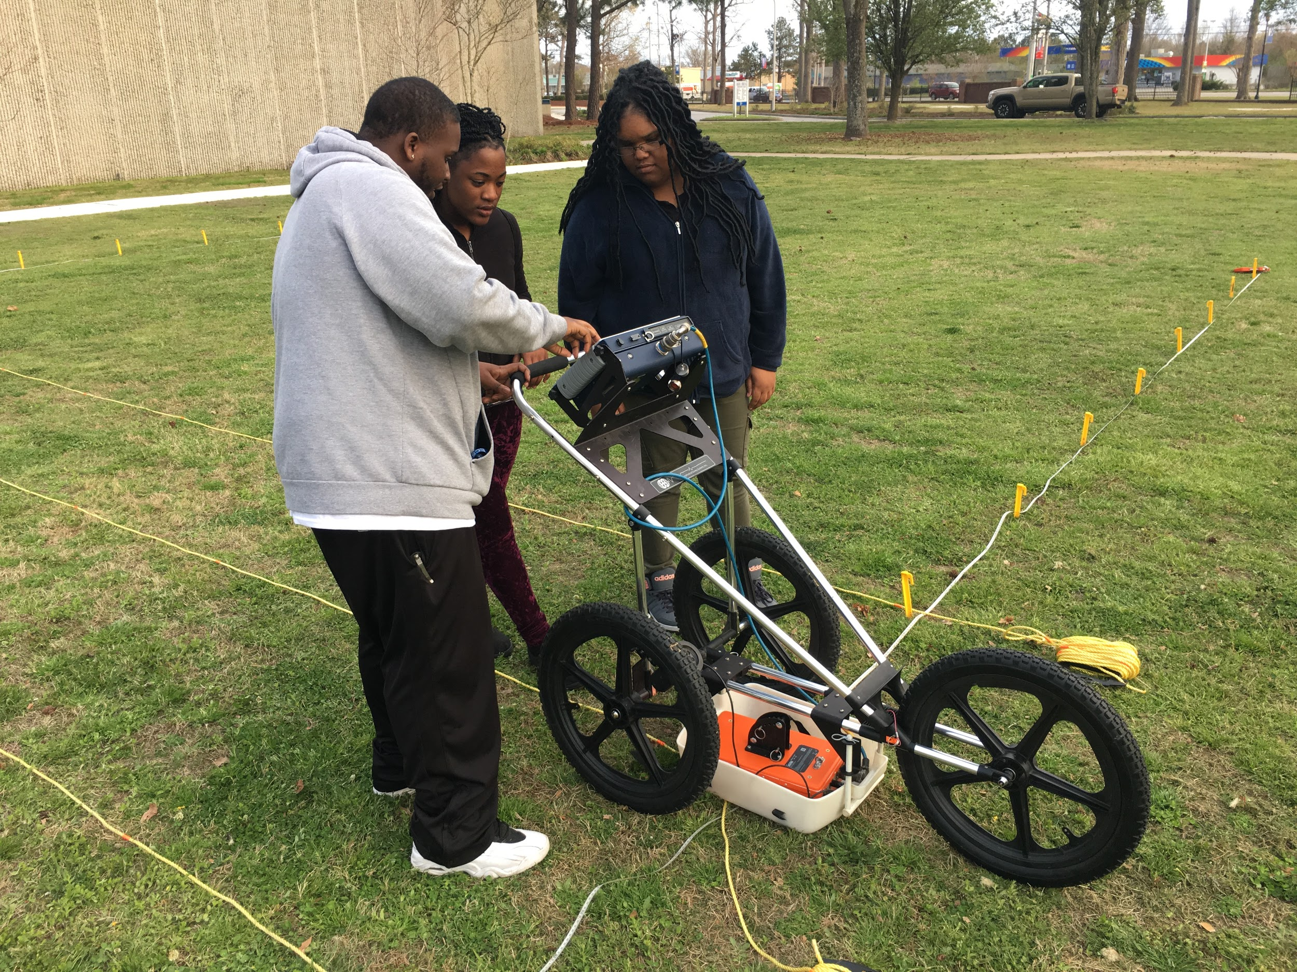
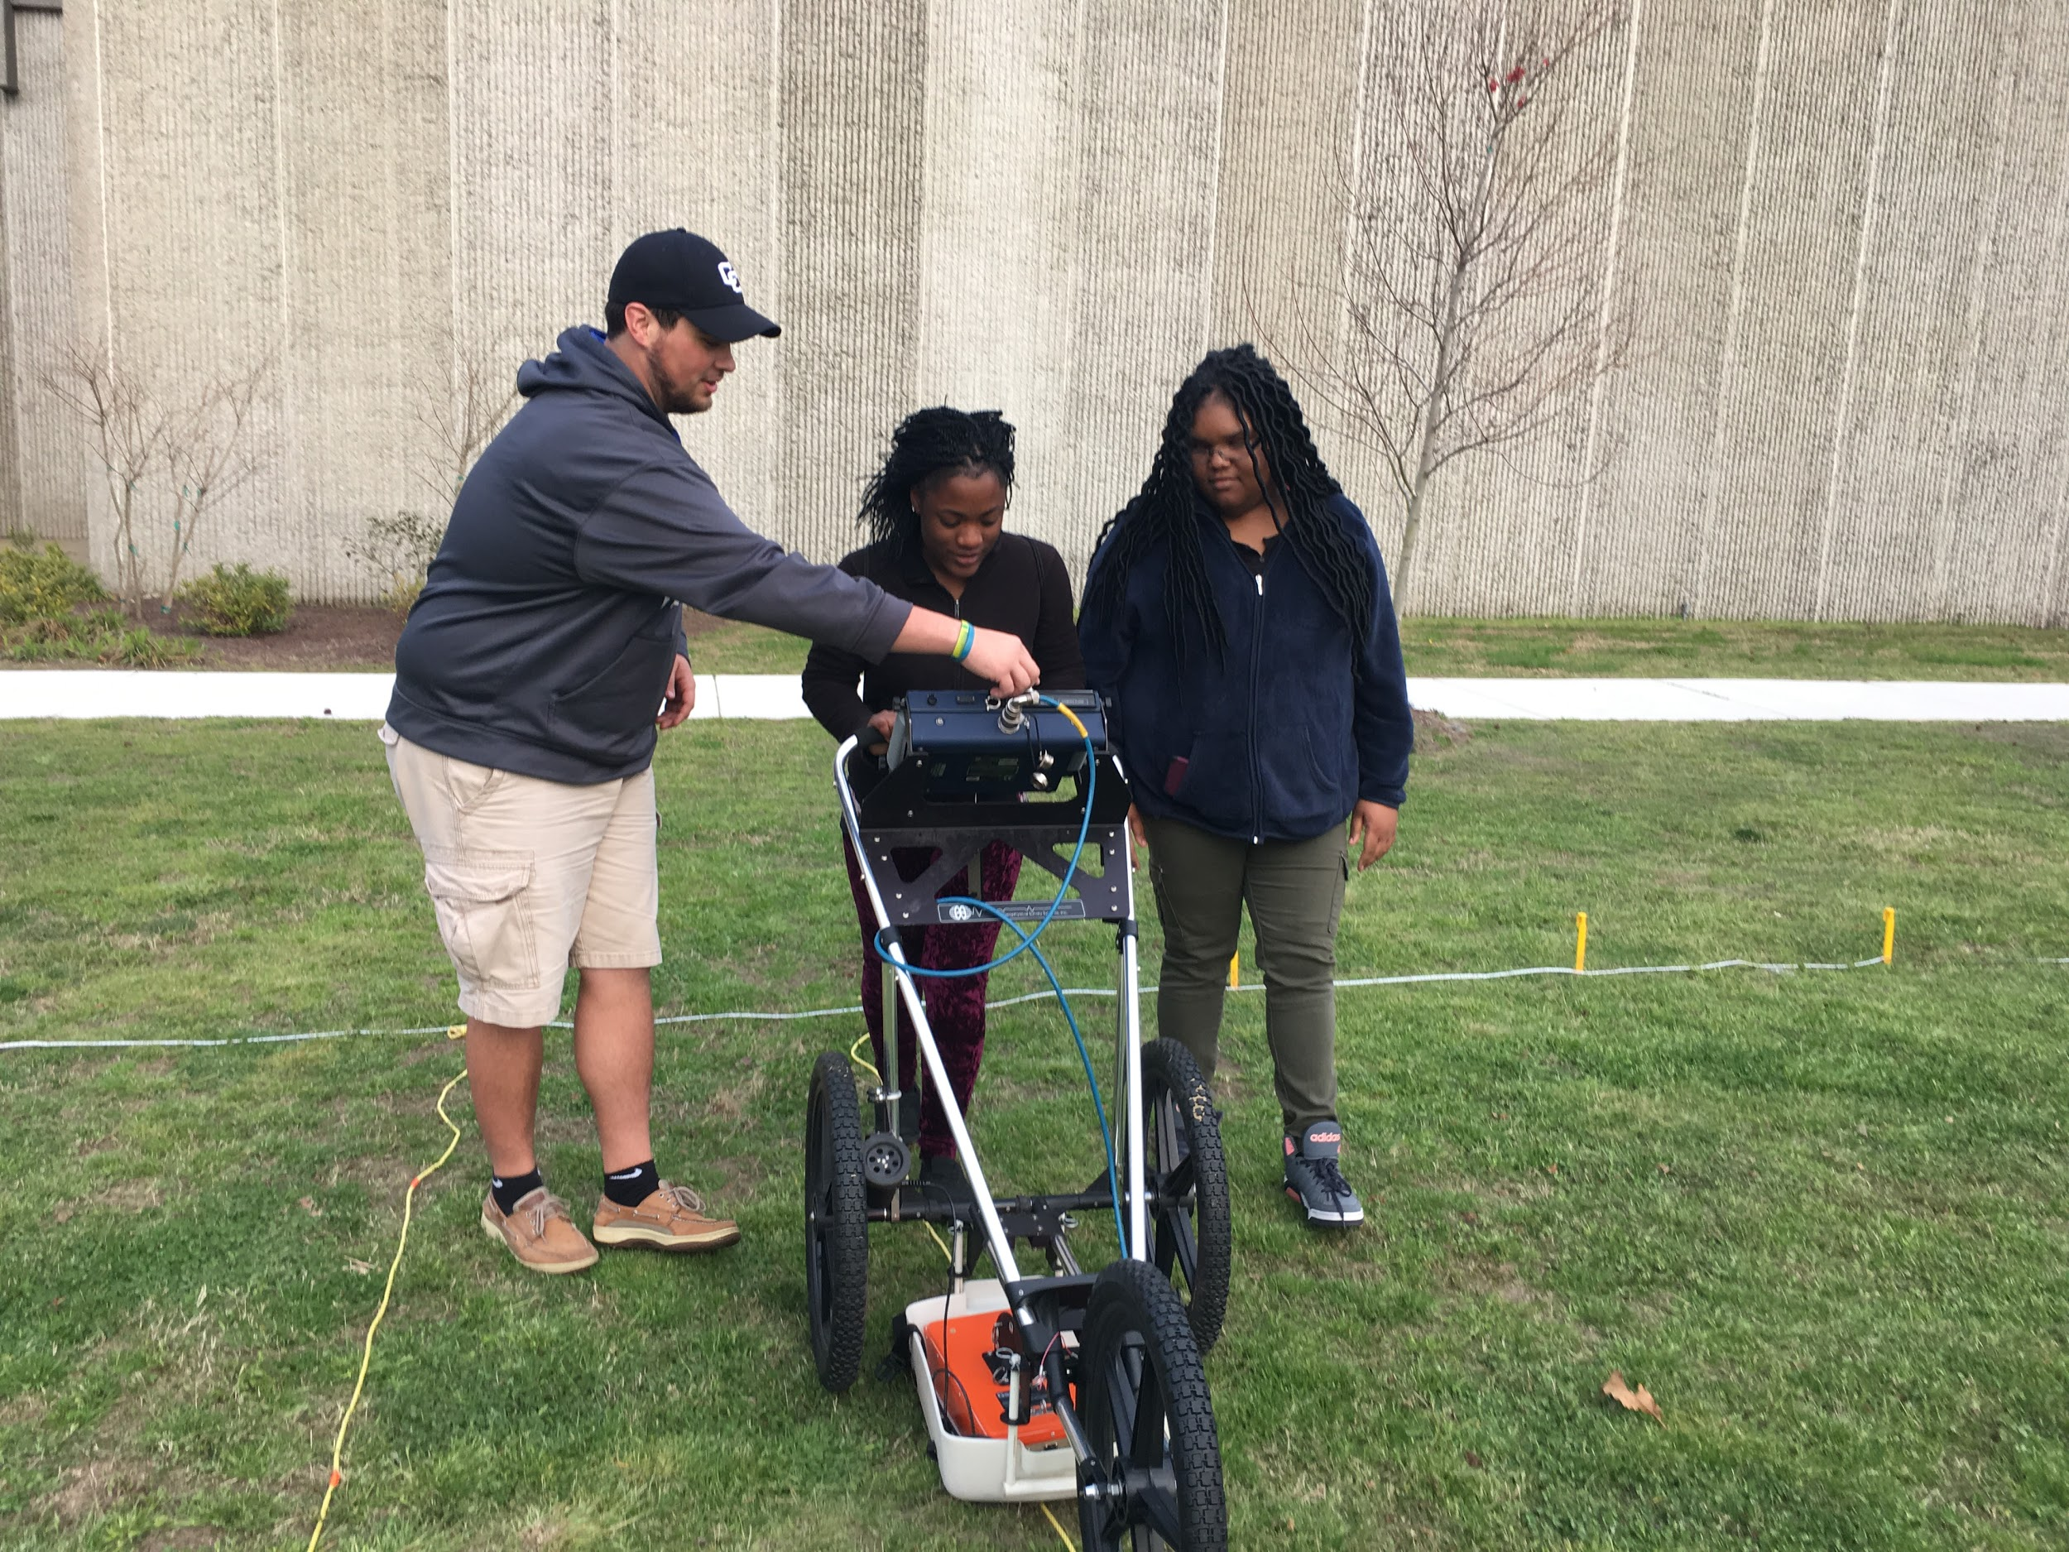

VI. Results
After completing 20 scans along the collection area, the team documented and saved the transects. From there we pulled the data from GPR and saved it to jump drive. The images we collected were uploaded a laptop with windows 7 and the Radan program in order to create 3d images. Unfortunately, there was a malfunction with the system prevented for the research team to create a 3D image. Using various color tables, we were able to highlight abnormalities in the soil, which we believed to be objects beneath the surface. However without exact blueprints of the location or excavation it is difficult to say exactly what the system found.

Conclusion
The ground penetrating radar team learned a great deal about the TerraSIRch SIR-3000 GPR system, the methods in which it is used, and situations it can be helpful. While ground-penetrating radar is not a new technology it is still widely used in a number of applications. Archaeologist, Land surveying companies, and general research can all benefit from the GPR technology. The team learned a number of skills while working with GPR. One of the greatest challenges was Trouble shooting, as the operating system used with the SIR-3000 outdated and required a level of expertise in operating system compatibilities.

Future work
In future studies the team agreed it would be more beneficial to scan an area the team had permission to excavate in order to confirm or deny the readings the system generated. Next time, created a 3D image of what is underneath the ground.

Acknowledgment
The team would like to recognize Dr. Linda Hayden for her continued efforts in the CERSER organization and Mr. Clay Swindell for his consult on various GPR methods and practices.

References
- Venkateswarlu, B., and Vinod C. Tewari. "Geotechnical Applications Of Ground Penetrating Radar (GPR)". N.p., 2017. Web. 11 Apr. 2017.
- De Vore, Steven L. "GROUND PENETRATING RADAR SURVEY OF PROPOSED ELEVATOR SHAFT SITE EXPLORATION (PEPC 47098) IN THE OLD COURTHOUSE AT JEFFERSON NATIONAL EXPANSION MEMORIAL, ST. LOUIS, MISSOURI". N.p., 2017. Web. 11 Apr. 2017.
- Chwatal, Werner et al. "Detecting Fold Structures At The Southern Flank Of The Neogene Vienna Basin In Eastern Austria Using Near-Subsurface Geophysical Methods". N.p., 2017. Print.
- "NIOSHTIC-2 Publications Search - 20023642 - Recent National Institute For Occupational Safety And Health Research Using Ground Penetrating Radar For Detection Of Mine Voids.".cdc.gov N.p., 2017. Web. 11 Apr. 2017.

