GLOBE Training for Preservice and Inservice Teacher Education at Elizabeth City State University

Dr. Darnell Johnson
Mentor
Elizabeth City State University
djohnson@cerser.ecsu.edu
Dana Chandler
Researcher
Elizabeth City State University
deeschandler@gmail.com
Joselyn Hathaway
Researcher
Elizabeth City State University
hathawayjoselyn@gmail.com
Heaven Tate
Researcher
Elizabeth City State University
tate.heaven@gmail.com

Jessica Hathaway
Researcher
Elizabeth City State University
hathawayjessica18@gmail.com
Dana Poole
Researcher
Elizabeth City State University
dana.poole@yahoo.com

Dr. Linda B. Hayden
Principal Investigator
Elizabeth City State University
haydenl@mindspring.com

Abstract—Global Learning and Observations to Benefit the Environment (GLOBE) is a K-12 environmental education program supported by National Aeronautics Space Administration (NASA), National Oceanic and Atmospheric Administration (NOAA), and National Science Foundation (NSF). GLOBE is a powerful teaching tool that enables students to use hands-on, inquiry-based methods to gather and interpret scientific data. Pathways in Mathematics Education and Remote Sensing (PiMERS) represents a joint effort between Elizabeth City State University (ECSU) and NASA Langley Research Center (LaRC) which held a hybrid regional teacher inservice and student preservice workshop on GLOBE Protocols at on the campus of ECSU located in Elizabeth City, North Carolina in the northeastern region of the state. A Protocol eTraining took place in January 2017 and the face-to-face workshop was held in February 2017. Over a two-week period, students and teachers learned basic GLOBE protocols and formed questions concerning each of the assigned GLOBE topics. During the face to face workshop participants collected data in the field, performed data/laboratory analyses, and compared data submitted by various schools around the world on the GLOBE website. The participants learned about remote sensing and viewed/manipulated images using image-processing software, and were introduced to the study of GLOBE Protocols as applied in northeastern North Carolina as well. Teachers and preservice students were excited about this hands-on experience in GLOBE and stated that this new learning prepared them to pass on this newly acquired knowledge. GLOBE protocols used in the workshop were recommended for incorporation into the current preservice teacher education program at ECSU.
As a result of the GLOBE training, the 2017 PiMERS Mathematics Team at ECSU established three environmental sites on the campus of ECSU. With these three established sites, the research team conducted investigations for the following GLOBE protocols: Clouds, Air Temperature, and Surface Temperature. For atmosphere investigations of air and surface thermometers; minimum, and maximum temperatures were recorded from the area located near the front of the Dixon/Patterson Hall building and the softball field on the campus of Elizabeth City State University. With the newly installed weather station loaned by LaRC, IRT207 Infrared Thermometers and digital multi-day max/min/current thermometers were used to record measurements of air and soil temperatures. For cloud investigations, the total cloud/contrail cover, sky color and visibility, cloud levels: high, mid, and low, and surface conditions were observed and recorded from the open area located near the front of Burnim Fine Arts Complex on the campus of Elizabeth City State University. All cloud observations were done visually.
The collection of environmental data from these three sites around the ECSU campus that encompass these protocols were conducted by four preservice mathematics education students and one university mathematics instructor from the General Studies Program. The team gained a better understanding of Earth System Science, its relationship to mathematics, and interrelated cycles which comprise an integrated system. The mathematics team uploaded the collected environmental data to the GLOBE website and provided environmental data that enabled scientists to help in the study the earth's system. The PiMERS Mathematics Team collected and evaluated obtained data, and created graphical models to express data quantitatively using the GLOBE website data resources.
The PiMERS Mathematics Education Team members researched the relationship of GLOBE protocols curriculum to the North Carolina Common Core State Standards for Mathematics and Science (NCCCSS). North Carolina adopted the North Carolina Common Core State Standards (NCCCSS) in K-12 Mathematics and K-12 English Language Arts on June 2, 2010 that were released by the National Governors Association Center for Best Practices and the Council of Chief State School Officers. With the adoption of these state-led education standards, North Carolina was in the first group of states to embrace clear and consistent goals for learning to prepare children for success in college and work. The Mathematics Standards and Science Standards are considered the gatekeepers for students who are college or career ready.
Keywords—Teacher Inservice Training, Preservice Education, GLOBE Protocols, Atmosphere, Clouds, Surface Temperature, Air Temperature, Remote Sensing, Chi Square Test, North Carolina Common Core State Standards for Mathematics, North Carolina Common Core State Standards for Science

Introduction
GLOBE is an international program that is provided for students, teachers, and the public. The program was launched in 1995 after being officially announced by the U.S. Government in 1994. Their mission is “to promote the teaching and learning of science, enhance environmental literacy and stewardship, and promote scientific discovery.” [1] This program is sponsored by NASA [2] and NSF [3] with the support of NOAA [4] and the Department of State. The major theme of the GLOBE program is based on topics related to earth science. The topics primarily associated with GLOBE include the atmosphere, biosphere, hydrosphere, and pedosphere. This program is also created to connect with all audiences and grade levels. For the elementary grade levels, the topics include more hands on activities and data collection while the secondary grade levels engage in more critical thinking and data analysis. This program is also beneficial in guiding teachers in lesson plans and students with projects and research [1].
Since GLOBE has a series of trainings for various topics, this allows teachers to engage in the activities with a professional so that they will be able to implement what they learned to their everyday classroom. Teachers are able to go through online tutorials that give them an insight to what to expect for the face to face workshop. GLOBE also connects to scientists in a way that benefits everyone. Scientists are able to access data in the GLOBE database, which allows them to track environmental and climate changes in various areas. The database contains accurate data which includes over 100 million measurements. The data found in the database is collected from students, teachers, and stations. Teachers engage in the training workshops to ensure that they have the have the proper training to help students take part in the GLOBE activities and entering data into the database. GLOBE also has an official website that allows teachers, school administrators, and scientists to become members of the GLOBE community [1].
There is a significant need to encourage and prepare minority and non-traditional high school students to pursue careers in the areas of science, technology, engineering and mathematics (STEM) on a national level. The purpose of describing the ways the research team developed conceptual frameworks and methodological approaches in their efforts to a responsible study and articulated the roles mathematics and science teachers play in enhancing how the understanding of GLOBE, two goals came to play a central role for students:
• Identifying ways in which mathematics and science teachers in a specific academic and social context assist their students in negotiating identities that have historically been constructed in isolation or in opposition to one another – namely becoming and being an adolescent while simultaneously becoming and being a mathematics and science learner.
• Identifying the knowledge, professional development, resources, experiences, and rationales mathematics and science teachers draw on as they engage in this identity socialization work in this particular academic and social context.
Care must be taken to ensure that students master and fully understand important topics in the mathematics and science curriculum, and that the continuity of learning progression is not disrupted. In particular, the Standards for Mathematical and Scientific Practice ought to continue to be emphasized in these cases. The Brookings Institute’s 2009 Brown Center Report on American Education found that the National Assessment of Educational Progress (NAEP) scores of students taking mathematics in the fourth and eighth grade varied widely, with the bottom 10% scoring far below grade level. And a report from the Southern Regional Education Board, which supports increasing the number of middle students taking Algebra I, found that among students in the lowest quartile on achievement tests, those enrolled in higher-level mathematics had a slightly higher failure rate than those enrolled in lower-level mathematics. In all other quartiles, students scoring similarly on achievement tests were less likely to fail if they were enrolled in more demanding courses. Mathematics performances have a major role in the understanding and application of science classes. These two reports are reminders that, rather than skipping or rushing through content, students should have appropriate progressions of foundational content to maximize their likelihoods of success in school mathematics and science. In the Common Core State Standards (CCSS), students begin preparing for mathematics and science in Kindergarten, as they start learning about the properties of operations and scientific discovery. Furthermore, much of the content central to typical Algebra I courses—namely linear equations, inequalities, and functions—is found in the standard 8th grade CCSS.
To prepare students for high school mathematics and science in eighth grade, districts are encouraged to have a well-crafted sequence of compacted courses. The term “compacted” means to compress content, which requires a faster pace to complete, as opposed to skipping content. Both are based on the idea that content should compact 3 years of content into 2 years, at most. In other words, compacting content from 2 years into 1 year would be too challenging for most, and as such content may be omitted. The CCSS have been developed to define clear learning progressions through the major mathematical and scientific domains so omitting content is not recommended.
The learning progressions of the CCSS necessitate that students are proficient with the middle school curriculum before beginning high school courses. However, once students begin their high school courses, they are not required to enroll in the grade level math and science. North Carolina Department of Public Instruction (NCDPI) does not provide specific criteria to place students into compacted courses. However, it is recommended that placement decision be based on solid evidence of student learning using multiple criteria.
The Institute of Higher Education Bachelor Performance Report from NC State University in 2009 – 2010 and UNC-Pembroke in 2004 – 2005 hosted Middle Educators Global Activities (MEGA), a partnership between K-12 teachers and the CED designed to enable educators to use technology in the classroom with a special emphasis on core content and interdisciplinary projects specific to the NC Standard Course of Study. MEGA includes over 875 teachers from 74 Local Education Agencies (LEA’s). An active listserv provides curriculum resource information to member teachers. The English as a Second Language (ESL) program holds its annual Symposium that covers topics such as literacy, technology, cultural and immigrant issues, No Child Left Behind (NCLB), and National Board Certification. In addition, ESL Globe, an on-line newsletter is a resource for ESL educators. In an effort to assist two Leandro LEAs, the SOE received funding for NC QUEST “Excellence in Teaching Mathematics and Science Project,” which provided 90 hours of Professional Development (PD) to 100 middle and high school math and science teachers in two local school divisions. In addition, GLOBE workshops were offered to middle and high school teachers from those counties. Faculty from the Chemistry Department offered Saturday enrichment workshops for middle school students from one local school division and mentored chemistry students carrying out science research projects [10-17].

Statement of Purpose
The purpose of this research was to learn the importance of GLOBE, what this program does for inservice and preservice teachers, and how the protocols can be utilized. A webinar and online GLOBE workshop was hosted by Dr. Jessica Taylor from NASA in January. All participants were directed to complete the online training which introduced them to the GLOBE website and the wide variety of protocols. All of the protocols were based on subjects in the earth science system. In collaboration with Dr. Taylor, preservice and inservice teachers were able to experience face-to-face activities on the campus of ECSU and discover how to incorporate information in the classroom.

Research Questions
- How can preservice and inservice teachers utilize the GLOBE protocols?
- What are the benefits of GLOBE in the classroom?
- In what role does GLOBE enhance critical thinking skills?
- Why is GLOBE important for global community?

Methodology
This study was conducted at ECSU [7] with 14 participants and consisted of two sessions. The first session was led by Dr. Jessica Taylor from NASA. During this workshop, she trained 3 inservice teachers and 4 preservice students on three GLOBE protocols: clouds, air temperature, and surface temperature. After becoming GLOBE certified, the PiMERS [5][6] mathematics education team lead the second session with a group of 7 participants. For both sessions, the same tools were utilized for collecting data. For the three protocols we used a cloud identification chart for the clouds, a max and min thermometer for the air temperature, and an infrared thermometer for the surface temperature. All of the participants were able to utilize these tools in order to collect data that would be added to the GLOBE database. At the end of each training session, all 14 participants were given a survey with a series of 12 questions. The questions were based on a Likert scale from 1 to 5.

Research Participants

Gander | Frequency Distribution for Participant Demographics of Inservice and Preservice and Inservice
 | Preservice | Inservice Elementary | Inservice Middle | Inservice High | Inservice College | ECSU Student
Female | 6 | 1 | 1 | 0 | 2 | 2
Male | 2 | 0 | 0 | 0 | 0 | 0

- The figure above shows the demographics of the GLOBE participants.
In the figure above, the demographics of those who participated in GLOBE were separated by gender and teaching level or status. A majority of the participants were female for a total of 12 and the other 2 participants were males. Also, 8 of the participants were preservice students, 4 participants were inservice teachers (1 elementary, 1 middle, and 2 college), and 2 participants were ECSU students. The demographics of the participants resulted in a total of 14 participants.

Data Collection and Results
The data sheets in the appendix were used to collect data from the participants in the training sessions and represents the first and second groups collectively considering the data corresponds with both groups. The first data sheet was used for the air temperature protocol. For this protocol, we used a max/min thermometer. The participants collected the data by holding the thermometer up in the air, allowing wind to enter the hole on the side of the thermometer in order to get an accurate reading. The second data sheet was used for the surface temperature protocol. The third and last data sheet contains the data collected for the cloud protocol. For this data collection, the participants used a cloud identification chart to document what kind of clouds were in the sky, how much of the sky was covered, and the level of the clouds. The participants used an infrared thermometer to record the temperature by pointing it toward the ground with an extended arm and pressing the button.

Surveys
The 12-question survey was completed by both groups of workshop participants in the February and March workshops. This survey consisted of a series of 12 questions and was used to gauge what participants experienced from the work sessions. Responses were based on personal experience using Likert scales from strongly disagree to strongly agree. The results were tallied and represented below in Figures II-IV.

Survey Question | In what role does GLOBE enhance critical thinking skills?
 | Strongly Disagree/Disagree | Neutral | Strongly Agree/Agree
The learning objectives of the workshop/presentation were clear. | 0 | 0 | 14
The content of the presentation was relevant | 0 | 0 | 14
The presentation setting was conducive to learning | 0 | 0 | 14
The presentation facility was clean and comfortable | 0 | 1 | 13

- The figure above answers the question “In what role does GLOBE enhance critical thinking skills?”
Survey Question | What are the benefits of GLOBE in the classroom?
 | Strongly Disagree/Disagree | Neutral | Strongly Agree/Agree
I can apply what I learned from this presentation | 0 | 0 | 14
The use of technology and visual aids made the instruction easier to remember | 0 | 0 | 14
I plan on using information from this session in my classes | 0 | 1 | 13
The session raised my awareness in the STEM field | 0 | 0 | 14
- The figure above answers the question “What are the benefits of GLOBE in the classroom?”
Survey Question | How can preservice and inservice teachers utilize the GLOBE protocols?
 | Strongly Disagree/Disagree | Neutral | Strongly Agree/Agree
The facilitator was knowledgeable on the subject. | 0 | 0 | 14
The facilitator exemplified commitment on the subject. | 0 | 0 | 14
The facilitator kept me interested and attentive. | 0 | 1 | 13
The facilitator seemed prepared and well organized. | 0 | 0 | 14

- The figure above answers the question “How can preservice and inservice teachers utilize the GLOBE protocols?”

Chi-Squared Statistics
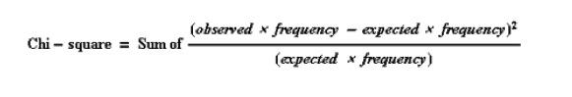
8.31529E-07 | 8.31529E-07 | 8.31529E-07
8.31529E-07 | 8.31529E-07 | 8.31529E-07
8.31529E-07 | 1.38402E-05 | 1.38402E-05
1.38402E-05 | 8.31529E-07 | 8.31529E-07

The Chi-Squared Test showed a comparison of observed and expected values, which are listed above and concludes that the impact of the GLOBE program would be considered a positive factor to influence preservice and inservice teachers [9].

Conclusion
From participants in the GLOBE workshops and training sessions, it was found that GLOBE training tended to be beneficial to both pre-service students and in-service teachers. GLOBE is not only for K-12 science classrooms, but for the purpose of educating the global community as well. This program has a variety of lessons that are flexible enough to be used on all grade levels. The online training aids in giving a detailed description of each protocol on the GLOBE website. Participants of the GLOBE workshops were allowed to conduct research in activities associated with protocols with a positive insight to science, science education, mathematics education, and research techniques.

Future Work
The PiMERS Mathematics Team will use a weather station loaned from NASA LaRC. Materials stored in the weather station will be used collect data that can be added to the GLOBE database. The team plans to set up the weather station in a permanent location and conduct continual research during annual events such as PiMERS Middle School summer program, local school division training, and inservice teacher training. By doing so, the team and other researchers will be able to monitor the local environment and observe seasonal or daily changes. The team also plans to present this information to Dr. Sheila Williams in the education department with the goal of having GLOBE become part of the curriculum.

Acknowledgments
The 2017 PiMERS mathematics education team would like to thank the CERSER principal investigator Dr. Linda B. Hayden, our mentor Dr. Darnell Johnson, Dr. Jessica Taylor from NASA, and the participants from the workshop and training sessions.

References
- "Home - GLOBE.Gov". Globe.gov. N.p., 2017. Web. 22 Mar. 2017.
- "National Aeronautics and Space Administration". NASA. N.p., 2017. Web. 22 Mar. 2017.
- "NSF - National Science Foundation". Nsf.gov. N.p., 2017. Web. 22 Mar. 2017.
- "National Oceanic and Atmospheric Administration". Noaa.gov. N.p., 2017. Web. 22 Mar. 2017.
- "Center Of Excellence In Remote Sensing Education And Research". Cerser.ecsu.edu. N.p., 2017. Web. 22 Mar. 2017.
- "NASA PIMERS :: ECSU". Nia.ecsu.edu. N.p., 2017. Web. 22 Mar. 2017.
- "Elizabeth City State University". Ecsu.edu. N.p., 2017. Web. 22 Mar. 2017.
- "North Carolina Public Schools". Ncpublicschools.org. N.p., 2017. Web. 22 Mar. 2017.
- McClean, Phillip. "Mendelian Genetics". Ndsu.edu. N.p., 2017. Web. 3 Apr.2017.
- National Mathematics Advisory Panel. (2008). Foundations for success: The final report of the National Mathematics Advisory Panel. Washington, DC: U.S. Department of Education.
- A study of U.S. eighth-grade mathematics and science teaching, learning, curriculum, and achievement in international context. Washington, DC: U.S. Department of Education, Institute for Education Sciences. National Center for Education Statistics. U.S. Department of Education. (1997, October).
- Common Core State Standards Initiative. (2010). Common core state standards for mathematics. Retrieved September 15, 2010, from http://www.corestandards.org/assets/CCSSI_Math%20Standards.pdf.
- Research issues in the learning and teaching of algebra. Reston, VA and Hillsdale, NJ: National Council of Teachers of Mathematics and Erlbaum. Walston, J., & Carlivati McCarroll, J. (2010).
- The Chicago Algebra Initiative. Notices of the American Mathematical Society, 57. 865-867. Jimerson, L. (2006).
- Darling- Hammond, L. 2007. Recognizing and enhancing teacher effectiveness: A policymaker’s guide. In L. Darling-Hammond and C. D. Prince (eds.), Strengthening teacher quality in high-needs schools-policy and practice. Washington, DC: The Council of Chief State School Officers.
- Perie, M., S. Marion, B. Gong, and J. Wurtzel. 2007. The role of interim assessments in a comprehensive assessment system: A policy brief. Washington, DC: The Aspen Institute.
- National Council of Teachers of Mathematics. (1995a). Algebra in technological world: Addenda series grades 9-12. Reston, VA.

Appendix A GLOBE Survey

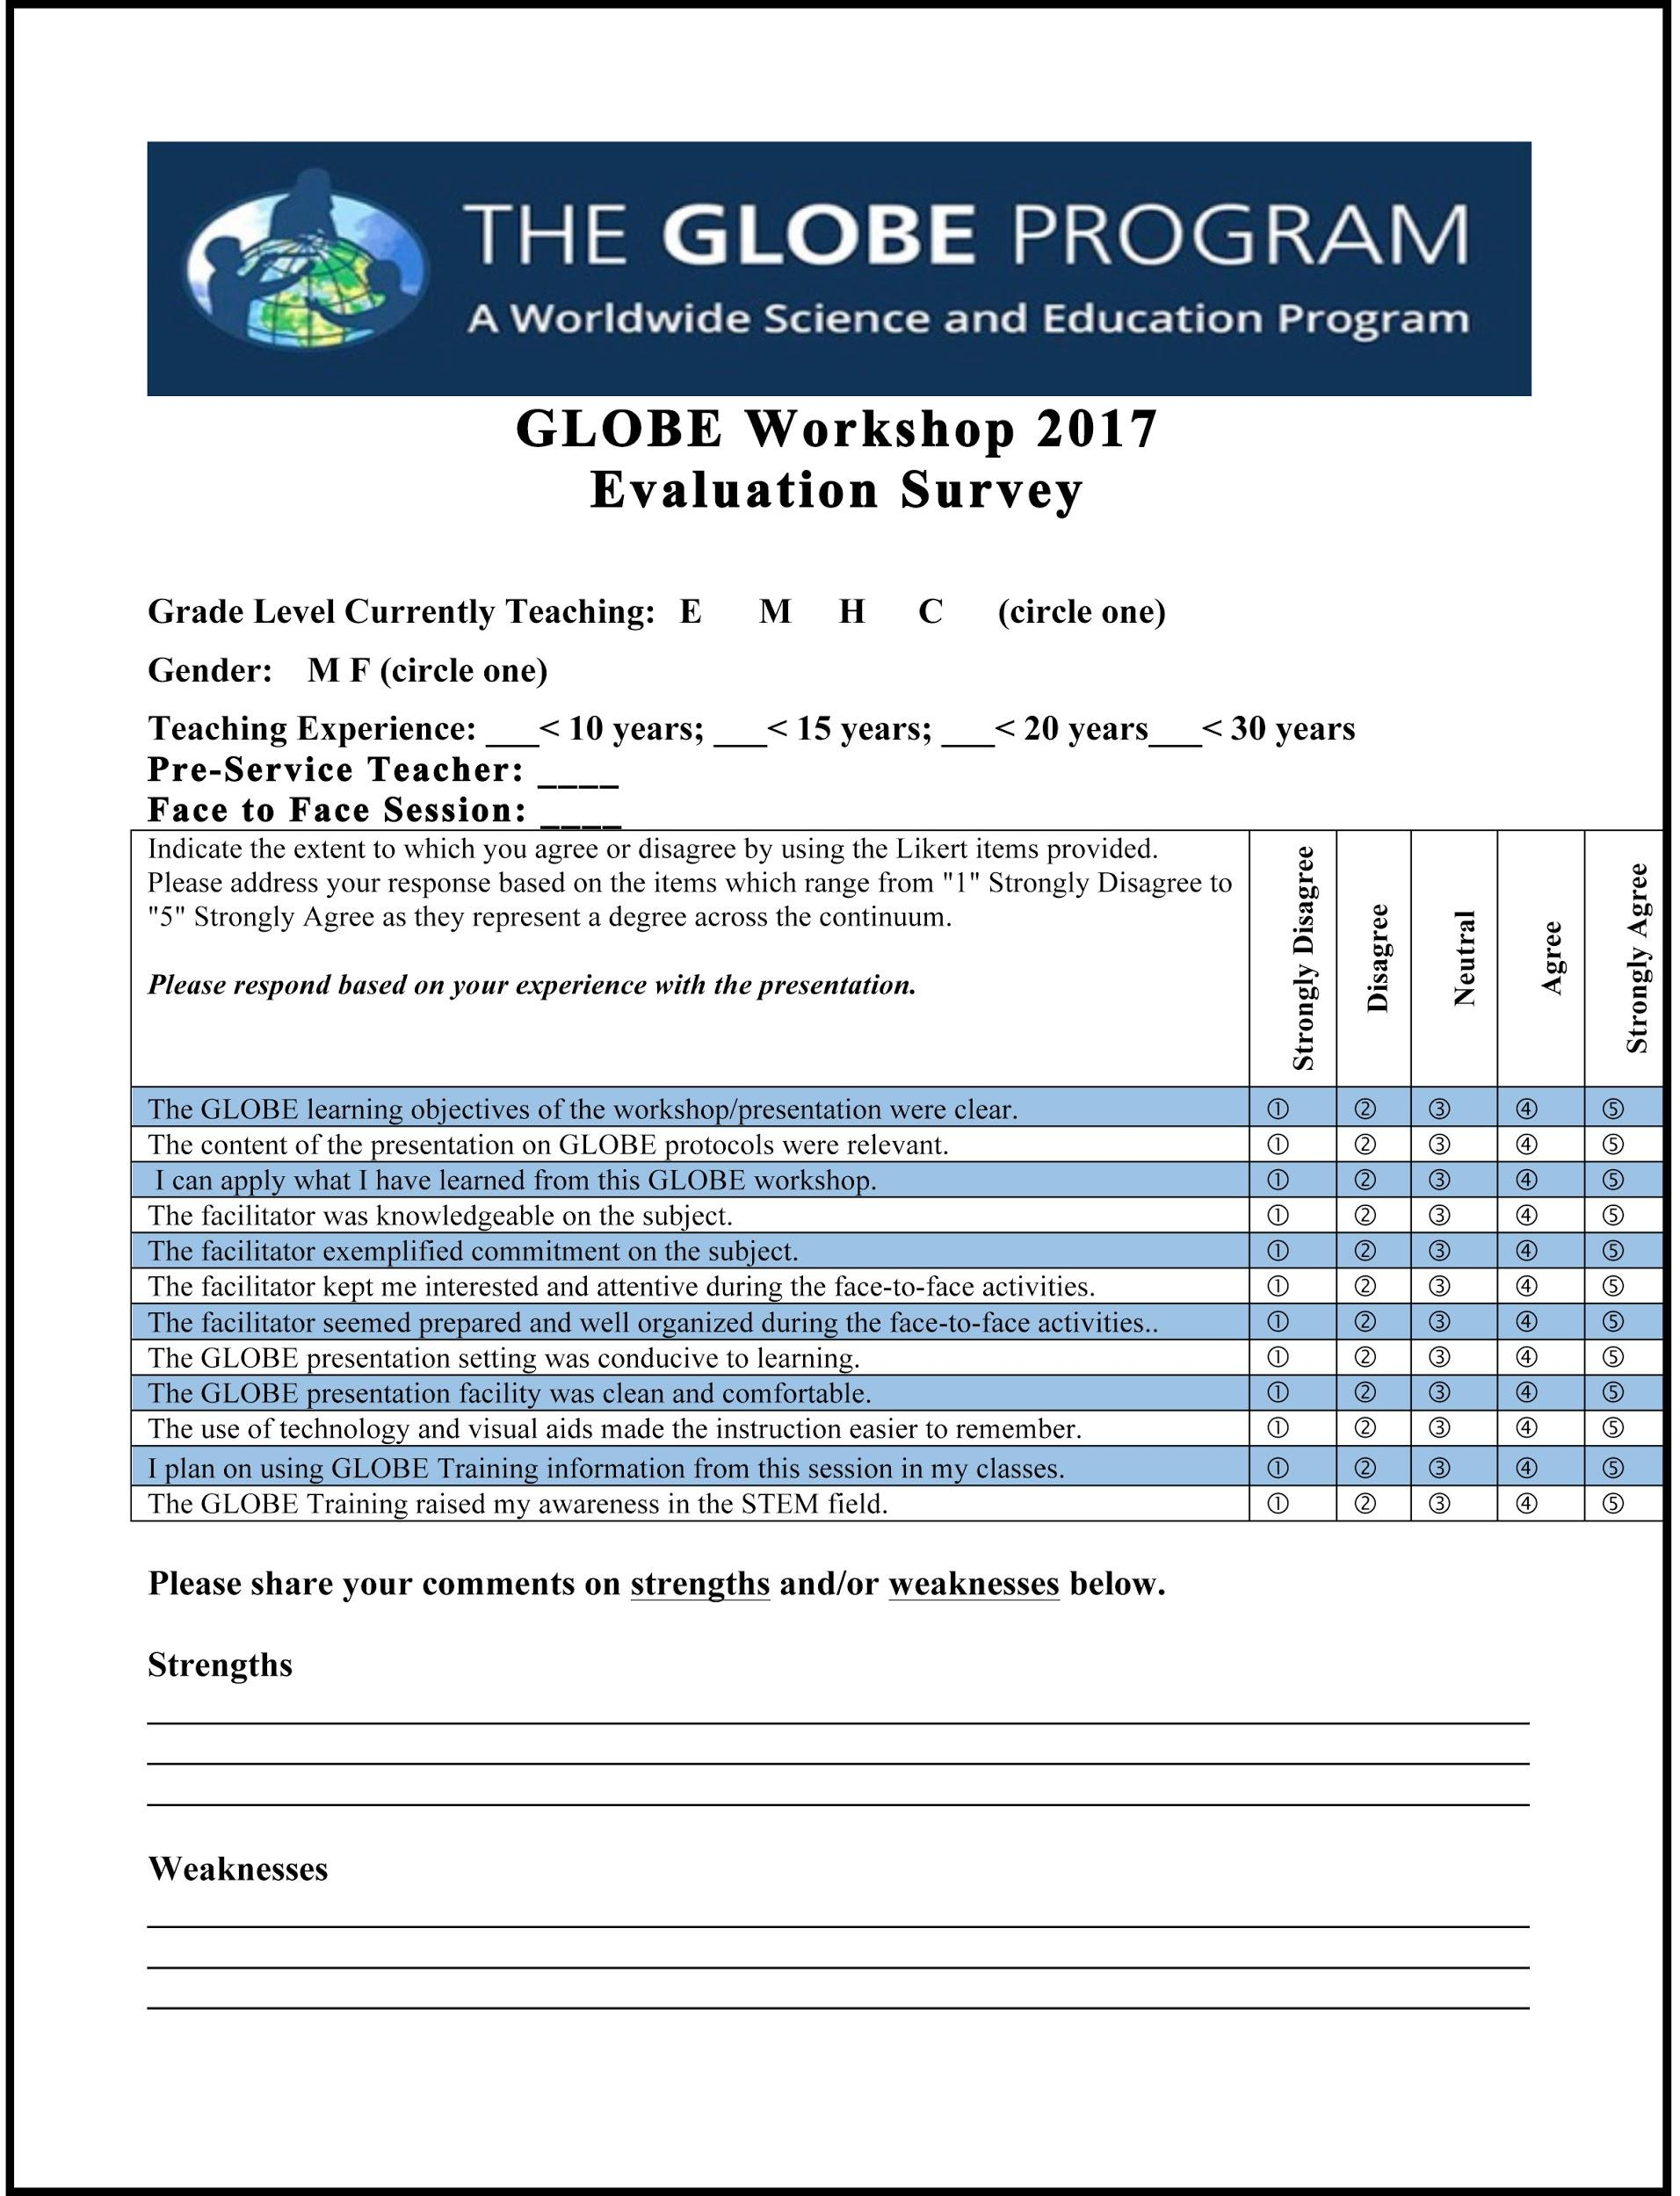

Appendix B Lesson Plan

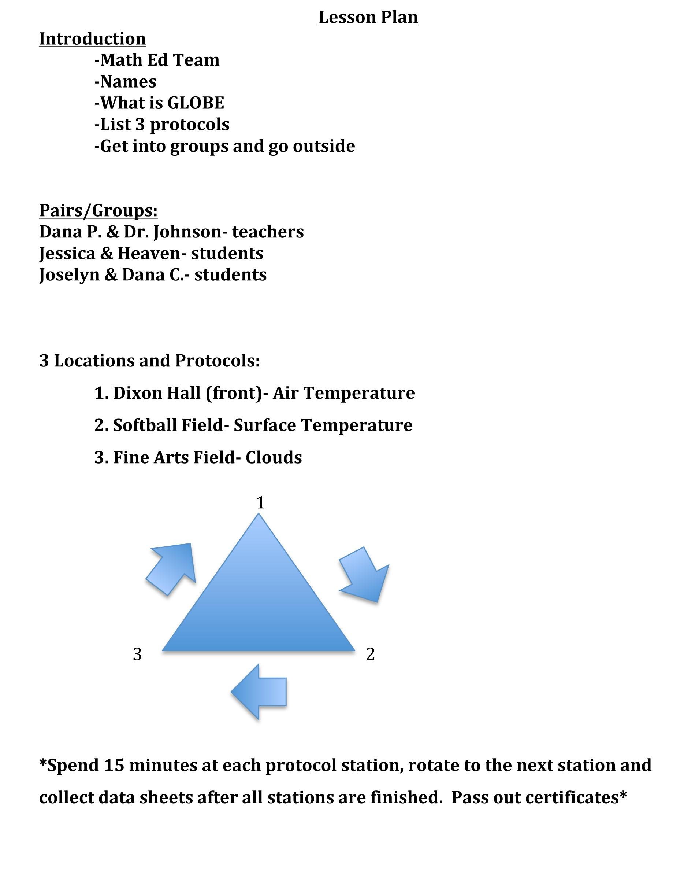

Appendix C Sign-in Sheet

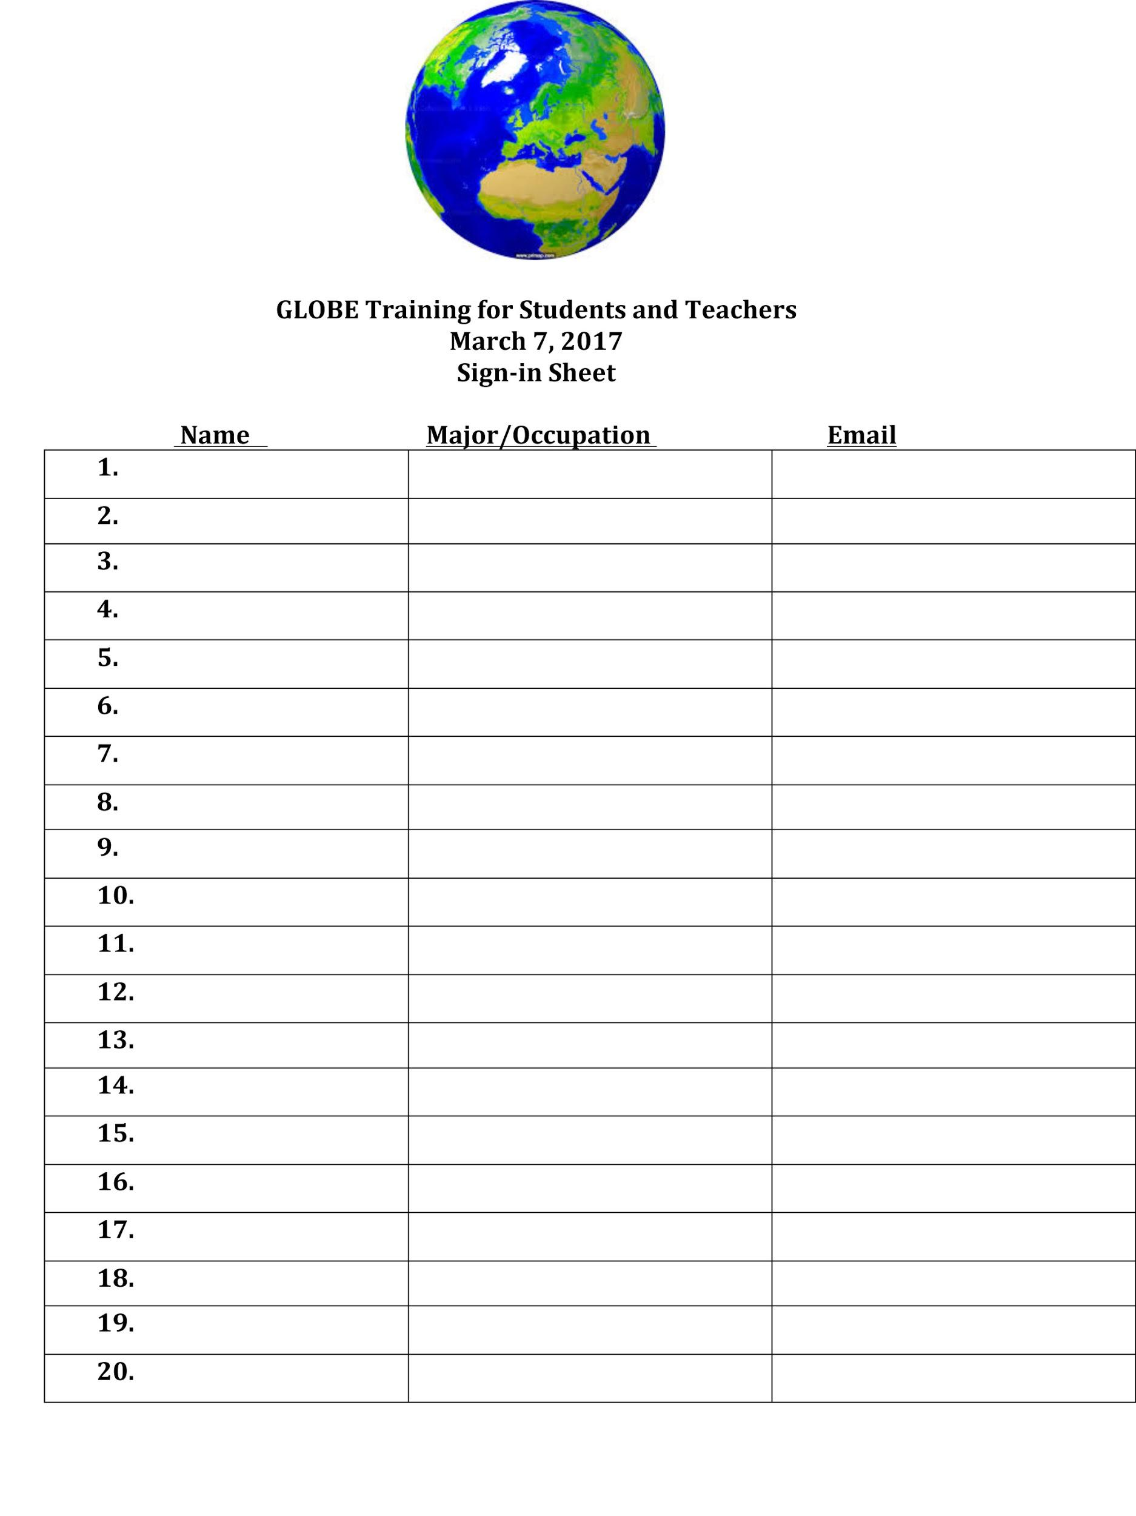

Appendix D Digital Multi-Day Minimum/Maximum Thermometer Data Sheet

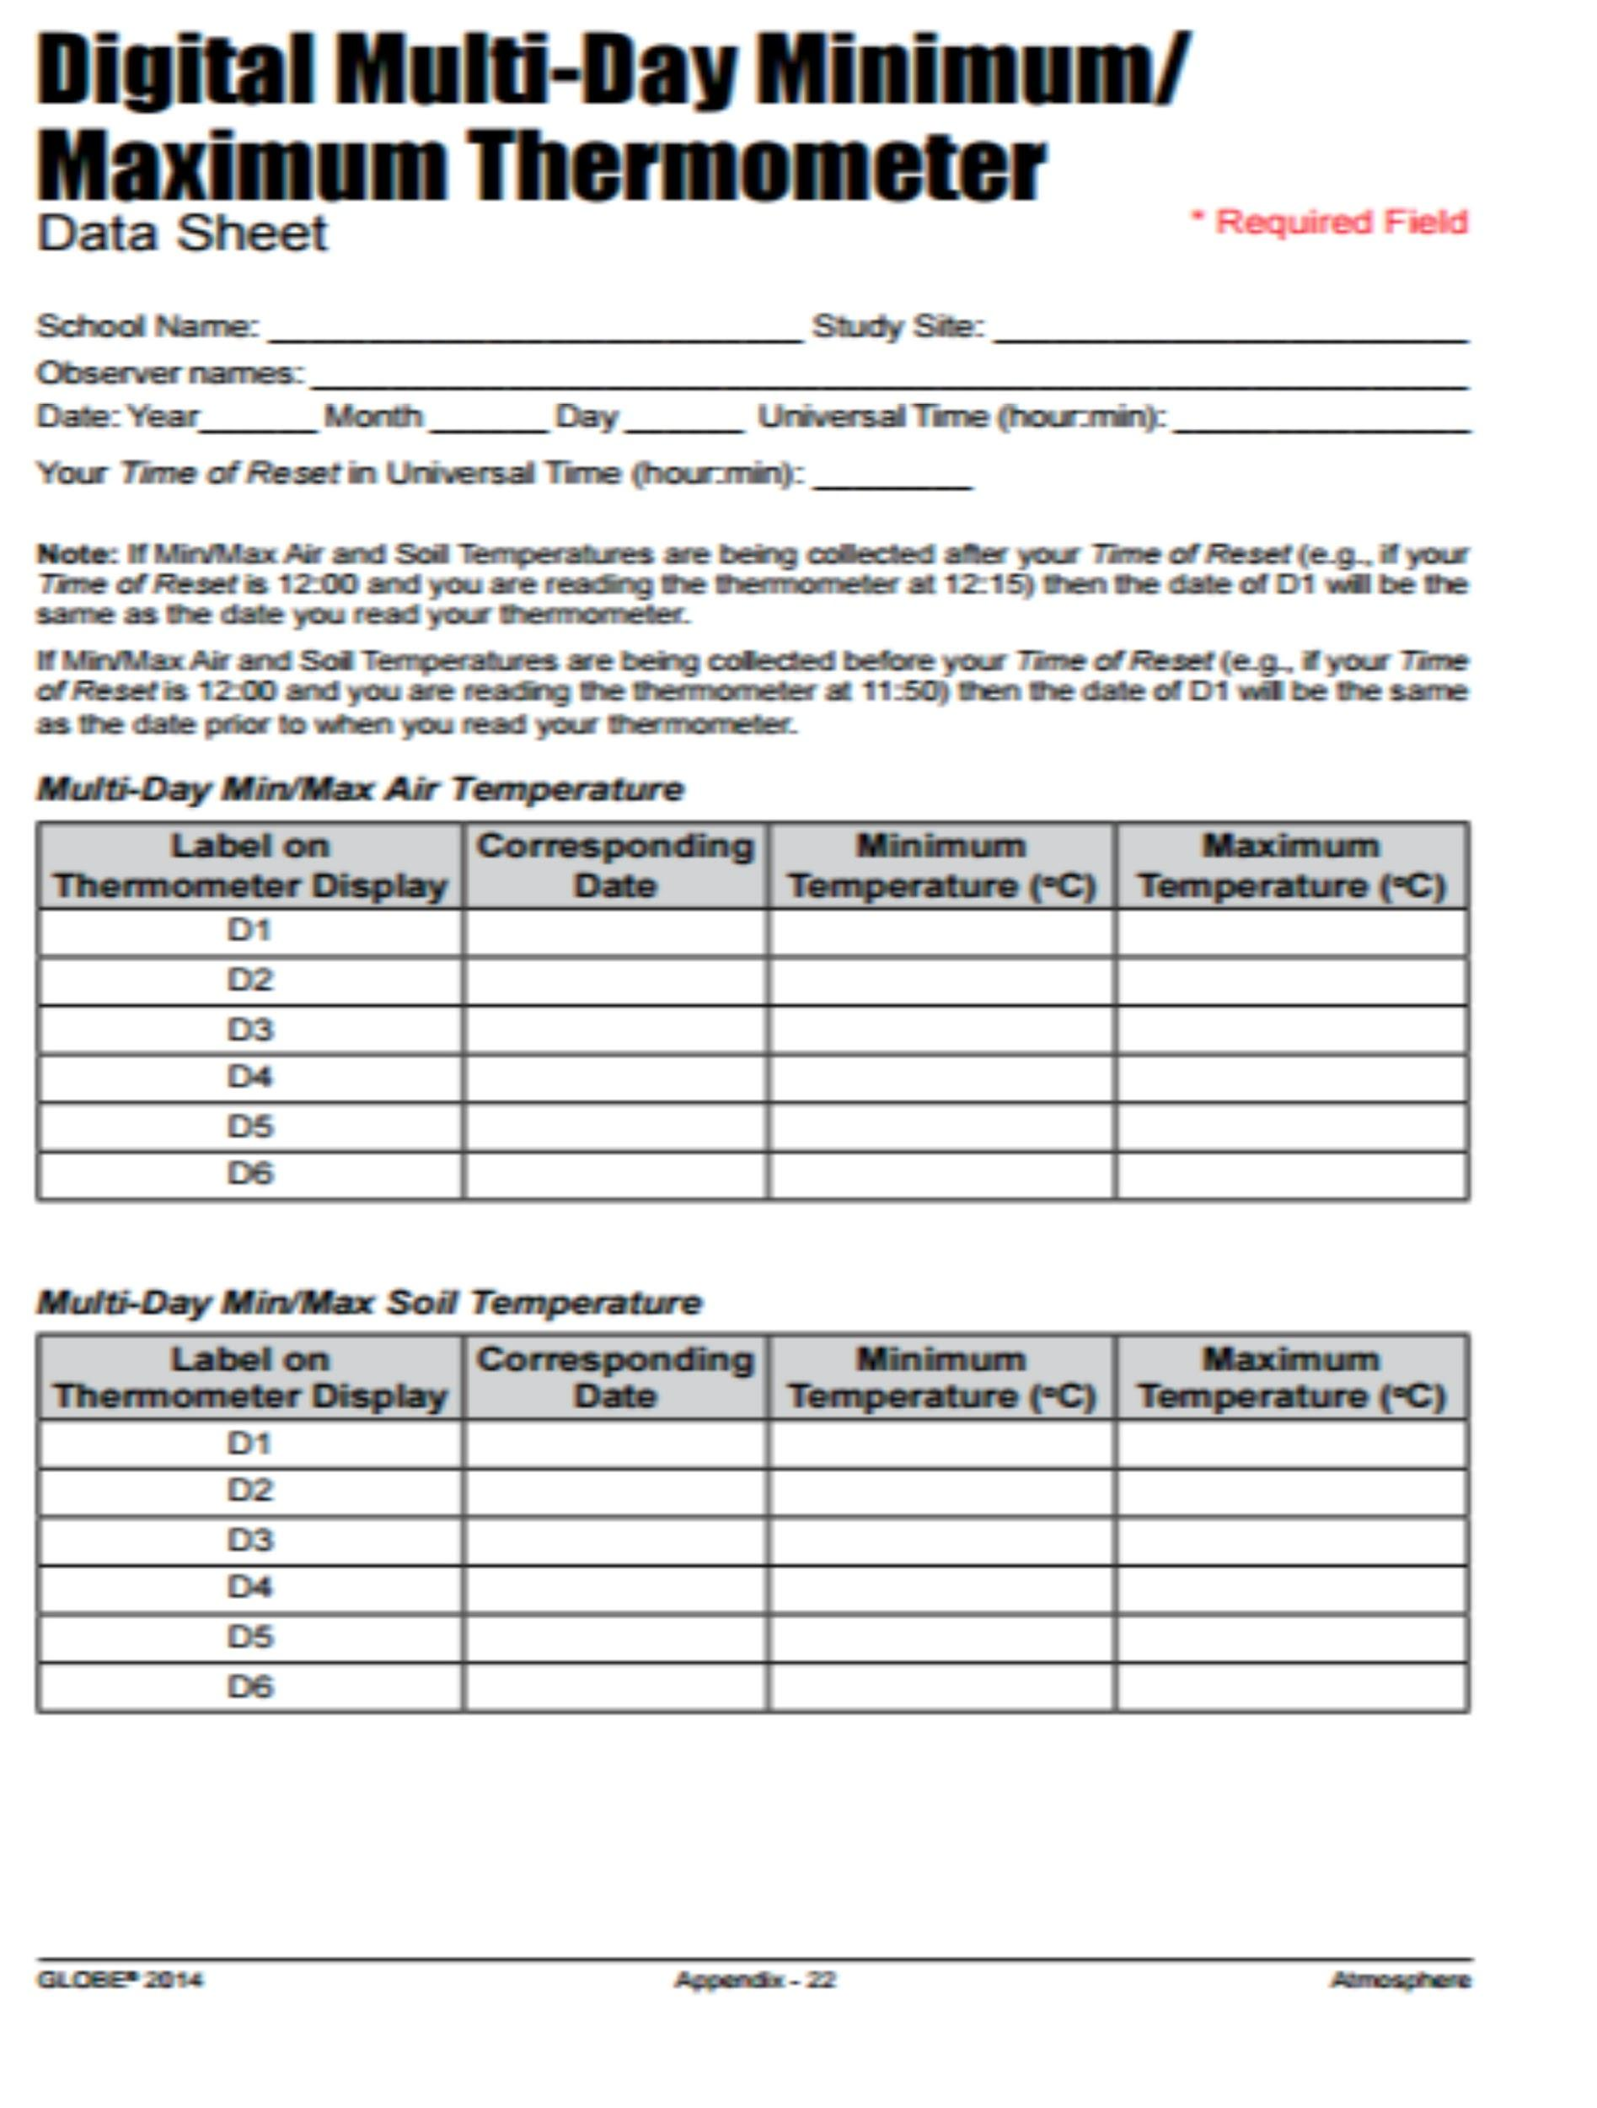

Appendix E Atmosphere Investigation Surface Temperature Data Sheet

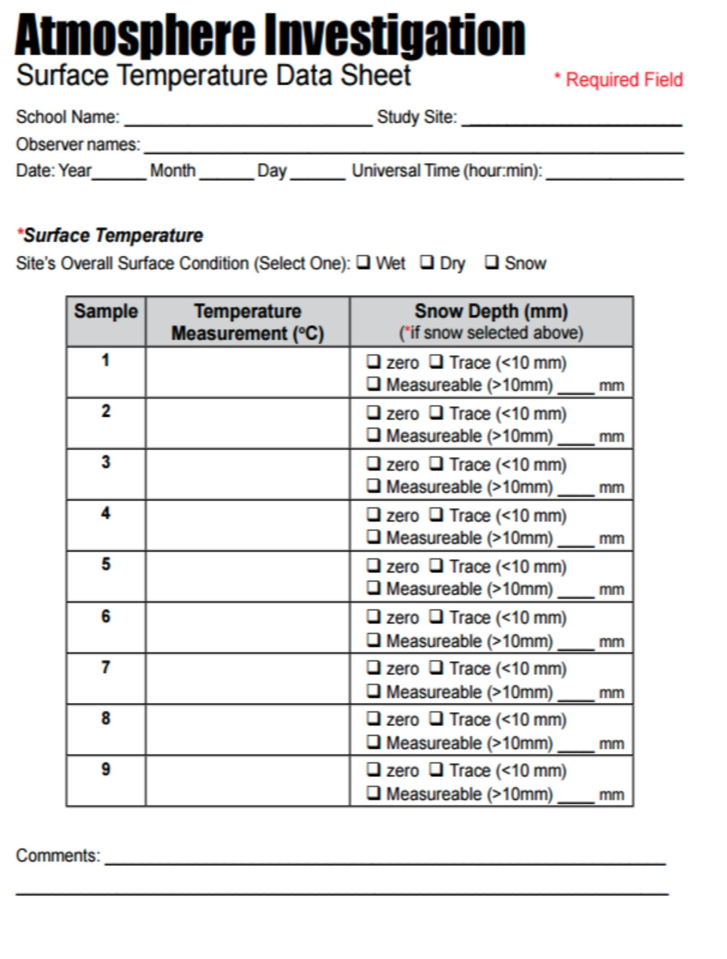

Appendix F Atmosphere Investigation: Cloud Protocol Data Sheet

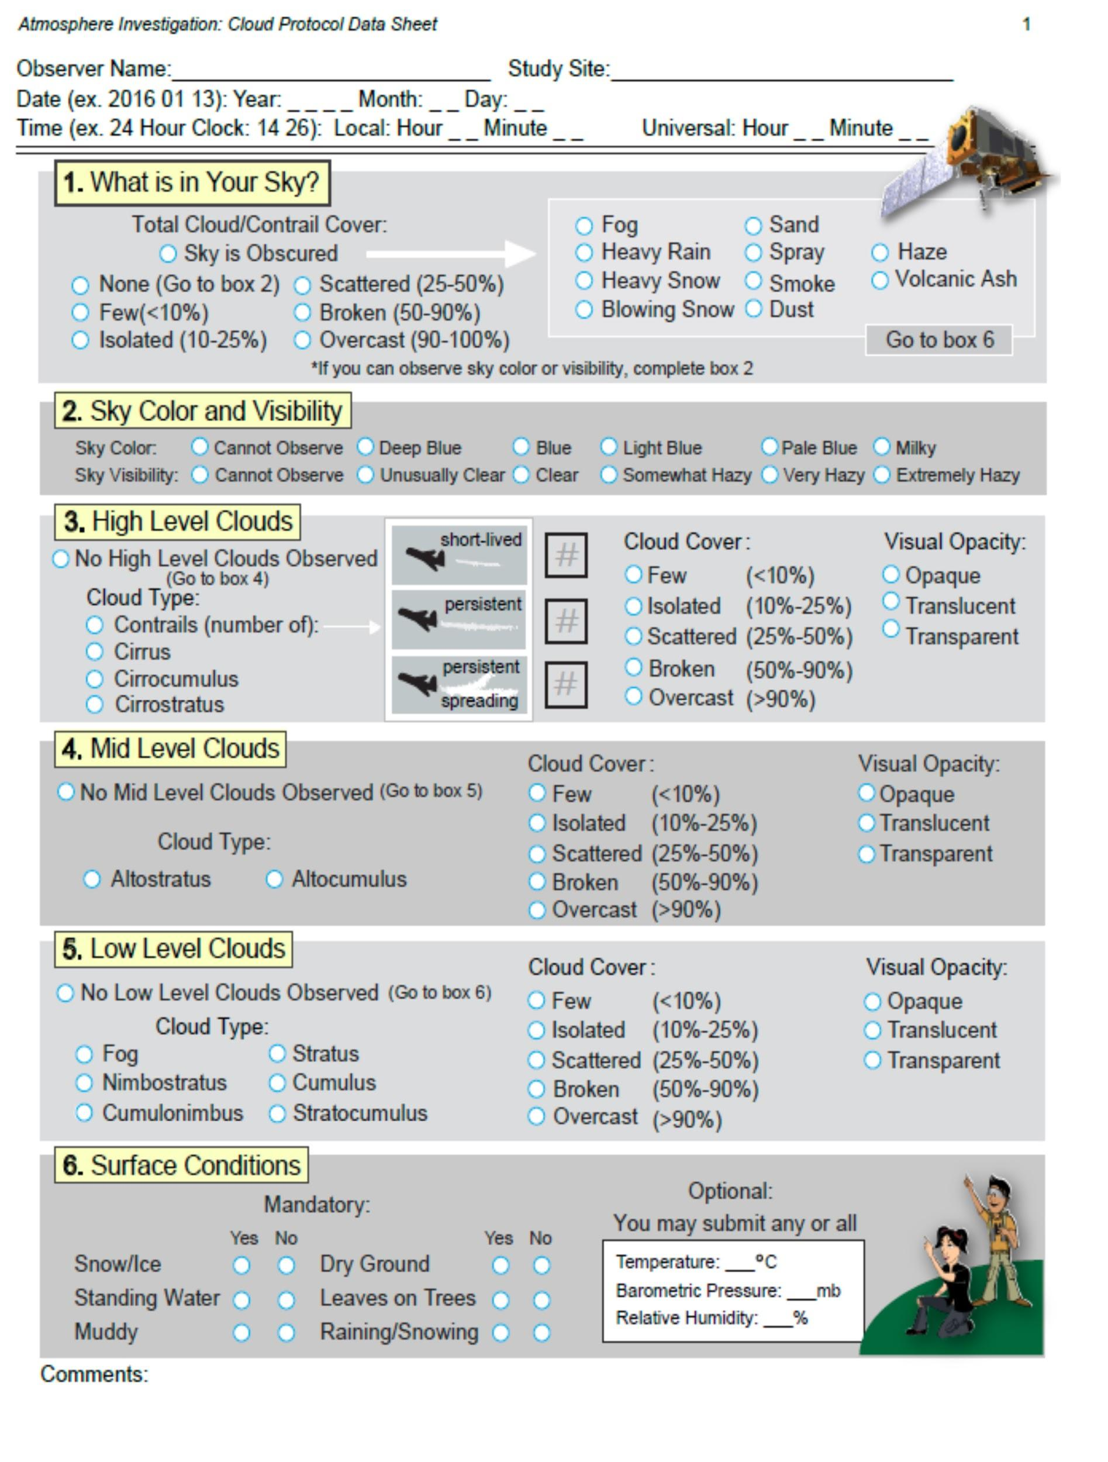

Appendix F S’Cool Cloud Identification Chart

