Implementation of Social Media for Dissemination of Research Activities at the Center of Excellence in Remote Sensing Education and Research at Elizabeth City State University
Antonio Guion, Charles Hockaday Jr., Anissa Norman, Joel Gonzales-Santiago Mentor: Mr. Jeff Wood
Center of Excellence in Remote Sensing Education and Research
Elizabeth City State University
Elizabeth City, North Carolina, USA

Abstract - The Center of Excellence in Remote Sensing Education and Research (CERSER) at Elizabeth City State University (ECSU) was established in the spring of 2003 to develop innovative and relevant research collaborations focused on remote sensing applications to coastal, ocean, marine, and polar research. The program has supported various other projects through grants and collaborations with the National Science Foundation, Office of Naval Research, the National Aerospace and Space Administration, and other various government and educational entities.
CERSER has utilized the web site located at http://cerser.ecsu.edu to provide documentation of research activities to funding agencies, faculty, students, and event attendees from its inception. This site provides information regarding past, current, and future events as well as research conducted by students in the program and with affiliated universities or government agencies. The sister site located at http://nia.ecsu.edu is the original location used for documentation of information from previous and current research projects under this program and remains active today.
In order to reach out to a broader audience, the implementation of social media was explored during this project. The goal of this research was to establish a social media presence on Facebook, Twitter, Instagram, and Google+.
This project explored the implementation of each social media application and identified appropriate audiences and methods of disseminating information. The methods included what information to post, when to post it, and how often to share. Best practices were taken from both educational and commercial sources
Index Terms— Facebook, Twitter, Google+, Instagram, social media, research, CERSER, ECSU, promotion

Introduction
Social media is defined as "a group of Internet-based applications that build on the ideological and technological foundations of Web 2.0 and that allow the creation and exchange of user-generated content."[19] Web 2.0 is a description of web sites that have client-developed content and are interactive. This is not a technical specification, but describes how pages are created and used.
Research institutions conduct research and publish their findings. Many institutions are able to publish; yet their research is not easily accessible to members of the public. The goal of this research project was to target solutions for research institutions trying to promote themselves and their research. The study consists of using social media in order to promote the Center of Excellence in Remote Sensing Education and Research (CERSER). The research demonstrates how to properly use social media for effective communication, promotion, and usefulness. The research explored the social media applications Facebook, Google+, Twitter, and Instagram.
Many programs currently also allow users to easily share and promote their content. For this reason, this research focused on social media applications by implementing four of those that are the most popular. The constant changes social media applications undergo makes any study applicable for the time of the research. Therefore this research is based on the current time span in which the study was conducted.

Applications

Facebook
Facebook is on online social networking site first developed for students at Harvard University. There were 1.59 billion active Facebook users as of December 31, 2015. The term Facebook is derived from the online directories at universities commonly known as “face books.” Facebook is available as an application for smartphones and tablets. Facebook does have a range of privacy option for its users. Users have the option to make their own pages private, public, or for friends only.
Once a user is registered they then create a profile and connect with other users as “friends.” They can then exchange messages, photos, and videos or create a general update known as a “status post” which can be viewed by anyone depending on certain parameters set by the user. Status updates can be in the form of videos, pictures, words, and music. Users can comment, like, and share the status updates making the application interactive. There is not a limit to how many pictures a user can post on Facebook. Users can also join or create groups based on common themes such as family, work, or school.
Facebook is a defined as a “free social networking website” that is available in 37 different languages. It accommodates different features such as the Marketplace so that users can post and read different ads. “Groups” is another feature that allows users with similar interests to get together and interact. “Events” allows users to create calendar events and publicize them, along with inviting people. “Pages” allows users to build pages within their own account and invite people to like them and promote it. Lastly, presence technology lets the user see if their friends are online or not. If a user is online, it is denoted by a green dot by their user name. If they are on their mobile phone, there will small phone icon beside their name. [1]
Mark Zuckerberg was a sophomore in college when he and his college roommates began developing the first site that would become Facebook. The original website was known as Facemash, which was launched on October 28, 2003. It was created by Mark Zuckerberg, Andrew McCollum, Chris Hughes, and Dustin Moskovitz. Mr. Zuckerberg was responsible for writing the code for the website. The website was created for entertainment purposes as a “hot or not” game for Harvard students. The site let the students compare student pictures side by side and pick who was hot or not. Mr. Zuckerberg expanded the Facemash “project” by adding images and giving users the ability to comment. The site was also a method for students to share notes and study with each other. Due to legal issues, the Facemash website was closed down and Mr. Zuckerberg faced charges of violating copyrights, breaching security, violating individual privacy, and even faced expulsion from college. The charges were later dropped. [20]
Mark Zuckerberg then began to work on a new website known as thefacebook.com. This website was the starter pack for what is now known as Facebook.com. Mr. Zuckerberg’s plan was to create a website where the Harvard students could connect with each other from anywhere on campus. With the help of his roommate, Dustin Moskovitz, they told their fellow students about the new website and within a day more than twelve hundred people registered. At that time, thefacebook.com was only available for Harvard students. Its usage quickly spread to the Ivy League colleges and then to most US universities. In 2006, Facebook became available to anyone over the age of 13 who had an email address.
In order to be a part of Facebook, users have to sign up using a valid email address or phone number. Then, users need to have a strong password to prevent hacking. Once the account has been created, the user can go in and change to name of the account by going to their account settings. In addition to having a Facebook account, users can create a page within their account. Pages can be created for uses such as promotions, small businesses, and advertisements. Pages can be created by logging into Facebook and selecting “Create Page” on the sidebar located on the left hand side of the screen. Users then have to choose from a list of options and their desired category whether it be “Education” or “Advertising”. Users have the option to put up a profile picture along with adding favorites. They also can setup their preferred page audience by using age range and interests.

Twitter
Twitter is an online social networking service that enables users to send and read short 140-character messages called “tweets”. Registered users can read and post tweets, but those who are unregistered can only view them. Users access Twitter through the website interface, SMS, or mobile device app. [17]
Twitter Inc. is based in San Francisco and has more than 25 offices around the world. [18] The application can be used on both a computer and a phone. When this software was created most of the users were in their late teens, but usage has spread to all ages at this time. Twitter was developed in 2006. The website was created so that individuals could “follow” one another, which is comparable to Facebook’s method of “adding” individuals. On Twitter individuals with accounts make posts titled “tweets”. When tweets are made, individuals are discussing what is going on at the moment or what is going on around where they are. They can take the form of text, image, or video. A tweet is also known as a status, where the user can place the user's thoughts or what the user is taking part in.
Twitter was developed at the company Odeo, which consisted of Jack Dorsey, Biz Stone, and Evan Williams. [16] The original developers acquired the company from the investors and shareholders and formed Obvious Corporation with other members from Odeo. [15] Twitter expanded greatly in 2007 when the company used a marketing plan to display Twitter messages on large plasma screens at the South by Southwest Festival. On that day, Twitter usage went from 20,000 tweets per day to 60,000 per day. During the event, Twitter won an award in the blog category.
Twitter is a social application where individuals can interact with one another. Another feature individuals use on Twitter is Direct Messaging. A Direct Message, also known as a DM, is used to privately send messages to another user. These messages will only be shown between the user and the person that the user is having the conversation with.
Users can also upload images and images to their account. These images or videos can be either labeled as a favorite or “retweeted” (forwarded) to another user. Retweeting enables information to spread across Twitter networks.
Tweets are made public by default and available to all users. Twitter has a privacy setting that allows you to protect your tweets so that they are only available to those who are “following” you. Individuals must request to follow you before these tweets become available to them. Users must be aware that third-party apps may have access to these protected tweets.

Instagram
Instagram is an online mobile photo-sharing, video-sharing, and social networking serving service that allows users to take images and videos, and share them publicly or privately. Instagram is a free mobile application that is distributed through App Store and Google Play and is available for iPhone, iPad, iPod Touch, and Android, while other third party Instagram apps are available for BlackBerry and Nokia-Symbian Devices. In September 2015, Instagram version 2.0 became available and included new and live filters, instant tilt–shift, high resolution pictures, no mandatory borders, one click rotation, and an updated icon.
Kevin Systrom and Mike Krieger founded Instagram, on October 6, 2010 as freeware, in twenty-five languages. [https://www.instagram.com/about/us/] Before developing Instagram, Mr. Systrom was a part of the startup Odeo, which later became Twitter, and worked two years at Google dealing with programs such as Gmail and Google Reader. The two were working on an HTML5 check-in project, Burbn, and decided to focus their development on mobile photography. The term “Instagram” is a combination of “instant camera” and “telegram.”
After acquiring Instagram in 2012, Mark Zuckerberg noted that Facebook was “committed to putting together and growing Instagram independently.” [14]

Google+
Google+ is a social media site created by Google. Many people already use Google for everyday electronic functions such as Internet searches, site summaries, and email. Google+ combines many of Google’s programs into one program.
Vic Gundotra created Google+ with a special Google team. The idea was to create a social media platform with Google’s vision of organizing the world’s information. Google has had previous work with social media sites such as Orkut, Wave, and Buzz. Orkut was very popular in South America and India but did not become popular in the United States and Google terminated it. Mr. Gundotra left the company in 2014, yet the site continues to grow under the guidance of the vice president of engineering, David Besbris. [13]
Google Circles is a function that allows users to define categories to other users. This is a one-way relationship in which the user will categorize a second user under a certain circle such as family, friends, acquaintances, co-workers, or any other user defined category. The circles created make it easy to share information with specific users. The users may also be part of multiple circles you assign them to. If Joe is a personal friend and a co-worker he can be in both circles. He will receive both shared content for the co-workers and friends circle. Circles is a good solution to the Facebook’s friends system where everyone had priority on the user's wall.
Hangouts is a video chatting service that can be used for instant communication with family, friends, or coworkers. It provides teleconferencing functions such as sharing live video, text instant messaging, clear audio, and screen sharing. The program is free and integrated within the Google system. Therefore, users have access to Hangouts as its own application, within Google+, and on mobile devices.
Google Events is a function in which users create invitations for an activity. The user can view images for that event and can find the date the image/video was taken, organize by the groups or user, and by number of shares on the images. Adding images/videos can be performed by anyone who is in the event. If the creator of the event does not want users to post images/videos they can remove the privilege. Images can also be removed by deleting the image/video or reporting the image/video if it violates the terms and conditions provided by Google+.
Google Polls is available to be created on the Classic Google+ but can still be voted on the newer version of Google+. Polls are used to gather information from your circles or individuals that it was emailed to.
Google+’s most common function is posting text and images. Both are created by selecting the “What’s new with you” section on the new Google+ or by choosing the post function on the classic view. Each has privacy setting which can be edited while posting. It can range from posting public to posting so that one other user may see it. When images are accepted into the uploader they are resized to fit the Google+ format. The number of images that can be stored on Google+ is unlimited, but must be separated into albums which can consist of no more than 1000 images.
Communities and collections are two aspects of Google+, which can be confusing. Collections are created by one user and that user can post inside of the collection. Other users can “follow” the collection to view the content on their stream. Communities are a collaborative page for multiple people. Anyone with permissions can post and share content into the community. It creates a collaborative section to Google+ in which many people can post, comment, and communicate with one another.
Unlike many other websites that sell user’s information to provide relevant advertisements Google+ does not have any advertisements. This is one of the benefits from having an all in one account from Google.
The new version of Google+ has removed many features of classic Google+. Therefore, by removing features, Google is creating a simpler Google+. The new layout focuses on information through one column. The menus are also simple and located on the left as a sidebar. [12]

Hashtag
A hashtag is a phrase after the pound symbol or hash mark that is used to categorize an Internet post. They can be used to express an emotion, describe an object or event, or as a filler for the post. The word hashtag is a combination of hash mark, describing the symbol, and tag, describing the grouping of posts. Hashtags were designed for Internet Relay Chat originally and then implemented in Twitter, a social media application. Today they have been implemented in many social media websites. While originally meant to categorize social media posts, users also now include hashtags to make humorous comments such as: #awkward, #funny, and #happyfriday. [11]

Methodology

Facebook

How to Sign Up
A user can sign up for Facebook by going to Facebook.com and scrolling down to the “Sign Up” section. Follow the screen prompts such as “First Name”, “Last Name”, “email or mobile number”, “Re-enter email or mobile number” (this is used for confirmation purposes), “New Password” and lastly the user's birthdate. Next, the user needs to select submit. After the user has signed up, they can upload a profile image as shown in Figure 1. [10]

Description of Interface
The next page that is displayed is the “News Feed”. Here, users can post statuses, which are in the form of words, images/videos, or any combination of the two. The “News Feed” page is split up into three sections. On the left hand side of the screen there is the user’s name and profile image. Under that there is an option to edit the image. The menu on the left has sections labeled “Favorites”, “Apps”, “Groups”, “Friends”, “Interests”, “Pages, “Developer”, and “Events”. These sections contain items with filters for posts and applications. Within the “Favorites” section there are tabs labeled “News Feed”, “Messages”, “Events”, “Saved” (this is where the links that users want to save for later are stored), and lastly, “Sale Groups”. The “Apps” section has tabs for applications, which can extend the capabilities of the page. The “Groups” section has the groups that the user is in. The “Friends” section has the friend groups such as “Close Friends”. There are other selections that can be made as the user interacts with the program. On the right of the Facebook News Feed page, there is a section for “Trending Topics” and this just tells users about the current events that are going on in the world today. Below that is the “Ticker”, and this shows users what their friends have recently done on Facebook, such as liking as status or sharing a post.
At the bottom of a Facebook page, is Messenger. Messenger is used as a method of communication with others through Facebook. The box of the screen is labeled “Chat” and next to it is a number, and this number tells the user how many of their contacts are online. Another way to describe how messenger works is through the use of presence technology. Presence technology lets the user see if their friends are online or not. If a user is online, it is denoted by a green dot by their user name. If they are on their mobile phone, there will small phone icon beside their name.

Posting Statuses
Users can post a status on Facebook. A status is information that can be displayed in the form of text or an image/video This is done by selecting the “What’s on your mind?” box in the center of the screen. Here, the user can type in their desired text. Images can be uploaded to the page also. After this is done, the user selects the “Post” button and a status has been made. This status can be found on the “News Feed” and on the user’s personal timeline. When users log on to Facebook, they can see the status also. Users have the option to “Like”, “Comment”, and “Share” the status. When users like a post, it is a way of showing affirmation for something that they find appealing. They also can “react” to posts now. Users are to hold down on the “Like” button, click on an emoticon, a graphic representation of an emotion, and react. Reacting to a posts is similar to liking them because they both showing affirmation. Users also have the opportunity to comment on statuses also. Commenting is a way of providing feedback on a status. Commenting on statuses is performed by selecting the “comment” button, entering text, and then selecting the “Enter” button on the keyboard. Sharing statuses is most common of Facebook users. Sharing is the reposting of a status, image, or a combination.
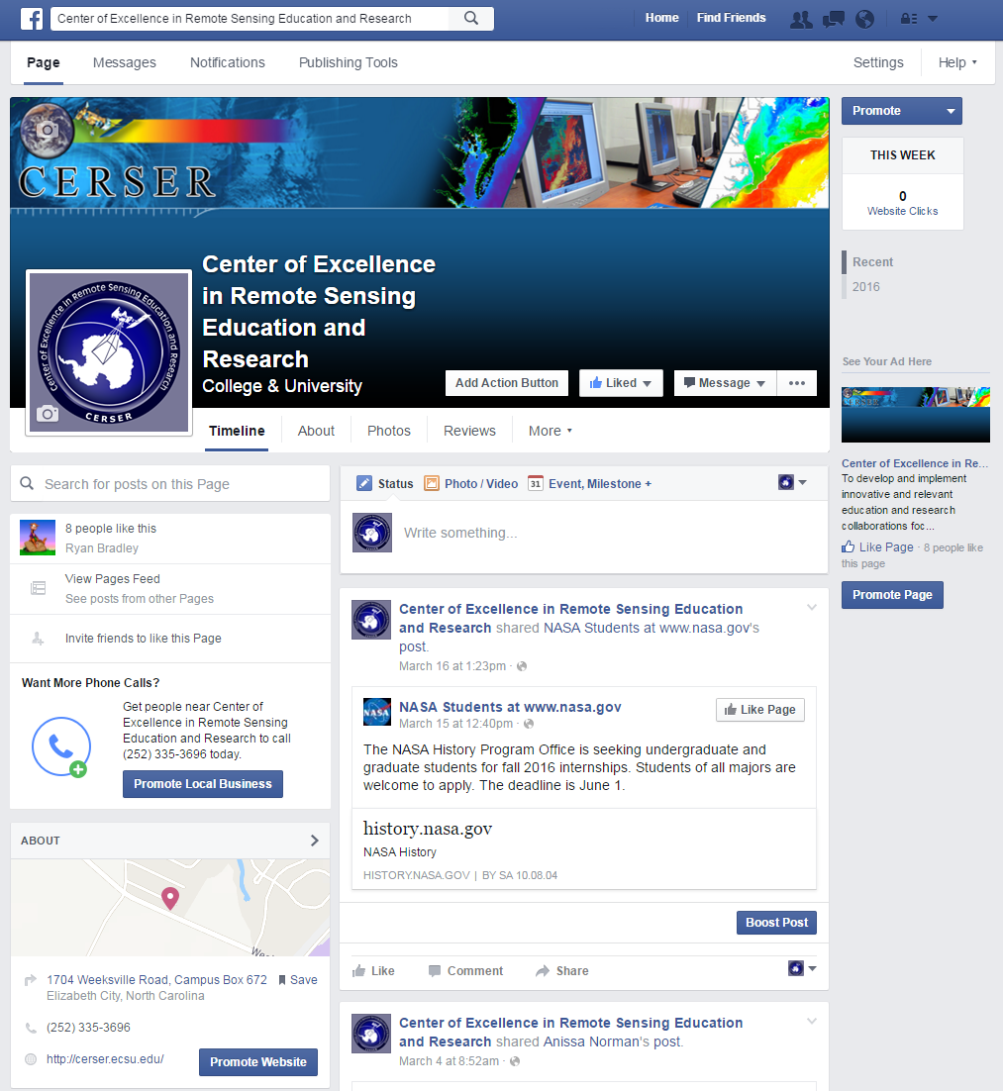
- CERSER Facebook page

Creating the a Facebook Page
Facebook users also have the ability to create their own pages inside of Facebook. These are called “Pages”. Pages can be created for uses such as promotions, small businesses, and advertisements. The first step taken in creating the Facebook CERSER page was to log into the CERSER administrator’s Facebook account and go to the “Create Page” label on the left hand side of the page. The next task consisted of the user choosing the category of “Company, Organization, or Institution” and then the subcategory of Education. Next the administrator would type in the “Company Name”, and afterwards select the “Get Started” button. The administrator was directed to the next page which was titled “Set up Name”, this page consisted of three sections (“About”, “Profile Picture”, and “Preferred Page Audience”). In the “About” section the administrator gave a brief description of the page and had the option to add a unique web address so that is easier for other users to find the Page on Facebook. The web address for the CERSER Page is www.facebook.com/ecsucerser. In the next section, titled “Profile Picture” and the administrator had the option to upload a picture from the computer and import one from the administrator’s personal Facebook account. In the last section, titled “Preferred Page Audience”, the administrator would set an age limit, which is 13 - 65+. Next, the location was selected which is Elizabeth City, NC. The gender can be set to “men”, “women”, or “anybody”. The gender for the CERSER Page was set to anybody. Lastly, “interests” can be used to help people find the page also. The interests used for the CERSER page were “Computer Science” and “Education”. The result is shown in Figure 1.

Privacy Settings
When it comes to having a Facebook page, there are many settings that the user may need to take into consideration. Privacy settings are the most important. These can be changed to where only certain individuals can see posts. People can request users to ask for permission before tagging themselves in a post. [9]

Twitter
The first step in creating the CERSER Twitter account was to utilize the web master’s email address to create the account. The next step was to go to the Twitter website and select “sign up” at the top right of the page. Information was then entered: name, phone or email, and a password. Once all of that was entered a username was chosen for the account. The last step was to confirm the account by checking the CERSER administrator’s email and selecting the confirmation link sent by Twitter.
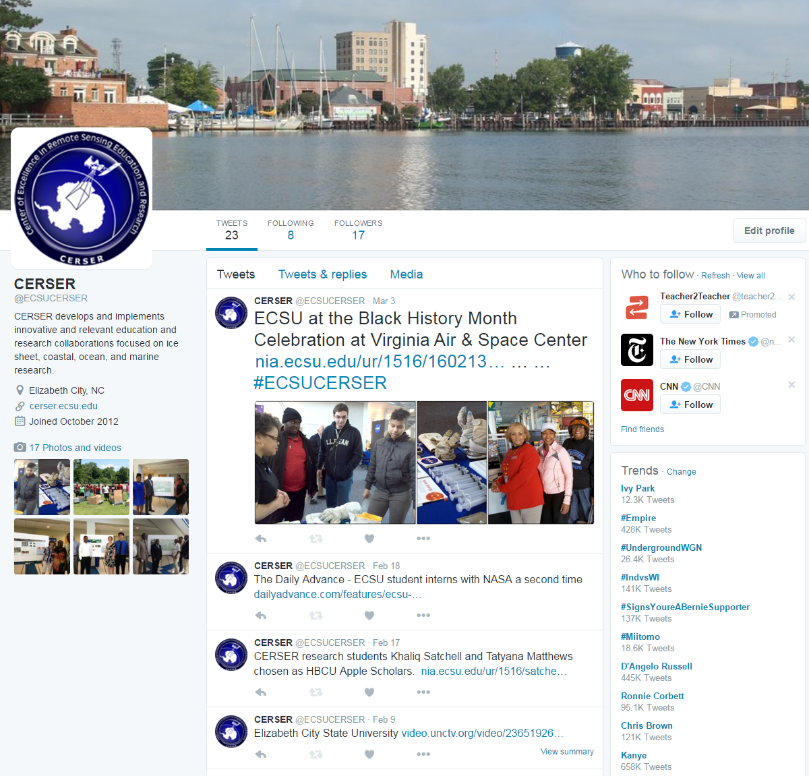
- CERSER Twitter interface
Once the administrator completed the account setup the homepage was then displayed. The administrator can now enter tweets at the top of the screen in the box labeled “What’s happening?” A tweet is information that the administrator is conveying and may take the form of text, images, and/or videos. Once the administrator finishes putting in the information, they select “Tweet” and Twitter will post the information to the timeline. The location of the administrator can be attached to the tweet.
To change the privacy settings, the CERSER administrator should select the profile picture at the top right and select settings from the drop down menu. This page provides the administrator with information and options regarding security, privacy, password, blocked accounts, and muted accounts.
The CERSER administrator can change the password. Mute is a feature that allows the administrator to remove an account’s Tweets from the CERSER timeline without unfollowing or blocking that account. Block is another function that disables a user from following CERSER on Twitter. To mute or block an account the administrator will go to the user’s homepage and select the three dots under the tweet that was placed on the CERSER timeline. A list of options containing block and mute will be displayed. Select the desired function to block or mute the user from the CERSER timeline. The final interface is shown in Figure 2.

Instagram
The process of creating an Instagram account was completed through a mobile device. The first step to creating the account for CERSER was to download the app through the Apple App Store or the Google Play Store. The CERSER web master’s email was used in the account registration.
Instagram prompted the registrant to create a username then set up a password for the account. Instagram requested the user to input their full name. A privacy sitting can be set if it is not desirable for the name to be displayed.
The CERSER logo was then added to the account. Once the process was complete, Instagram provided the chance to follow other accounts.
The CERSER admin can now post images and three to sixty second videos, and be able comment and use hashtags and tagging in posts. [8] The final interface is shown in Figure 3.
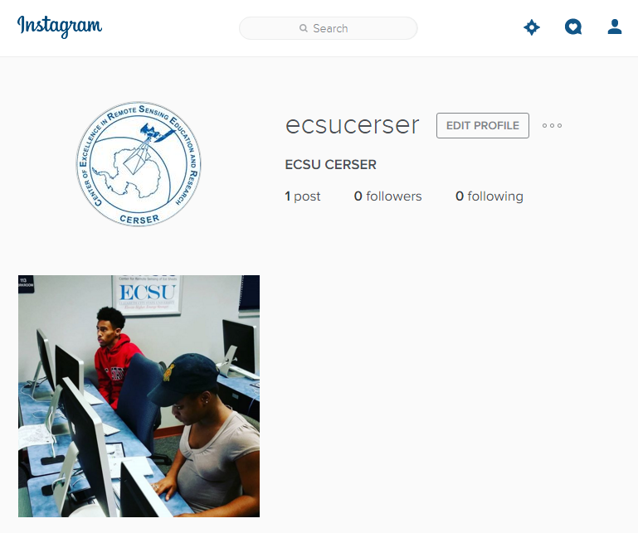
- CERSER Twitter interface

Google+
In order to create the CERSER Google+ page, a Google account was created using the webmaster's email. Once the Google account is established, the administrator's name is then entered followed by the gender. Profile, logo, and cover images are then uploaded to the account. Much of the information needed is connected to the users Google account so entering of information is minimal.
A CERSER Community was established in order to link program alumni with the current page. This will be a two information link allowing the alumni to view what is going on inside CERSER today and gives the program a method of following graduates through their continued instruction and careers. The interface is shown in Figure 4.
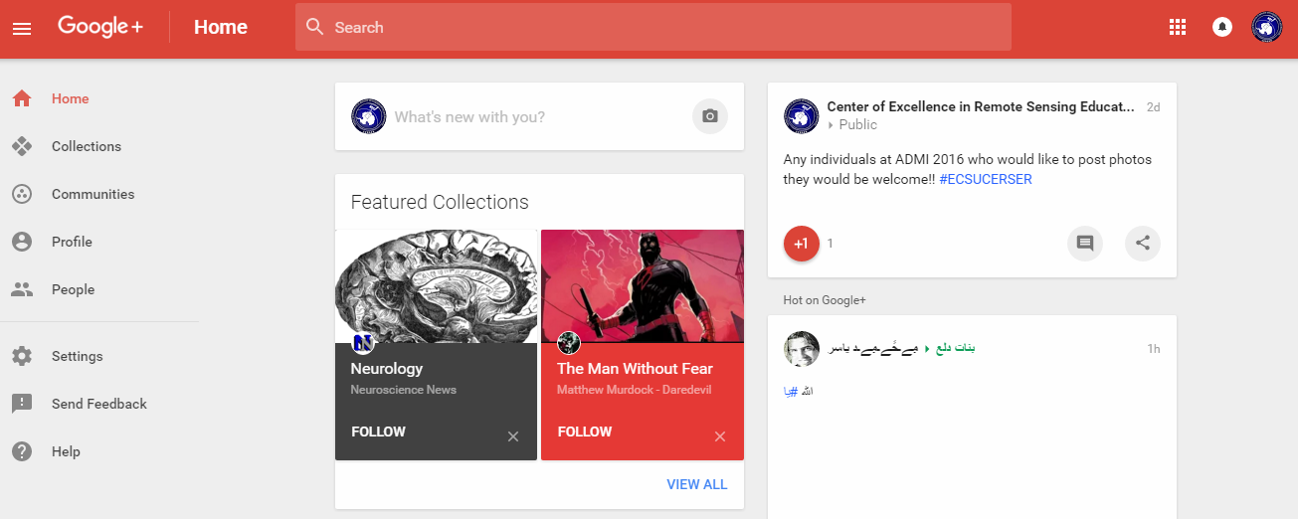
- CERSER Google+ interface

Hashtags
Hashtags should be used strategically to promote CERSER by including relevant hashtags to every post to social media. With every post created, CERSER should have a maximum of three hashtags and a minimum of one. On Twitter, certain hashtags can be created for the event attendees to use such as #ECSURW16 for the 2016 ECSU Research Week. CERSER can view the tweets, or posts, made by both event organizers and attendees using the hashtag. This can be utilized to see photos, gather feedback, and promote certain events. [6] [7]

Results
This project entailed many decisions that would not affect a basic user of these social medias. The fact that a Facebook account is required to be an individual and cannot be a group or organization led the researchers to use Facebook Pages. Facebook Pages are used by many major universities such as Boston College, UC Berkley, and Michigan State University. [http://blog.hubspot.com/marketing/best-college-facebook-pages]
Twitter and Instagram were easily set up and required minimal input to get to a working state. A valid email and posting of logos and cover photos allowed the sites to come online quickly.
Google Plus held a variety of options, but each was dependent on obtaining a basic Google account first. One of the options was utilizing the Google Pages to add CERSER to searches and maps as well as supplying the interactivity of a standard Google Plus account. This option was utilized as a starting point for future research into this social media.

Conclusion
Entering the social media arena is a daunting task when taking on several sites at once. This did allow the team to compare capabilities between each and possible interaction between them. While Facebook has been the most used in the past, Instagram and Twitter are quickly gaining ground in usage. Facebook still remains the most used and most versatile of the four social medias researched with its access to many applications for extending the capability of the page.
These three medias hold an advantage over Google+ in their interactive use and their simplicity. Google+ also lacks the number of users that many social media sites currently have making its future unknown.
This project forms the basis for further research into the usage and interactivity of the four social media platforms implemented. Focused research on the individual usage of each media should be completed for greater skill in utilizing the sites to full potential. Social media is a fluid dynamic with constantly changing faces making it an ever-moving target.

Future Works
This project should continue to develop and be monitored for future CERSER and ECSU events. Once the CERSER Facebook Page reaches 30 likes, the Facebook analytic tool Insights will be available to monitor usage [3] Twitter and Instagram will need external analytic software that is available on the Internet to monitor their usage. Google+ uses Google Analytics to further examine others who use the social media sites. With Google analytical data, the developers could gather information about the viewer's age, gender, and more to determine if the social media content is being promoted correctly. [2]
The social media sites established during this project should also be included in events such as the Celebration of Women in Mathematics, IGARSS, and Summer REU. In these events attendees will be able to post photos, videos, and relevant text to provide followers with instant feedback on their research and experiences. Through this interaction, future projects should be able to gather information about the successfulness of the events, which events are most posted about, how to further improve events, and better ways to integrate social media into future events. The project should also be able to obtain content from current students when they attend conferences and other program related activities.
Currently the social media applications Facebook, Instagram, and Twitter have the capability to be linked. This ability allows a user or administrator to post to one site and the information be displayed on the other two. Future research should focus on linking these accounts in a way that does not intrude into the privacy of the site administrators. [4] [5]

Acknowledgment
We would like to acknowledge the assistance of Dr. Linda Hayden who has provided the funding and the opportunity for this projects completion.

References
- "What is Facebook? - Definition from WhatIs.com", WhatIs.com, 2016. [Online]. Available: http://whatis.techtarget.com/definition/Facebook. [Accessed: 05- Apr- 2016].
- "Getting the Most out of Google+ with Google Analytics", Social Fresh, 2016. [Online]. Available: https://www.socialfresh.com/google-plus-google-analytics/. [Accessed: 05- Apr- 2016].
- "What You Need to Know About Facebooks New Insights and Analytics", 2016. [Online]. Available: https://blog.kissmetrics.com/facebook-insights-and-analytics/. [Accessed: 05- Apr- 2016].
- "Using Twitter with Facebook", Twitter Help Center, 2016. [Online]. Available: https://support.twitter.com/articles/31113. [Accessed: 05- Apr- 2016].
- "How do I link my Instagram account to my Facebook profile? | Instagram Help Center", Help.instagram.com, 2016. [Online]. Available: https://help.instagram.com/176235449218188. [Accessed: 05- Apr- 2016].
- T. Elgar, "A list of top professional services marketing hashtags (via Passle)", Passle, 2015. [Online]. Available: http://blog.passle.net/post/102ct8a/a-list-of-top-professional-services-marketing-hashtags. [Accessed: 05- Apr- 2016].
- "#Hashtags: Why Theyâ€™re More Useful to Marketers Than Ever | Simply Measured", Simply Measured, 2014. [Online]. Available: http://simplymeasured.com/blog/hashtags-why-theyre-more-useful-to-marketers-than-ever/#sm.00014ax6b0j6le9c102sl6rajv6vj. [Accessed: 05- Apr- 2016].
- "Creating an Account & Username | Instagram Help Center", Help.instagram.com, 2016. [Online]. Available: https://help.instagram.com/182492381886913/. [Accessed: 05- Apr- 2016].
- H. Facebook, "How to Use Facebook", wikiHow, 2016. [Online]. Available: http://www.wikihow.com/Use-Facebook. [Accessed: 05- Apr- 2016].
- "How do I sign up for Facebook? | Facebook Help Center | Facebook", Facebook.com, 2016. [Online]. Available: https://www.facebook.com/help/188157731232424. [Accessed: 05- Apr- 2016].
- "Definition of HASHTAG", Merriam-webster.com, 2016. [Online]. Available: http://www.merriam-webster.com/dictionary/hashtag. [Accessed: 05- Apr- 2016].
- "How Google Plus Works", HowStuffWorks, 2011. [Online]. Available: http://computer.howstuffworks.com/internet/social-networking/networks/google-plus3.htm. [Accessed: 05- Apr- 2016].
- "Google+ creator Vic Gundotra leaves social network in a lurch - What's next?", Tech Times, 2014. [Online]. Available: http://www.techtimes.com/articles/6066/20140426/google-creator-vic-gundotra-social-network.htm. [Accessed: 05- Apr- 2016].
- E. Rusli, "Facebook Buys Instagram for $1 Billion", DealBook, 2016. [Online]. Available: http://dealbook.nytimes.com/2012/04/09/facebook-buys-instagram-for-1-billion/?_r=0. [Accessed: 05- Apr- 2016].
- N. Carlson, "The Real History Of Twitter", Business Insider, 2016. [Online]. Available: http://www.businessinsider.com/how-twitter-was-founded-2011-4. [Accessed: 05- Apr- 2016].
- Profilerehab.com, 2016. [Online]. Available: http://profilerehab.com/twitter-help/history_of_twitter. [Accessed: 05- Apr- 2016].
- "A Guide to Twitter", Hatchforgood.org, 2016. [Online]. Available: https://www.hatchforgood.org/explore/5/a-guide-to-twitter. [Accessed: 05- Apr- 2016].
- "Twitter - Social Media - LibGuides at Health Sciences Library, University of Colorado Anschutz Medical Campus", Hslibraryguides.ucdenver.edu, 2016. [Online]. Available: http://hslibraryguides.ucdenver.edu/c.php?g=259576&p=1732314. [Accessed: 05- Apr- 2016].
- A. Kaplan and M. Haenlein, "Users of the world, unite! The challenges and opportunities of Social Media", Business Horizons, vol. 53, no. 1, pp. 59-68, 2010.
- S. Phillips, "A brief history of Facebook", the Guardian, 2007. [Online]. Available: http://www.theguardian.com/technology/2007/jul/25/media.newmedia. [Accessed: 05- Apr- 2016].
.

