Facts and Fictions about Standardized Testing

Dr. Linda B. Hayden
Principal Investigator
Elizabeth City State University
1704 Weeksville Road, CB 672
Elizabeth City, NC
haydenl@mindspring.com
Dr. Cheryl J. Lewis
Mentor
Elizabeth City State University
1704 Weeksville Road, CB 672
Elizabeth City, NC
Cjlewis1@mindspring.com

Cameron Bernado
Elizabeth City State University
Cibernado028@students.ecsu.edu
Jessica Hathaway
Elizabeth City State University
Hathawayjessica18@gmail.com

Joselyn Hathaway
Elizabeth City State University
Jhathaway548@students.ecsu.edu

Abstract— Criticism of standardized tests is nothing new [1]. Banesh Hoffman, professor of mathematics and former collaborator with Albert Einstein, made exactly this point in his 2003 book “The Tyranny of Testing”. Some standardize test have been found to be culturally bias, and have not necessarily been an accurate predictor of student success in undergraduate or graduate school.
Due to these concerns, testing companies, colleges/universities, and test-takers are seeking ways to level the playing field. As a result, several questions have been raised: 1) Is standardized testing really necessary and can these tests truly predict ones success in their academic career and/or profession? 2) What are the characteristics of people who do well or poorly on these tests? 3) Is there a magical formula to passing a standardized test? 4) Has research proved that certain test-taking strategies are more effective than others? 5) Are there campus/institution practices/interventions that can be used to successfully address problem areas and/or to close achievement gaps?
This group of researchers examined various test-taking techniques and tips, as a means to identify, select, and/or reject “common” test-prep endorsements that will aid to
the enhancement of one’s success rate on test day. There has been a number of studies conducted that have been very effective in improving the test scores of individuals who are taking standardized testing (such as the SAT, ACT, PRAXIS, GMAT, and GRE).
Index Terms— Achievement Gaps, ETS, Standardized Testing, Test-Taking Strategies.

Introduction
In the spring of 2016, the URE mathematics research team from the Center of Excellence in Remote Sensing Education and Research program at Elizabeth City State University, initially began its study by familiarizing themselves with the content area of various standardized test (such as the ACT, SAT, GMAT, GRE, and PRAXIS exams), followed by probing for what colleges/universities, local education agencies (LEAs), State Department of Instructions, other governmental agencies and employers may consider to be a passing/recommended test score for each of these exams. Still further, these researchers reviewed an array of sources to determine both pros and cons about standardized testing. Finally, this group searched for effective test-taking techniques and strategies to assist test takers in enhancing their standardized test scores.

Objectives
The purpose of this study is three-fold: 1) to define what is standardized testing and to identify facts & myths about standardized testing, 2) to describe some of the factors that have been noted as factors that can influence standardized testing performance, and 3) to identify tips/strategies (if any) that can improve students’ performance on standardized test?

Research Questions
The following research questions guided this study:
    - What is standardized testing?
    - Is standardized testing really necessary and can these tests truly predict ones success in their academic career and/or profession?
    - What are the characteristics of people who do well or poorly on these tests?
    - Is there a magical formula to passing a standardized test?
    - Has research proved that certain test- taking strategies are more effective than others?
    - Are there campus/institution practices interventions that can be used to successfully address problem areas and/or to close achievement gaps?

- What is Standardized Testing?
According to US Legal.com, standardized testing is a test administered and scored in a consistent or standard manner. A well designed standardized test provides an assessment of an individual's mastery of a domain of knowledge or skill; it implies the following [2]:
- provides a systematic procedure for describing behaviors;
- provides specific procedures for administration and scoring;
- substance for test is arrived at from experiment or observation;
- questions have an established format and set of materials;
- same response modes are expected from all candidates;
- provides tables of norms and scores of test takers so that comparisons can be made.

- The Necessity of Standardized Tests
It is a fact that standardized testing is a lucid business. Every year, Americans spend millions on the tests they are requested to write in order to be evaluated for admissions into undergraduate, graduate, or professional programs, and many millions are spent on coaching schools in an attempt to raise scores [3].
Even though all colleges/universities don’t require test scores, it still remains as an easy way to weed out applicants. Furthermore, since colleges/universities do not pay for the results of these test, it is more cost effective to continue to use them. As a result, they have little incentive to examine test validity.
Standardized tests are not necessary to measure a student’s success and knowledge. Using the results from a students test can be invalid. A reason why standardized tests don't accurately measure the student’s success is because the test maker is assuming that every student knows the same material and thinks the same way. Depending on who is grading the test, the grader may look at the answer from their own point of view, but fail to realize that each student may approach the question differently. Also, the test taker could know all of the material but may have test anxiety. Some students take tests well with all of the information in front of them, while other students may not be able to comprehend that information at one time. Using the standardized tests to measure student’s success discriminates against those students who may know the material but are not good test takers.

- Characteristics of Test-takers
The influence of socioeconomic factors on standardized test scores has long been debated and studied [4]. Time and time again, research has cited disparities in test performance based on factors such as ethnic background, household income, parental marital status, educational attainment levels and school resources (quality teachers/
teaching, state-of-the-art technology and equipment).
The characteristics of those who do well on standardized tests often include those in the upper class and white (European-American) students [5]. This is due to the abundance of resources and the motivation to learn. These students were able to do well because of their environment and those who had an influence on them. The characteristics of those who didn't do well on the standardized tests included students that were in the lower class and/or single family homes, and/or black (African-American) students [6]. These students may not have had the funds or resources to get the materials they need to further their learning. It is a fact that some individuals are influence by those surrounding them (home, community and/or school). It can have an effect on whether or not they have the motivation to learn. Poorer students tend to come from poor public school districts tend to have “watered down” curriculums, less than stellar teachers/ teaching, and in many instances lack adequate books and supplies. Consequently, when it comes to taking standardized test they are underprepared.

- Magical Formula(s)
The question has been raised, are there secret ingredients used for passing standardized tests? No. However, there are other ways that can assist test-takers while they are taking their test. There are tips and strategies that students can use to help the student approach the questions in a more productive manner. The best way to pass standardized tests is to practice.
Many times, students are able to go online and find free versions of their standardized test. This is one of the most effective ways to expose the student to what kinds of questions the test may ask and how the test is structured.
The article, 8 Tips to Help You Pass a Standardized Test, is basically an article that does exactly what the title states. There is no magic formula to doing well on standardized tests [7]. Everyone has their own strategies when it comes to preparing for tests, but this article gives the reader a head start just in case they have no idea where to start. The first tip is to start studying early. Good study habits over a period of time are better than cramming a lot of material in the night before. Read often to build your vocabulary and to also build an understanding of current events. You should also get a good night’s sleep the night before the test so that you are well rested. Mixing up your study habits are also a great idea when studying for standardized tests. Mixing up the materials will help you retain the information much better. Also, try to understand the test from the perspective of the test writer.
Understanding how the test is scored will come in handy when figuring out the questions you possibly missed. You should know if you will be penalized for the questions answered and missed, or if you are only scored for the questions you answered correctly. Get a full night’s sleep on the night before the test and keep activities at a minimum on the night before. You should wear comfortable clothing during the test. You should also set yourself up for success on the day of the test. Have a good breakfast and think positively on the way to the testing site. Review your answers on the test to make sure you answered the question exactly how you want it to be answered. Bring two sharpened; soft lead number two pencils to the testing site just in case the site does not have any. Last but not least, do not panic! If you feel nervous about a question, skip it and go back to the question later. Relax, take a deep breath, and answer one question at a time. Be sure to answer the easier questions first to make sure you have as many correct answers as possible. If you have time left over, go back and try your best to answer the more complicated questions.

- Effective Test-taking Strategies
Research has proved that a combination of test taking strategies can affect the test results in an equal way. Many of the strategies were combined to make steps towards effectively answering the questions. However, the strategy that was stressed the most was practice. The motto “practice makes perfect” was shown in the research. The reason why this is the most effective strategy is because it gives the student exposure to the actual test.

- Fight/Flight Responses
Apparently, there is no such thing as a naturally bad test-taker. However, researchers have proven that if a student has negative thoughts about taking the test it is more than likely that they will not do well, this response is called the fight or flight mechanism. Dr. Jack Schafer says the signals that are released in the brain are taken as a threat, which triggers the fight/flight response. One function of the fight/flight response is to prevent logical thinking of incoming information. The fight/flight response is the natural reaction the body has when it is frightened or put in an uncomfortable position. Test anxiety is another form of fight/flight response; some students make themselves believe that they are bad test takers [8]. Although a student may know all of the material for a test, the fear of the test itself can cause a student to forget all of the information on test day. To avoid the fight/flight mechanism during tests, you should meditate. Also, remind yourself that you know the material and make yourself believe that you are not afraid, nor nervous.

- Tips on Essay Writing
Thinking that you can make up anything on the essays and answer the questions without reading the passage is a common myth about test taking. Most students believe that highlighting, note-taking and re-reading passages will help during test taking, but it is best to just summarize the passage at the end. Summarization forces the student to engage their critical thinking skills to determine the main focus of the passage.

03. Tips on Answering Standardized Testing Questions
In Justin Kruger’s article titled, “Counterfactual Thinking and the First Instinct Fallacy”, he states that changing multiple choice answers helped students overall nearly three times as often [9]. If a student goes back to a question and asks why the correct answer is correct, the student is much more likely to uncover a flaw in his original thinking. Students should refrain from changing answers.

- Institutional Practices/Interventions
In order to take different standardized, there is a need for test preparation. Bowie State University (BSU) has multiple ways to prepare their students for the PRAXIS exam. For example, there is a PRAXIS Lab that increases student awareness of technological issues involving teaching; it has been a highly valuable resource tool. There is also a web-based interactive assessment and preparation tool for the PRAXIS I exam called PLATO. Last, but not least, Education course 220 is a 3 credit class offered to education majors getting ready for the PRAXIS exam. Peer tutors and also Educational Testing Service study guides are available in the library at BSU.
At Delaware State University, they offer programs and courses to prepare their students for tests, certifications, and degrees. One of the scholarship programs offered to students who are seeking to be in the education field id the Scholar Teacher Education Program (STEP) Scholarship Program. This scholarship program covers the student’s tuition and fees, which includes their books, room, board, etc. For this program, students are not required to take the Praxis. Also, of the courses offered to assist students is Individualized Instructional Preparation in Education (EDUC-000). This course helps students enhance their reading, writing, mathematics, speech, and test taking skills. This course is worth two credit hours and is similar to a General Education (GE) course because it does not fulfill the degree requirements. The students enrolled in this course must go through the Teacher Education Screening Process.
Elizabeth City State University offers courses during the fall and spring semester that assist students who are interested in taking the PRAXIS exam. Students enrolled in the English course will have the opportunity to participate in reading activities that help students understand the content of reading selections and identify important details of the passages given. The instructor of the course also reviews general education requirements for prospective teaching majors and analyze each exam area. Mathematics courses are also offered to students preparing for the PRAXIS exam; the class demonstrates techniques on how to solve the types of test questions on the exam, as well as provide test-taking strategies. Learning Express and NorthStar Learning are math resources utilized during the course to strengthen the students' mathematical skills and knowledge development.
The Online Writing Lab (OWL) at ECSU is also available for all students. English majors and professors dedicate their free time to service individuals who may need tutoring, or help with an essay. Style writing techniques are critiqued and perfected in OWL; it is very beneficial when preparing for any standardized exam. Senior seminars and SAT workshops are available to students of ECSU year around. Vouchers are given to students that are not capable of paying for it themselves. The Model Scholars Program was created to help students who scored low on the SAT's get into ECSU by taking classes over the summer for class credits.
Norfolk State University has websites, YouTube videos, seminars and courses to help their students to pass any standardize testing. One of their major tips is time management. In order to pass the test you have to set up a schedule for yourself to allow amiable time to study and prepare for the test. The next was having effective study strategies. It is one thing to have the material but it’s important to be familiar with new information by reviewing each day. Don’t cram the day before study all along. Also read, not just magazines, but new articles and scholarly books. This will help with the reading selections of the test. There is also a tutoring schedule that list times and days of the week along with what classes are tutoring at that time. NSU also offers a test preparation guide that is designed to assist students in developing the competencies needed to reason. This guide also offers information and where and how to find sample testing items.

Methodology
In addition to conducting a fairly extensive literature review, this research team analyzed four HBCU Peer Institutions to see if these (Standardized Testing) facts and fictions were applicable to the aforementioned HBCUs student population. This data consists of the following variables: (1) Total Student Enrollment, (2) the Number and/or Percentage of Pell Recipients, (3) the Average Combined SAT Scores for Incoming Freshmen, (4) the Average GPA of Incoming Freshmen, (5) the Total # of Incoming First Time, Full-time Freshmen, and (6) 1st Year Retention Rates- First Time.
Data on each of the four HBCU institutions from 2010 -2014 was secured from the National Center for Education Statistics’ Integrated Postsecondary Education Data System (IPED. It was recorded in an EXCEL spreadsheet. From this spreadsheet, three tables was created depicting the percentages of Pell grant recipients, average SAT scores, and 1st year retention rates. Table I was created to illustrate the percentage of students who received PELL grants from 2010-2013. Table II demonstrated their average combined SAT scores and Table III revealed the 1st year retention rates of these institutions.

Results

Table I. Percentage of Pell Grant Recipients
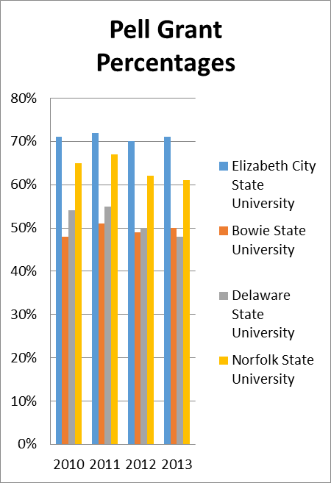

Source: NCES Integrated Postsecondary Education Data System (IPED), 2016

Table II. Average SAT Combined Scores
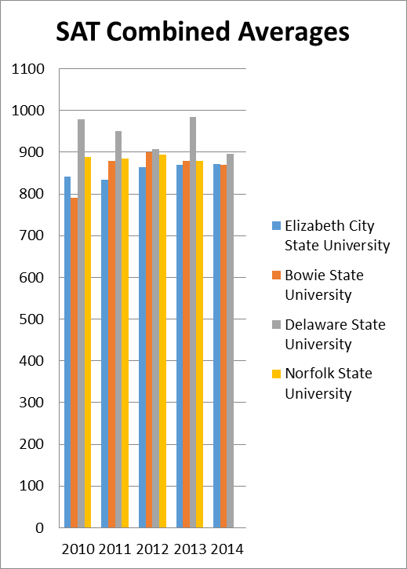

Source: NCES Integrated Postsecondary Education Data System (IPED), 2016

Table IV. Chi-Squared Retention Rates
Retention Rate Statistics
Statistic | DF | Value | Prob
Chi-Square | 12 | 2.2006 | 0.999

Table V. Chi-Square SAT Scores
SAT Scores
Statistic | DF | Value | Prob
Chi-Square | 9 | 11.6252 | 0.2353

Table III 1st Year Retention Rates
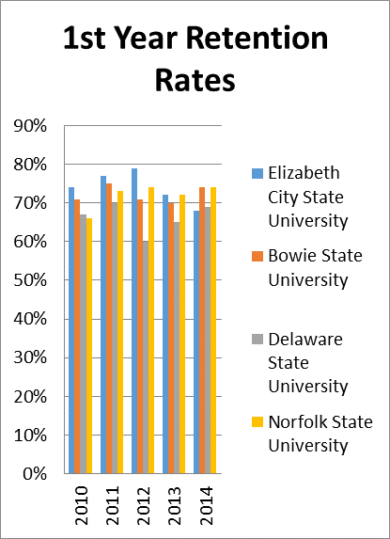

Source: NCES Integrated Postsecondary Education Data System (IPED), 2016.

Conclusion
Table I displays the percentage of Pell Grant recipients for the four HBCU’s researched over a four-year period. ECSU has a 72% average for Pell Grant recipients; BSU’s Pell Grant recipient average was 49.5%. While DSU’s Pell Grant recipient’s average is 52%, NSU’s average is 64%. It was observed that ECSU’s percentage was the highest of the four HBCU’s and BSU’s percentage was the lowest.
Table II shows the results of SAT scores for the researched HBCU’s over a four-year period. ECSU’s average SAT score was 852 out of 2400 while BSU’s average was 862. DSU’s average was 955 and NSU’s average was 886.
Table III displays the results of first year retention rates from the four HBCU’s researched. ECSU has the highest retention rate, which was 76%. BSU and NSU have a common average of 71% and DSU has the lowest average of 65%.

Chi-Squared tests were done on the retention rates and SAT scores to show the significance of the two regarding the four HBCU’s located on Table 4. Chi squared tests are used to show the goodness of fit between sets of values; the results of the data can range from 0 to 1. According to Ronald F. Patterson, a mathematician of Winston-Salem State University, all probability values above .05 imply that the universities involved in the study are not significantly different in any way. Chi-Squared results show that the probability of the HBCU’s retention rates is .99, which means there is absolutely nothing significant about the four institution’s retention rates. However, the probability for their SAT scores is .23. The SAT’s probability is lower than the retention rates which could possibly mean that there is significance between the four institutions regarding SAT scores, but because of the fact that it is above .05, the institutions are not different in any way.

Future Work
For future works, this team would like to investigate predominately white institutions with the same standards that have been set for this particular research project. Also, it would useful to examine exemplary programs that have been proven to enhance standardized testing scores beginning with K-12 through graduate and professional school. Investigating the success rates (test scores, promotion rates, retention rates, graduation rates) of students enrolled in these exemplary programs and determining whether there is any significant difference in the success rates of participants based on their gender, race, and socio-economic status would also be interesting to include in future works.

Acknowledgment
We certainly would like to acknowledge Dr. Linda B. Hayden who has provided the funding for this research project. In addition, the team wishes to recognize Dr. Cheryl J. Lewis for her guidance, input, and support throughout the duration of this project. Still further, Mr. Brian Jordan, Program Specialist, Office of Institutional Effectiveness, Research, and Assessment for his assistance in our statistical data analysis. Dr. Sheila H. Williams, Director of Teacher Education & School Partnership for her candidness regarding the pros & pitfalls of Test-takers of the PRAXIS exam at Elizabeth City State University and other HBCUs.

References
- B. Hoffmann, The Tyranny of Testing. Mineola, N.Y.: Dover Publications, 2003J. Clerk Maxwell, A Treatise on Electricity and Magnetism, 3rd ed., vol. 2. Oxford: Clarendon, 1892, pp.68–73.
- Standardized Test Education Law & Legal Definition, definitions.uslegal.com/s/.standardized-test-education/, March 15, 2016
- C. Carter, Case Against Standardized Tests (1999), Testshttp://testcritic.homestead.com./standardizedtesting/.
- [4 -6] L. Sheu, S. Dada, Impact of Household Income on Standardized Test Scores, Georgia Institute of Technology, smartech.gatech.edu, http://hdt.handle.net/1853/54227, p. 1-19, November 2015. [Accessed February 23, 2016].
- [7] "8 Tips to Help You Pass a Standardized Test",GetCollegeCredit, 2014.
- [8] B. Lewolt, "Brain Research on Test Taking Strategies: There is no such thing as a naturally bad test taker–True!”, Brainx.com, http://www.brainx.com/resources /blog/bid/51477/Brain-Research-on-Test-Taking-Strategies-There-is-no-such-thing-as-a-naturally-bad-test-taker-True. [Accessed: 29- Mar-2016].
- [9] Kruger and D. Wirtz, "Counterfactual Thinking and the First Instinct Fallacy", Journal of Personality and Social Psychology,pp.1-40,2016.

