Ground Penetrating Radar Survey of Edenton Green for Early Structural Remains

Shanecia Beckworth
Dept. of Mathematics, Computer & Information Sciences
Mississippi Valley State University
Itta Bena, MS
shanecia12.beckworth@gmail.com
Dominique Marshall
Dept. of Physics, Atmospheric Science & Geo Science
Jackson State University
Jackson, MS
dominique.j.marshall@gmail.com
Ryan Lawrence
Natural Resources and Earth Systems Science Ph.D. Student
University of New Hampshire
Durham, NH
ryan.d.lawrence@gmail.com
Dr. Malcolm LeCompte Ph.D.
Elizabeth City State University
Elizabeth City, NC
malcolm.lecompte@cerser.ecsu.edu

Introduction
Edenton, North Carolina was established in 1712 as the Towne on Queen Anne's Creek. It was later known as Ye Towne on Mattercommack Creek and, yet later as the Port of Roanoke. It was renamed Edenton and incorporated in 1722 in honor of Governor Charles Eden who had died that year.
Edenton played a key role in the development of the colonies, the state of North Carolina, and the United States of America. From this era, a total of 7 original buildings still remain in standing from the colonial period including: St. Paul’s Church, Iredell House home site, Bennett’s Tavern, Charleton House, James Coffield House, Cupola House, and the 1767 Colonial Courthouse (figure 1). Edenton was once one of the nation's chief political, cultural, and commercial centers.
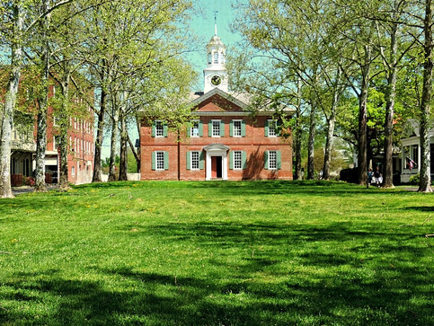
- Present day structure of the 1767 Colonial Courthouse and the Edenton Green that is located directly across.
In early May 2014, a local gas utility company began an unauthorized excavation of the historic Edenton Green with intentions of laying a gas line. Judge Thomas Newbern fortuitously happened upon this activity on his way to the courthouse and inquired about their legal authorization for the excavation. He also noticed their digging had exposed a thin layer of red bricks approximately 12 inches below the surface. These bricks appeared to be of very early colonial manufacture. The workers were immediately ordered to cease all excavation. Local historians and archaeologists were contacted and informed of the discovery of the bricks buried on the town green in front of Edenton’s historic 1767 courthouse.
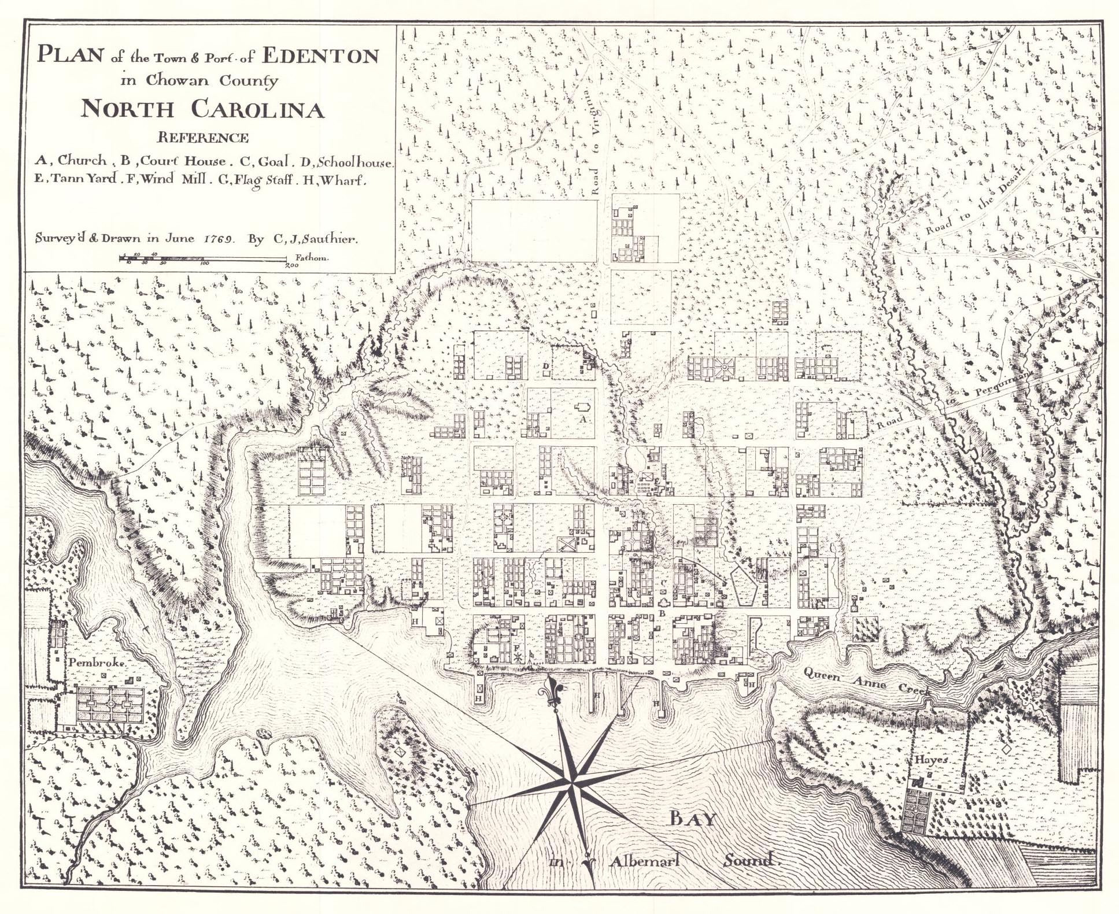
- C.J. Sautier’s hand-drawn map of colonial Edenton, circa 1769
Local town lore and colonial documents asserted the existence of an original structure located on the green that predated the courthouse and was replaced in function by the later building. An early, circa-1767 colonial map showed a small structure on the upper green near the present courthouse. Dr. Malcolm LeCompte was subsequently contacted for his assistance based upon his participation in previous work applying Ground Penetrating Radar (GPR) to other local archaeological projects.
This objective of this study was to perform a GPR survey of the Edenton’s upper courthouse green and determine the shape, extent, and depth of any structures that might be buried there.

Methodology
The Edenton Green, Edenton, NC (36° 03’ 26” N, 076° 36’ 29” W) is a ~ 24 x 109m rectangular shaped area. The site is predominately covered with grass and has trees outlining the area.
This project included two major phases consisting of work performed in the computer laboratory and work performed collecting data in the field. Two types of software applications were used for the processing three kinds of data including colonial maps, USGS digital aerial photographs and Ground Penetrating Radar survey data.
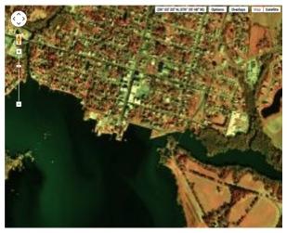
- A 1998 Digital Ortho-Quarter Quad (DOQQ) Aerial Image of Edenton. This Image was digitally compiled with the colonial map for the georegistration process.
Maps and aerial photographs were geographically co-registered using EnviClassic 4.7, while the digital data collected by the GPR was processed for analysis and display using GSSI’s RADAN 6.6. The web-based utilities of Google Earth, and Earth Explorer also proved useful. For execution of fieldwork the GPR was the primary technical tool used, along with a Garmin 60xs GPS, and a standard magnetic compass. Lengths of cord and flagged pins were used to set up the Courthouse green survey grid.

Software Preparation
A 1767 map of Edenton was provided by Edenton’s historic site manager, Karen Ipock (figure 2). The map was georegistered to an aerial 1998 Digital Ortho-Quarter Quad image of Edenton obtained from United States Geological Survey’s Earth Explorer website (earthexplorer.usgs.gov) (figure 3).
An image-to-image georegistration was performed using EnviClassic 4.7, where geographic coordinates were assigned to known structures appearing on the old colonial map including the 1767 Courthouse, Cupola House, and the intersection of what is now E King St and Broad St. The images linked images and allowed a before and after effect to provide GPS coordinates of the buildings used for reference. This process developed approximately correct geo-coordinates for the green and the small structure useful for defining the extent of the GPR survey area. A grid to define the survey area and transect-paths was laid out as described below.

GPR Survey and Data Collection
A 16 x 21m grid with 1m increments running south to north within the selected area of the Edenton Green was established using a compass, cordage, flags, measuring tape, and GPS. A baseline was established first to work from at 36° 03’ 27” N, B. GPR Survey and Data Collection
A 16 x 21m grid with 1m increments running south to north within the selected area of the Edenton Green was established using a compass, cordage, flags, measuring tape, and GPS. A baseline was established first to work from at 36° 03’ 27” N, 76° 36’ 29” W to create the grid. Cordage and flags were used to create the base-point and transect paths. Once the outer edges of the grid were in place, the transect paths were established in 1m increments (running West to East) between lines laid (figure 4) south to north. Flags were located at the southern start and northern terminus of each transect to provide an aim-point and to insure a clearly defined data collection boundary and accurate data collection.
- A computerized depiction of how the grid was established by determining a West t0 East line and continuing with a base point from which all other coordinates were established to create the grid.
Using the Ground Penetrating Radar, data was collected using a parallel - unidirectional (south to north) pattern. Ground Penetrating Radar works by transmitting a tiny pulse of electro-magnetic energy into a material and recording the strength and the time required for the return of any reflected signal. A series of pulses over a single area make up what is called a scan. Reflections are produced whenever the energy pulse enters into a material with different electrical conduction properties or dielectric permittivity from the material it left. The strength, or amplitude, of the reflection is determined by the contrast in the dielectric constants and conductivities of the two materials. While some of the GPR energy pulse is reflected back to the antenna, energy also keeps traveling through the material until it either dissipates (attenuates) or the GPR control unit has closed its time window.
Once one transect was completed and the GPR data file stored, a new file was created for the next pass. There were 32 transects and corresponding data files collected at a half meter spacing between transect lines.
Data are collected in parallel transects and then placed together in their appropriate locations for computer processing in a specialized software program such as RADAN 6.6 developed by Geophysical Survey System, Inc. (GSSI). The computer then produces a horizontal surface at a particular depth in the record. This is referred to as a depth slice, which allows operators to interpret a plan view of the survey area.

C. Image Processing
The data and 3D imaging process of the 32 transect files was collected after the survey. After data collection, the individual files were uploaded to a windows laptop PC and processed using GSSI’s RADAN 6.6 software. GSSI’s RADAN 6.6 software allows the archaeology team to process the data in four important aspects, which are: zero correct, background removal, migration, and gain equalization.
The zero correct technique was used to remove the section of data that occurs before the direct wave. This process or technique insured that while doing the analysis of the data, only the data that was obtained from the ground being directed exposed to the waves was used. Then there is the background removal process which removes the signal to noise accuracy throughout the files where the noise is removed for consistency in data. After the background removal process, hyperbolic diffraction patterns were reduced or eliminated using the migration feature. Removal of the hyperbola tails represented the location more accurately and in some cases the size of the target. The gain is the amplification of the Radar signal. The equalization process will be applied to the data set to ensure the gain throughout each transect is consistent.
The color band was changed to better see what objects or features were in the ground. The team chose various color bands from the RADAN software based upon clarity and depiction to provide a more accurate analysis of the data. Some of the features were better seen in one and others in two. The images were viewed in 3D creating a colorful depiction of the materials located meters deep in the ground. The colors enhanced the ability to see shape, size, and depth of the structures in the area.
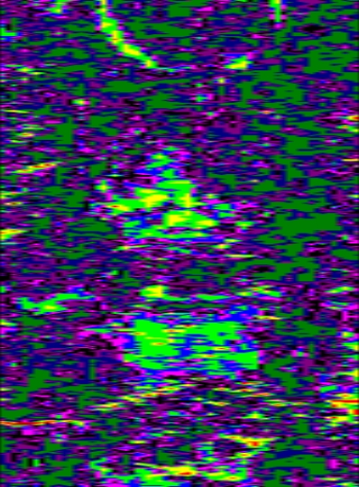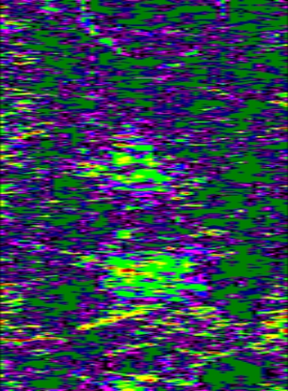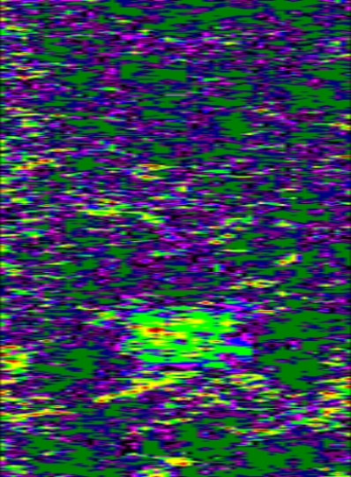
Depth: 0.32m
Depth: 0.54m
Depth: 0.60m
- Processed images of the compiled transect files, a 2-dimensional perspective of the results.

Results and Discussion
At the very top of the processed images (figure 5) there appeared a semi-circle that appeared at about 0.5 meters then disappeared. There was a large rectangular shape object that appeared close to the surface. It disappeared then appeared again as the depth of the 3D registration proceeded. At about 1.25 to 1.5 meters the object was still present, but its appearance was of a circle. At the bottom, there was an object to appear, and the team thinks it may be steps. There was an image for years before where there where two sets of steps on the green as it maneuvered down to the waterfront. There is no conformation whether the steps were removed or simply covered up. Then as the depth was at about 2 meters, there was a strong signal of an object that appeared as a line. The linear feature was still in appearance at 2.5 meters and very close to 3.

Conclusion
Now that the data has been received and analyzed it has been concluded that there is in fact something hidden beneath the grassy plain of the Edenton Green. This conclusion came from ECSU’s Research Experience for Undergraduates-Marine, Ocean, & Polar Science radar team as well as GSSI‘s Sara Gale and Dan Welch, Technical Support. Following the conclusion a presentation was made to the appropriate town officials and other interested individuals. The next step will come from the North Carolina State Archaeologist who will examine and test the surveyed green and possibly the unsurveyed parameter as well to determine if excavation of the green should take place.

Acknowledgements
There were many people who contributed to the success of this project. Many of whom did so by inspiring our drive and thirst for science. As a team we would like to thank Dr. Linda Hayden for her continued support of this project. A special thanks goes to both Dr. Malcolm LeCompte and Ryan Lawrence for being excellent role models and mentors throughout the entire process; each of them sacrificed a great deal of time and so much knowledge and inspiration was gained over time. We would also like to thank both Sara Gale and Dan Welch of GSSI for the efforts in helping us to understand the software and analysis. A great deal of gratitude and thanks goes to the citizens of Edenton for their continued support, hospitality, and enthusiasm for the project as a whole, but specifically Karen Ipock for her contribution to the historical background, Judge Thomas Newbern in his discovery, and Jerome F. Climer as he was the nucleus for collected most of the towns support. Each of you played a vital role in unearthing this mystery.

References
- Daniels DJ (ed.) (2004). Ground Penetrating Radar (2nd ed.). Knoval (Institution of Engineering and Technology).
- Conyers, Lawrence B. And Dean Goodman 1997 Ground Penetrating Radar: An Introduction for Archaeologists. Walnut Creek, CA.: Altamira Press
- Radan 6.6 User’s Manual, “The Difference is in the Data” 2005. Published by Geophysical Survey System, Inc.

A

