Draft
Early North Carolina Colonial and Native American Contact Site: Ground Penetrating Radar Survey

Rashad Williamson
Archaeology Team Member
MVSU
Itta Bena, Mississippi
rashadwilliamson3@gmail.com
Michael Cobb
Archaeology Team Member
ECSU
Elizabeth City, NC
Mrcobb948@students.ecsu.edu
Kelechi Onyiriuka
Archaeology Team Member
ECSU
Elizabeth City, NC
kconyiriuka@gmail.com
Dr. Malcolm LeCompte, Ph.D.
Archaeology Team Mentor
ECSU
Elizabeth City, NC
Malcolm.lecompte@cerser.ecsu.edu

Dr. Linda Hayden, Ph.D. Principal Investigator
Elizabeth City State University
1704 Weeksville Road, Box 672
Elizabeth City, North Carolina 27909

Abstract— The earliest English colonial populations in the new world spread rapidly through southeastern Virginia and northeastern North Carolina in the late 16th and early 17th centuries. These peoples had to overcome insufficient food sources, threat of attack by hostile indigenous peoples, and even hostile European powers. Early, mutually beneficial, contact and relations with non-hostile Native Americans were often sought by European colonists as a survival strategy. Sites characterized by close proximity between colonists and natives are well known in northeast North Carolina. Opportunities for participating in the archaeological investigations of early historic colonial sites became possible with a collaborative research effort undertaken with the Museum of the Albemarle (MOA) and the Elizabeth City State University’s Center of Excellence in Remote Sensing Education and Research (CERSER) in June 2012. Students in a summer research program for undergraduates have engaged in a Ground Penetrating Radar (GPR) survey of a site related to the Culpeper rebellion of 1677. This summer, in collaboration with MOA, a high-resolution GPR survey was performed of a known Native American settlement site that existed in close proximity to early colonial habitations near Edenton, NC, on the Chowan River. The survey was designed to reveal the presence of any buried remnant structures that might indicate adoption by Native Americans of cultural features of colonial life such as defensive fortifications, or structures that may have served either religious or commercial purposes such as a church or trading post. Alternatively, evidence for the presence of dwellings might indicate a closer affiliation between struggling colonists and the indigenous population. The early colonial and Native American contact site survey team learned to use the Geophysical Survey Systems SIR-3000 Utility Scan Ground Penetrating Radar (GPR) and the associated RADAN 6.6 data processing software. It performed a Ground Penetrating Radar survey at 0.5-meter spatial resolution of the most promising areas for colonist and Native American interaction as defined by prior MOA archaeological studies in collaboration with the museum’s archaeologist. Data collected was processed and examined for any evidence of buried structural features. Surveying such sites with GPR is important due to modern threats to the maintenance of their pristine state. Threats to such sites include residential development, forestry operations, agricultural, and increasing shoreline erosion.
Key Words—Ground Penetrating Radar (GPR) System, transect, RADAN 6.6 software, grid system, raster pattern.

Introduction
Ground penetrating radar (GPR) is a geophysical method that uses radar pulses to examine the subsurface of an area. This method uses electromagnetic radiation, found in the microwave band of the spectrum, and detects the reflected signals from subsurface structures based on their electrical conductivity properties and relative density. This equipment can quickly and accurately locate buried archaeological features, artifacts, and important cultural strata in the near surface. In this research, we used GPR for various purposes, including detecting and mapping subsurface archaeological artifacts, features, and patterning ^{[1]}. The goal of our research was to determine if there is any evidence of Native American or colonial structures buried in the sites that we examined. In order to accomplish this, the team planned the survey based upon the location, nature of the terrain, how flat and uncluttered it was with ground cover (tress and bushes). Before the GPR was used, a grid was created using previously placed benchmarks denoted by surveyor’s stakes in the ground with flags upon which were inscribed the coordinates of the points.
The site that was selected has been predetermined to be a refuge for Native Americans, and perhaps colonial habitation. See Figure 1.0. The location of the site along the Chowan River makes it an ideal location for a settlement to thrive, promoting the possible collaboration between the natives and colonial people. The reason why the Chowan River area was chosen by the Museum of the Albemarle (MOA) is because it had greater possibility of being a Native American or colonial settlement. This is because of the high abundance of spring water present. Abundant fish and wild game provided a ready food source. In addition, large forested areas provided a source of wood for construction purposes. Also, this area had a sheltering cover and tributary creek that was used as a natural defense from hostile indigenous people and even hostile European powers. A quick around the area before conducting the GPR survey turned up some archaeological artifacts that were hypothesized by a local expert in Native American artifacts to be 600-2000 years old. A piece of a ceramic plate was discovered on the site, and also a piece of a pottery that may have been used by the Native American was also discovered; these objects can be viewed in Figure 2.0. The purpose for the research was to determine whether the area we mapped out is promising to the possibility of having any buried structural evidence of Native American or colonial artifacts. MOA archaeologist Clay Swindell, obtained access to the early colonial Native American site near the Chowan River in Bertie County he had identified in his earlier research. Clay Swindell obtained the permission of the landowner to explore and perform a GPR survey of the site identified by his earlier research.

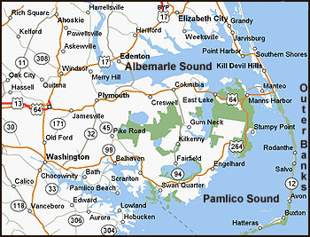

- The site was located inside the circle inscribed on the map in northeastern North Carolina.
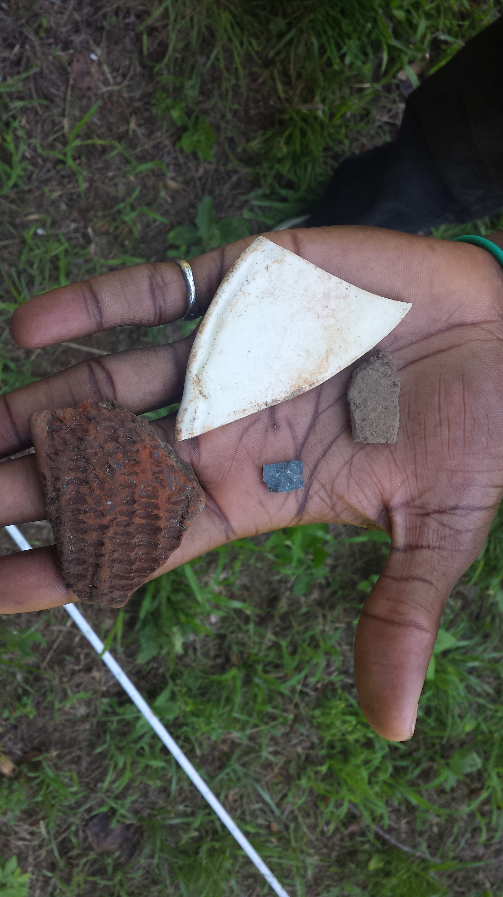
- Artifacts that were found on the surface of the surveyed site.
The use of the GPR survey in this study will reveal the presence of any buried remnant structures or features in our intended area. After we use the GPR survey system, the data collected was uploaded in the RADAN 6.6 data processing software. RADAN also helps the GPR data to be filtered, viewed and manipulated in multiple interactive 2D and 3D views. This software played a major role in our experiment because it helped us determine if our intended area possesses a more solid chance of having any of the sought structures.

Materials and Methods
In order for the research to be carried out successfully there were some essential materials that were needed. The main piece of technological equipment was the GPR and RADAN 6.6 software. Figure 3.0, located below, is a simple depiction on how the GPR actually works. Other materials utilized during the process include: graph paper, a meter stick, rope, a GPS and flags. The research can be looked at as having two main components: field work, and image processing.

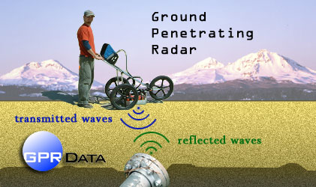
- How the GPR works.

Field Work
The most important part of the research experiment was visiting the site to collect data. This required the archaeology team to visit the site near the Chowan River in the vicinity of Edenton North Carolina with the intention of collecting data. While on the site, the team implemented a grid system on two area plots. The grid was implemented marking out a baseline for tapes, ropes, and other planning tools to aid the GPR plan. Several flags were placed to insure that the entire area was included in the data collection. Ropes were tied horizontally to flags to insure smooth and accurate data collection while using the GPR system. The area of the first plot was 15 by 25 meters and the second plot was 20 by 26.8 meters. See figure 4.0. After measurements were done, we ran the GPR system in both plots in a raster pattern. This pattern of scanning insured that all areas in both plots the team anticipated to survey where covered. The team made careful navigation around trees in the areas, but there was still some possible error due to the trees being located in the path of the GPR. The use of the GPR system was very crucial because the system worked by sending a tiny pulse of energy into a material via an antenna. An integrated computer records the strength and time required for the return of any reflected signals.

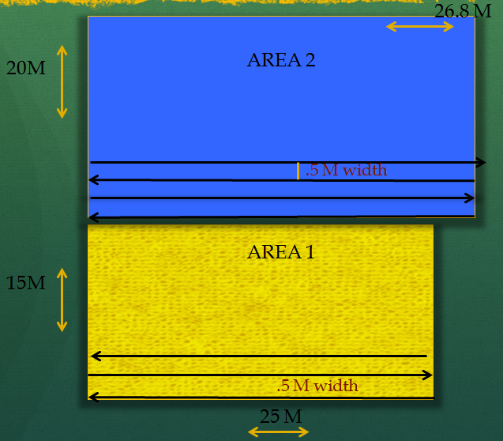
- A map of the two areas that were surveyed. The map also shows the raster pattern that was used to collect transect data.

Imaging and Image Processing
Several files of information were collected after the team surveyed the area using the ground penetrating radar. The first area surveyed was 15 by 25 meters, and the team collected 37 files, while the second area surveyed had dimensions of 20 by 26.8 meters, and 45 files were collected from that area. The RADAN 6.6 software, developed by Geophysical Survey System, Inc (GSSI) was used to process the data. This software was capable of giving us the ability to look at the collected images in three-dimensional display. The RADAN 6.6 software allows the archaeology team to process the data in three important aspects, which are: zero correct, migration, and gain control. See Figure 5.0.
^{[2]}Zero correct technique was used to remove the section of data that occurs before the direct wave. This process or technique insured that while doing the analysis of our data, we only used the data that was obtained from the ground being directed exposed to the waves. Migration was an important technique used to process our data. Migration is a processing procedure that reduces or eliminates hyperbolic diffraction patterns in the data. It basically takes out the tails of the hyperbolas to more accurately represent the location, and in some cases, the size of the target. This makes the recognition of point reflectors much easier, especially in 3D files. Migration also offers a simple and accurate way of calculating the radar velocity (and thus dielectric) of the material your target is in, from the shape of the hyperbolas. The most important aspect in image processing is the gain equalization. The gain is the amplification of the Radar signal. The archaeology team applied a gain averaging to the data to ensure the gain collected during each transect was consistent.
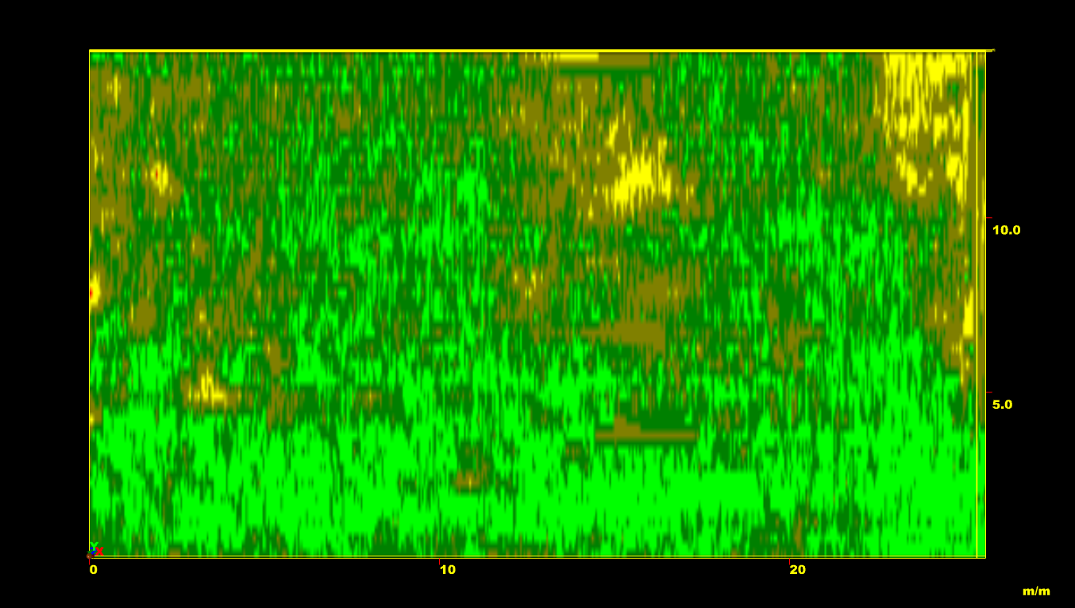
- A processed image of the data collected in area one at a depth of 1.15 meters. This was the depth at which area one showed the most subsurface material.

Analysis
The data analysis of this research experiment was carried out using three-dimensional display. The radar returned signals at progressively deeper depths that could be displayed as 2-dimensional images. This is similar to slicing a block of swiss cheese that reveals different patterns of holes at different depths. Linear features that may be present became very visible. Identifying structural elements, roots, nidden collection, and other objects, become easier to identify. The file collected during the field survey was uploaded to the RADAN 6.6 software from the GPR system, and then a transect model was built using the files. The length corresponded to the size of the file. The path of the GPR data collection from east to west or vice versa across the width of the area is defined as one transect. Each GPR data file collected consists of one transect. If trees were present along a transect the path was broken into two data files segments and recombined in computer software.

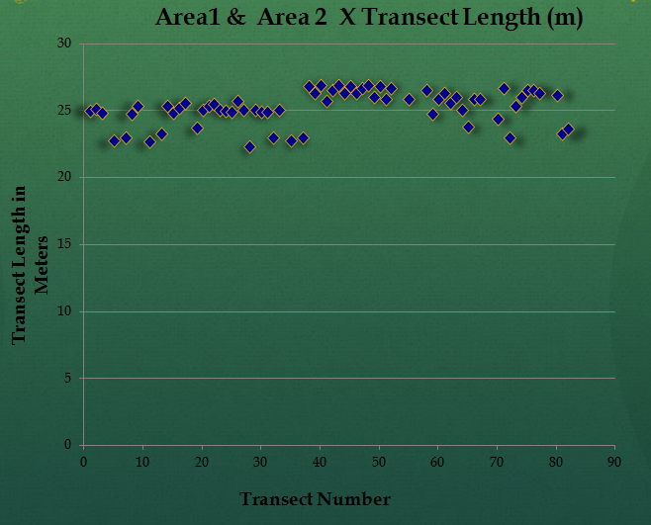
- A graphical display of the combined transects lengths of both area one and area two. The plotted points helps display accuracy, and it helps pin-point transects that were affected by trees.
The team built the transect model using RADAN software; the transect model was built until it runs into an object in the concentrated area, when this happened, a new transect was inputted into the RADAN software manually. In order for the team to accomplish the analysis of these data, first, the team completed the zero correction (ZC), migration (MIG), and gain equalization (GC). After the ZC, MIG, and GC were completed, the color band was changed to better see what objects or features were in the ground. The team chose color band three from the RADAN software to better and accurately analyze the data. In order from the highest frequency to the lowest, color band three consisted of yellow, green, red and brown. Using color band three, the images were viewed in 3D creating a colorful depiction of the materials located meters deep in the ground of the two areas. The colors enhanced the ability to see shape, size, and depth of the structures in the area.

Results
After the image processing and analysis of areas one and two was performed using RADAN 6.6 software, it was determined that subsurface materials were present in both areas, with the majority been in area two. See figure 7.0. The Archaeology team reviewed the images thoroughly in 3D format; it was observed that there were significant sized objects in area two with excessive depth. The object initial formation appeared to be in area one, but it was not greater in size nor depth as compared to area two.
In area one, the archaeology team determined that there might be enough substantial evidence to suggest that area one contains archaeological artifacts but further research on area one needs to be done to prove or disprove this theory. The team looked at the areas in various depths by using the RADAN 6.6 software in 3D format. After the analysis of area one in depths of 0.25 meter, 0.50 meter, 0.75 meter, 1.0 meter and 1.15 meters, the team was convinced that the depth of 1.15 meters held substantial evidence to suggest that area one contains some sort of structure. This theory is not conclusive because future work needs to be done on this area to determine if in fact area one has something buried there.

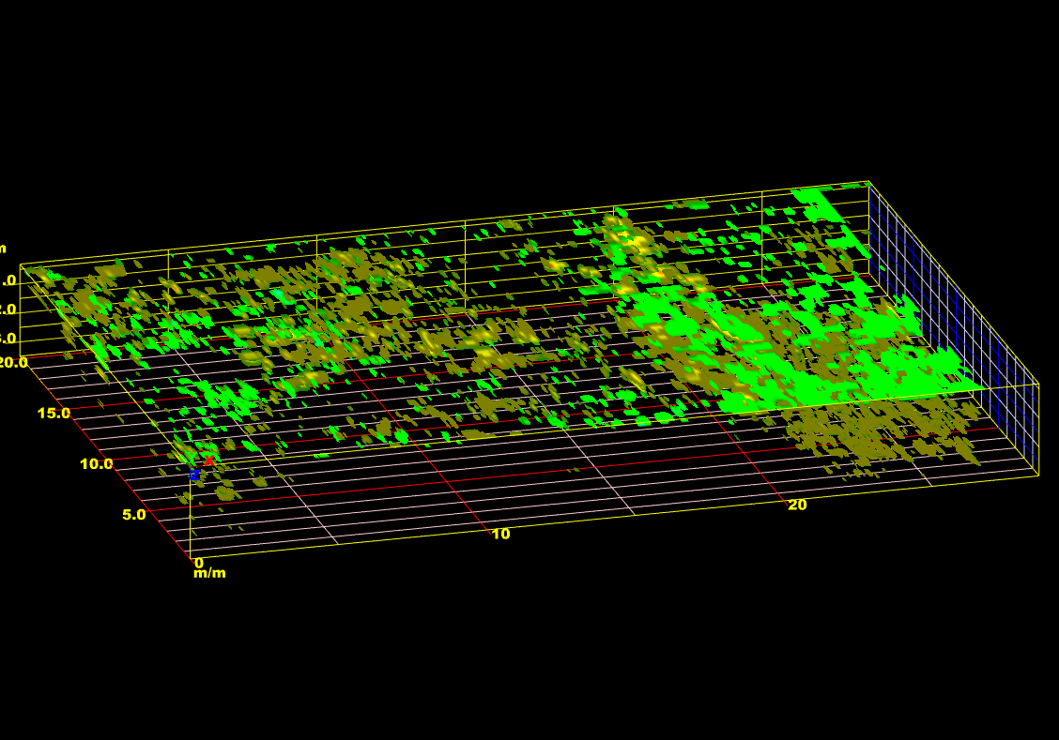
- A 3D model of the data retrieved from area two. This model shows the abundance of subsurface material present in that area.
The analysis of area two was very critical since the team observed significant size object in this area with excessive depth. This area shows great potential of having the possibility of some sort of structure or artifact being in the subsurface area due to the information received from the graphical data. The graphical data of area two showed an abundance of subsurface materials that can be conclusive if future research is done on this area. The archaeology team evaluated area two in depths of 0.25 meter, 0.50 meter, 0.75 meter, 1.0 meter, 1.25 meters, 1.50 meters, 1.75 meters, 2.0 meters, 2.25 meters, 2.5 meters, 2.75 meters, and 3.0 meters using the RADAN software in 3D format. The team came to a conclusion that the probability of area two been a colonial habitation or having Native American artifacts or structure was greater than area one. Substantial evidence after the examination of area two in 3D format was established and this might indicate or imply that area two might contain early structural evident of Native American, or colonial structures. This speculation is not irrefutable because future works are needed to be done on this site to decide whether area two holds essential proof of colonial or Native American structures.

Conclusion and Future Work
After the completion of this research, we have compiled solid data that has led the archaeology team to determine that there is in fact an abundance of extended features in both surveyed areas; the question is, what is it? Since the material responded positively to the electromagnetic waves of the GPR, the archaeology team is positive that the extended features present is magnetic; but further work such as excavation is needed to be done to more accurately determine what these features are. The next step will be presenting this information to the appropriate archaeological personnel so that they can decide if enough relevant information has been formulated to promote further processing of the site.

Acknowledgements
The authors Michael Cobb, Rashad Williamson, and Kelechi Onyiriuka, would like to thank Dr. Malcolm LeCompte for being an amazing mentor to the team; he encouraged us in numerous capacities, even outside of our research. We also would like to extend a thank you to Edward Clay Swindle for his assistance with helping us obtain access to the research site. We warm-heartedly would like to thank Dr. Linda Hayden for giving us the opportunity to participate in such a program that allowed our minds to engage in learning, exploring, and developing a new understanding of science, technology, engineering, and mathematics (STEM) concepts that will benefit us greatly along our road to success.

References
- Daniels DJ (ed.) (2004). Ground Penetrating Radar (2nd ed.). Knoval (Institution of Engineering and Technology).
- Conyers, Lawrence B. And Dean Goodman 1997 Ground Penetrating Radar: An Introduction for Archaeologists. Walnut Creek, CA.: Altamira Press
- Radan 6.6 User’s Manual, “The Difference is in the Data” 2005. Published by Geophysical Survey System, Inc.

