Analyzing Long-Term Drought Effects on Land Surface Temperature and Vegetation Using Aqua-1 Satellite Data
Dr. Linda Hayden, PI
Elizabeth City State University
Elizabeth City, North Carolina, USA
http://nia.ecsu.edu

Autumn Luke, Andrew Brumfield, Je’Aime Powell
Elizabeth City State University
Elizabeth City, North Carolina, USA
http://nia.ecsu.edu
Eric Baptiste, Karen Dubey, Jane Zeer
SeaSpace© Corporation
Poway, CA, USA
www.seaspace.com

Abstract— According to the State Climate Office of North Carolina, since 2007 the northern coastal plain of North Carolina has been experiencing a long-term summer drought. The primary goal of this research was to find a correlation between land surface temperature and vegetation due to long-term drought using satellite data. The team collected imagery data through the SeaSpace© TeraScan® system in order to produce land surface temperature and normalized difference vegetation index products. The data products were averaged into monthly and yearly composites so that the team could use TeraVision to depict the differences of values for the products.
Keywords-Land Surface Temperature; Vegetation; Aqua- 1; TeraScan©; SeaSpace Corp.; Drought’ MODIS; Pasqoutank county; Gates county; MODIS; AVHRR

Introduction
After observing the Palmer Drought Severity Index (PDSI) data sets for summer 2002-2011, provided by the State Climate Office of North Carolina Climate Retrieval Observations Network Of Southeast (CRONOS) Database, the team observed that there has been a long-term drought since 2007 in the Northern Coastal Plains of North Carolina [1] \. Summer was defined as the months of July and August. The State Climate Office of North Carolina NC CRONOS defines that long-term drought as being cumulative, and their data representative of weather patterns of the current months in compared with previous months as shown in Figure1. Therefore the PDSI attempts to measure the duration and intensity of the long-term drought-inducing circulation patterns without including man made changes. The Palmer Z Index denotes dry and wet spells on a scale between -6 to 6, respectively as shown in Figure 1. After 2006 all PDSI values were negative, indicative of drought during the entire period.
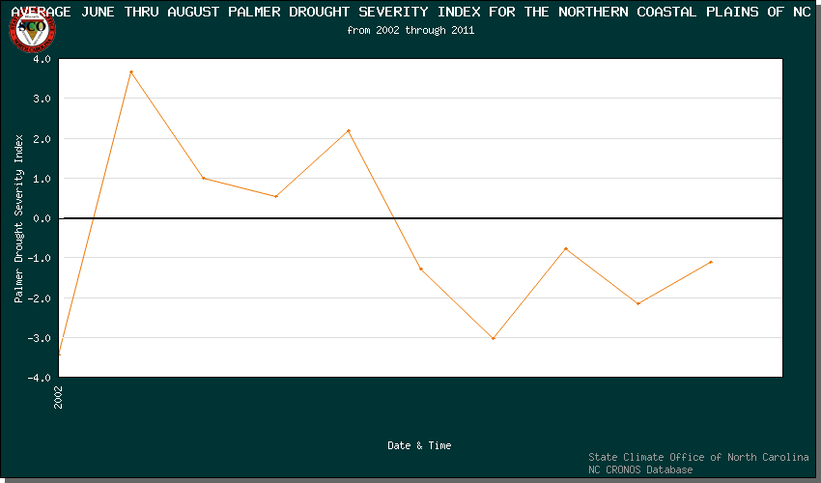
Figure 1: The Palmer Drought Severity Index attempts to measure the duration and intensity of the long-term drought-inducing circulation patterns. Man-made changes are not considered in this calculation. PDSI index values generally range from -6 to +6, where negative values denote dry spells, and positive values denote wet spells.

The team’s objective was to analyze how long-term drought in summer months’ affected vegetation and land surface temperature in the Pasquotank and Gates county areas. The team chose to focus on the summer months, July through August, so that data results will not be skewed due to fall, winter, or spring seasonal conditions. Vegetation would be in various stages of change dependent on the season.
The polar orbiting satellite that carried the Moderate Resolution Imaging Spectroradiometer (MODIS) sensor that was chosen to retrieve data from was Aqua-1 [4]. Satellite data can have data degradation at the near and far edges. Therefore the team only downloaded daytime orbits with a minimum elevation of 55 degrees. Due to cloud coverage over the area of interest, utilizing the “composite” command in the TeraScan software generated monthly composites of images. During TeraScan training, the team’s training mentor, Jane Zeer explained how the “composite” command takes a calculation that eliminates “bad-values” in multiples images, such as clouds, and creates one image [2]. There are many versions of composite in TeraScan. Specifically the team used the method that averages the good values located in the same location in each image.
The team chose to use data from NASA’s website Level 1 and Atmosphere Archive and Distribution System (LAADS). LAADS provided the ability to search for archived MODIS telemetry in Latatude/Longitude-based parameters that was not limited to real time data[6]. This was useful because the team needed to retrieve raw data from 2007 to 2011 with at least 35% coverage for the “LocalECSU” master and 70% coverage for the “GlobalECSU” master. A master is defined as an area of interest in TeraScan from where the data will be exclusively extracted and processed [2]. The team downloaded the files by using the “laad_fetch.sh” TeraScan function which executed the SeaSpace “configproc” script. During the “configproc” a series of conversions took place to convert “pds” files into “hdf” files and “hdf” files into “tdf” files. A “pds” file is the original satellite data format, hdf is a common data format, and tdf is a TeraScan data format. After the file was converted into a “tdf” file, a calculation with the different channels was applied to create both Land-Surface Temperature (LST) and Normalized Difference Vegetation Index (NDVI) products. LST used level-2 and level-3 data in an algorithm designed specifically for the MODIS instruments. The NDVI equation was equal to the quantity of the infrared channel minus the near-red channel divided by the quantity of the infrared plus the near-red channels [3]. This equation made the product “greener” to differentiate the differences in dense vegetation and low vegetation.

The channel resolution for the MODIS telemetry varied from 250-1000 m, dependent on the channel. When the data is processed into LST and NDVI, TeraScan resampled it to 1 Km by 1 Km pixels over the area of interest. Once the team had the LST and NDVI, the data was then be analyzed in TeraVision using specified palettes representing different values. The next step was to identify sub regions across the study area, then average values to use for comparisons between the years and against various locations.

SeaSpace©
The way that SeaSpace utilized telemetry was by having a data stream containing all sensors from certain satellites that got processed by being ingested. The “batch Ingest” TeraScan command separated the sensors, made individual channels, and differentiated information received by the sensors on the satellite. AVHRR was the telemetry that the NOAA satellites had. Once the information was processed through TeraScan the user would no longer use the raw data from the telemetries, but receive the data in house.

Polar Orbit
The polar orbiter that the team chose to retrieve data from was Aqua-1. Polar Orbiters are positioned 8-9,000 miles from the Earth. In twelve-hour sequences, daytime and nighttime, the front orbit and back an orbit that causes ascending and descending graphs of each pass. Polar Orbiters are sensitive to obstructions such as buildings and trees that block signals, creating masks that produce gaps in the raw data received from the satellite’s pass. Clouds created masks, so sight preparations are important when setting up these antennas.

Manipulating LST & NDVI
Since there were no previous data shelves in TeraScan® for LST and NDVI, the team must add them to the data shelf to be able to view and take info. Adding to the Data Library first select “Edit Data Library”, next select “Private Shelves” and click “New”. Find the Directory where the saved composite is located and click “Accept”. Name the Shelf “LST Month Year”, click “Accept”. Now move the cursor to “Data Types” then click “New”. Make sure the Data is Visible under “Files” and click “Accept”.
Continue until all months for each year is in the “Data shelves” and begin to load all months of data in the same frame. Terascan default is to have LST values displayed in Kelvin Units and in Black & White. In order change kelvin units to Fahrenheit go to layers tool and select the layer with LST in the name. Click on edit to change units color scheme. To show the difference in temperature values, the palette blue, green, red, and yellow was used. Still in the layers tool, add land borders and current location. Then to add legends for the color palette, and add text uses the Annotate tool.
To find a trend of LST /NDVI patterns in the summer months of July and August The team will take the values at lat/long locations in Pasquotank and Gatesville County. The townships chosen were Providence, Newland, and Salem in Pasquotank, Hall, Gatesville, and Hunters Mill Townships in Gates County. By using the survey tool the team then use the "Go to Cursor" to position the mouse over the townships lat/long location and record the value into Excel to generate a graph.

Methodology
The question has been raised as to whether or not the long-term drought has an effect on temperature and vegetation. The team collected Aqua-1 passes along with the ancillary data in the period of 2002 to 2011 to determine if there was a change. If change occurred, the team judged if there had been a positive or negative correlation by inserting the data collected into a data set in Microsoft Excel.
Using LAADS website the team was able to access the MODIS Level 1 data for LST and NDVI products for July and August of 2010 and 2011. They used two commands in the terminal called “Laads_search” and “Laads_fetch.sh” to retrieve the data. Laads_Search presents a prompt with questions such as, the satellite name, lat/long locations, and the start date. Then it asked for minimum sun elevation, the team’s data requires sunlight for the channels to gather data in NDVI and LST. To obtain good data passes the team set the lowest elevation at 50/55 and the set the amount of days of data needed (30 Max). The prompt should then print satellite name, date and time, duration of the pass, satellite maximum elevation (relative to the targeted area), and Sun elevation. The passes selected to be downloaded are from a list of passes which has an elevation greater than 50. Laads_fetch.sh was used to retrieve the data from LAADS website into the team’s system. The command prompts the user to give specific information about a pass. Information needed to look up a passes are the following: a pass number to store the new data determined by the satellite; a satellite name; a date (yyyy/mm/dd); a time (in five minute increments.); number of granuales; and the amount of days after selected date.
For number of granules, if the duration of the pass plus the amount of time it took to complete the pass was less than or equal to five minutes enter one, if greater than five minutes and less than ten minutes enter two, and if the pass is greater than ten minutes enter three. A pass did not take longer than fifteen minutes to complete therefore the greatest number of granuales a user should have had three.
After the download finished the data was processed through the config_proc files which held the masters. The masters would insure the pass was over the Area of Interest (AOI). Programed in the team’s master files for Elizabeth City State University, data must cover 30% of the AOE for data to be processed into LST and NDVI products.
Once the two products of each pass data that was downloaded could be composited into monthly images. They were the averaged composites of the best passes in each month of each year. To perform the function, the command “composite” was used TeraScan. First the files for the composite were select and named “LST/NDVI Month Year”. The file was then generated in that directory.

Analysis
The data showed that when the line of regression for LST decreased NDVI increased showing an inverse relationship between temperature and vegetation. Each township expressed an inverse relationship between LST and NDVI. For instance, in Providence township LST’s value of 96ºF with NDVI’s value of .72 in 2011. Therefore in high land surface temperatures vegetation could be abundant. Also in Hall Township NDVI had the highest value in 2011, but the land surface temperature was above 90ºF. Not only was there an inverse relationship between LST and NDVI, but the graphs expressed that LST is beginning to decrease while NDVI was beginning to increase. July of 2011 the LST value was greater than 2010 and the LST value is greater in August of 2010 in comparison to 2011. Also, the July of 2010 NDVI value was greater than 2011 and the NDVI value was greater in August of 2010 was greater than 2011.

TeraScan® displayed the data in Degrees Fahrenheit over Northeast part of North Carolina. Figure 2. Displays the composited data of LST passes in July and August of 2010 and 2011 processed in Terascan® TeraVision Software.
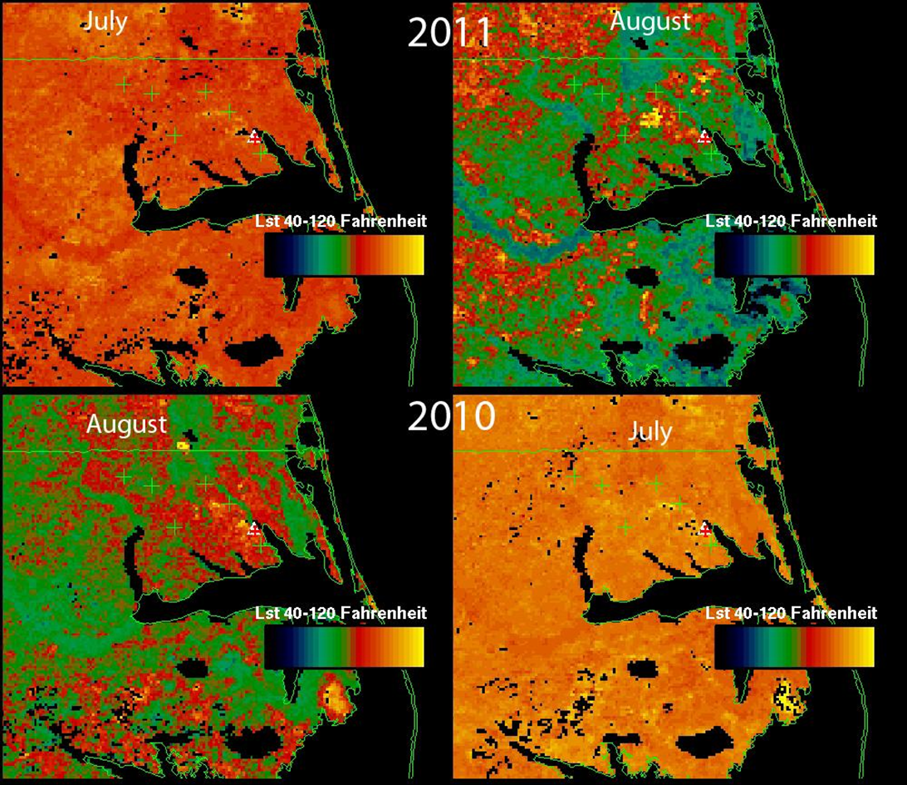
Figure 2: LST monthly composites for July and August 2010 and 2011.

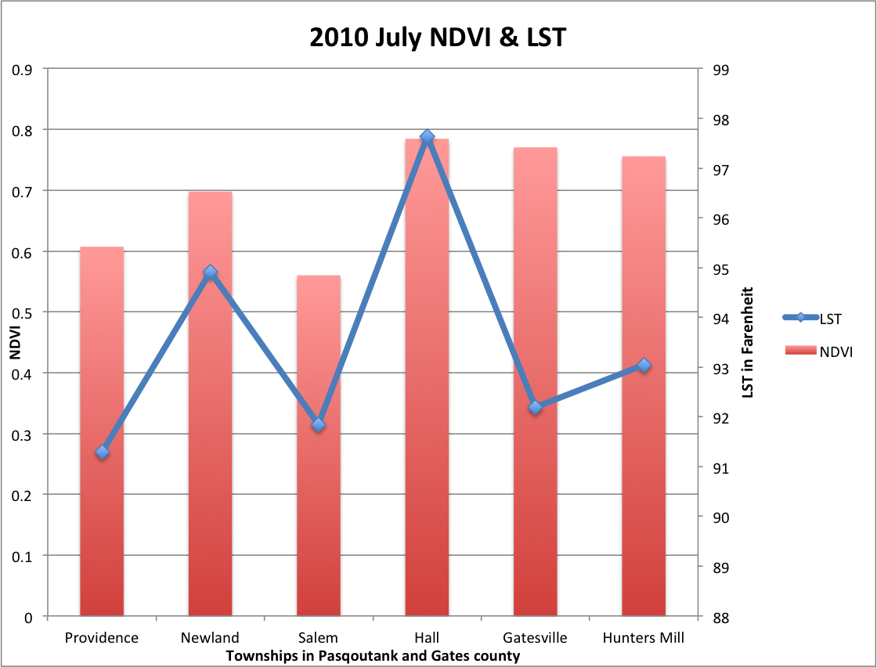
Figure 3: The red bar graph represents the NDVI value and is compared with the blue line that represents the Fahrenheit degrees of the LST in each township in July 2010.

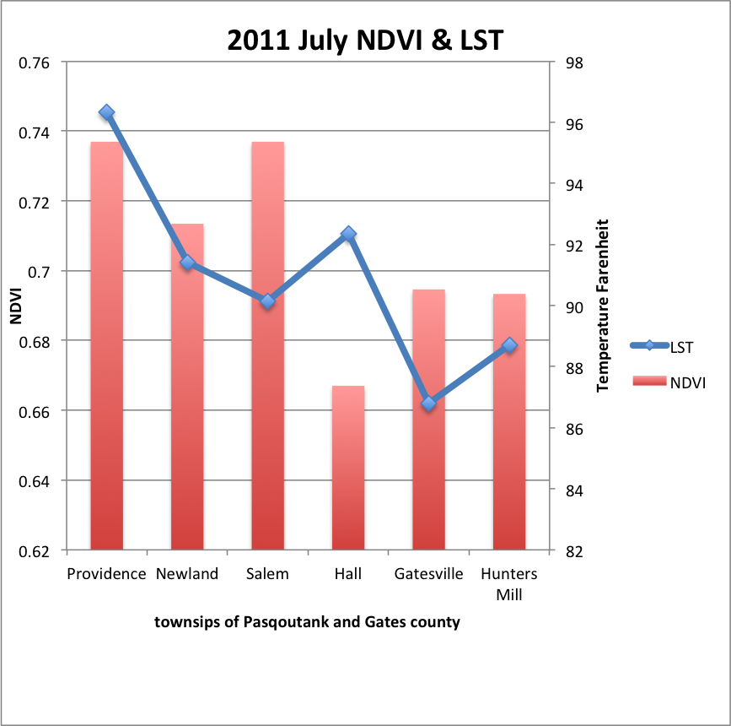
Figure 4: The red bar graph represents the NDVI value and is compared with the blue line that represents the Fahrenheit degrees of the LST in each township in July 2011.

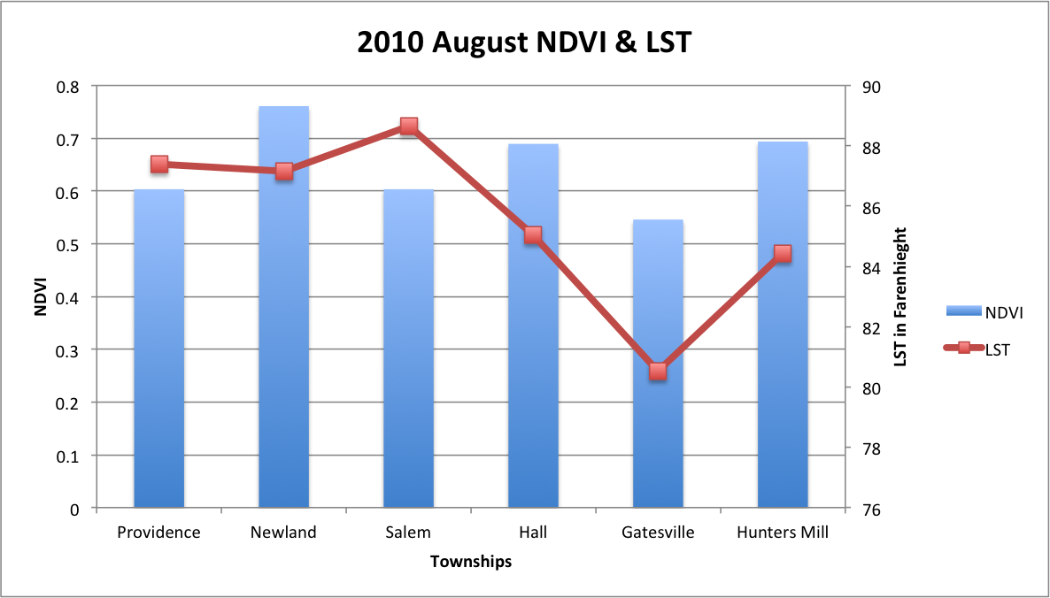
Figure 5: The red bar graph represents the NDVI value and is compared with the blue line that represents the Fahrenheit degrees of the LST in each township in August 2010.

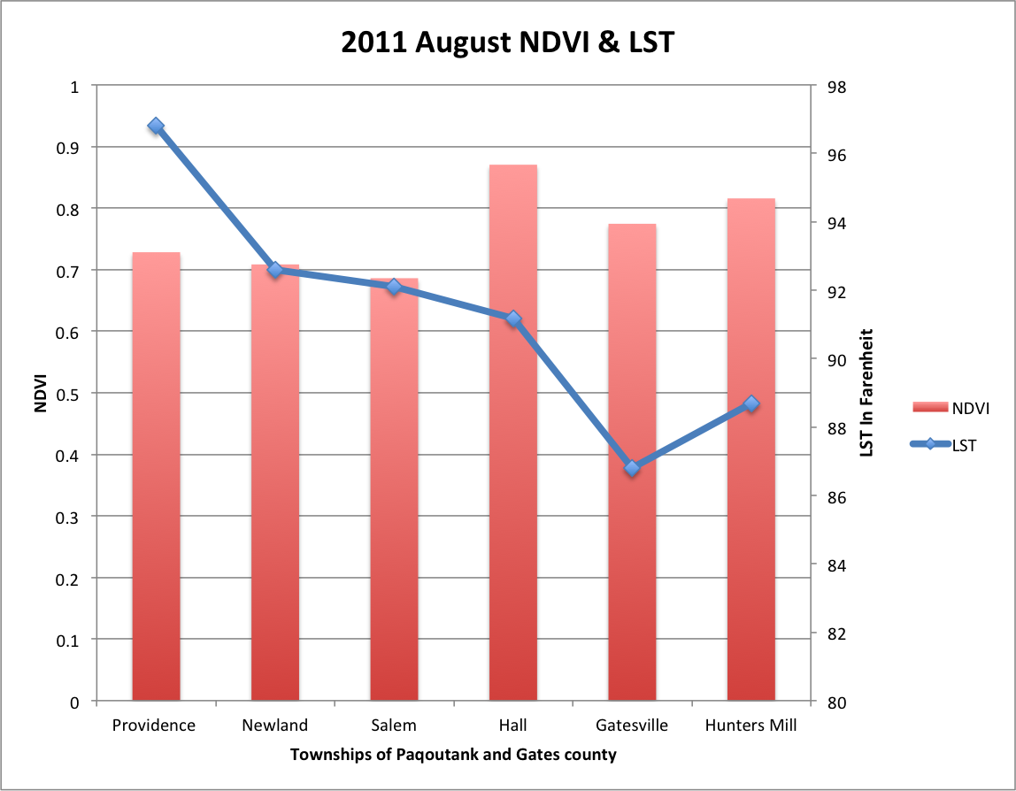
Figure 6: The red bar graph represents the NDVI value and is compared with the blue line that represents the Fahrenheit degrees of the LST in each township in August 2011.

Conclusion
There had been a question raised whether the severe long-term drought since 2007 in the Northern Coastal Plains of North Carolina had an effect on land surface temperature and vegetation. According to the team’s data analysis using linear regression NDVI and LST had 11% accuracy. Therefore the team concluded that there was no correlation between land surface temperature and vegetation due to long-term drought based on the data that was retrieved. However, the team believed that there could be other factors that contributed to the result having no correlation. The team questioned whether other factors such as man made changes have had an effect on the results. The team also recognized that having two years of data could have played a part in having no correlation in the analysis.

Future Work
There are other objectives that the team could fulfill in this project to receive better results. A comparison of five years would better illustrate a pattern. Future work will include retrieving Aqua-1 Level 1 for the period from 2007-2009 and combine it with the results from 2010-2011. Then conduct a LAADS search as stated in the methodology. In the original comparison June had to be taken out of the analysis because all the products would not download. Therefore, in addition to including more years the team would also include the month of June. To visualize the data sets also include the “kmz” files of LST and NDVI products of 2007-2011 layered in Google® Earth.
As stated in the MOU, SeaSpace© will establish a TeraScan® server, user software applications, and establish an east coast satellite data collection facility. This would include the hosting of a 2.4m X/L Polar Orbiter antenna system, a 5.0m Geostationary L_Band antenna, and a 3.7m C-Band antenna along with their associated acquisition and processing servers [7]. The system will be upgraded from 32 bits to 64 bits located in Dixon Hall on ECSU’s campus in order to meet TeraScan’s® system requirements.

References

- State Climate Of North Carolina, (n.d.). US Drought Monitor of North Carolina. Retrieved from http://www.nc-climate.ncsu.edu/climate/climdiv.php
- Zeer, J. (2012, June). Interview by CReSIS ECSU [Personal Interview]. Terascan training. , SeaSpace® , Retrieved from www.seaspace.com
- Wiscombe, W., & Przyborski, P. (n.d.). Measuring Vegetation (NDVI & EVI) Retrieved from http://earthobservatory.nasa.gov
- Dubey, K. (2012, June). Interview by CReSIS ECSU [Personal Interview]. Terascan training. , SeaSpace© , Retrieved from www.seaspace.com
- Level 1 and Atmosphere Archive and Distribution System, (n.d.). Data Search. Retrieved from http://ladsweb.nascom.nasa.gov/data/
- MODIS Land Surface Temperature an Emissivity Algorithms and Products By Zhengming Wan University of California, Santa Barbara
- Elizabeth City State University, and SeaSpace® Corporation. "ECSU Research Week 2012 :: Tuesday." ECSU Research Week 2012 :: Tuesday. N.p., 7 Feb. 2012. http://nia.ecsu.edu/ur/1112/rw12/rw12tuesday_mou.html

