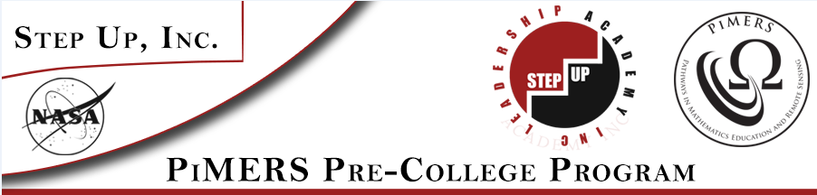

Virginia Air & Space Center Field Trip

To: PiMERS Pre-College Participants
From: Roger Hathaway, Program Coordinator
Reason: Virginia Air & Space Center Field Trip
Date: July 18, 2018

The agenda for the Virginia Air & Space Center Field Trip will be as follows:
Depart from the side of Dixon Hall on the ECSU campus at 8:00 am on Wednesday, July 18, 2018
Arrive at the Virginia Air & Space Center on Settlers’ Landing in Hampton, VA at 10:00 am

10:00 am Tour the Center
12:00 noon IMAX Theater
1:00 pm Lunch
2:00 pm Depart for ECSU
3:30 pm Return to Dixon Hall on ECSU campus

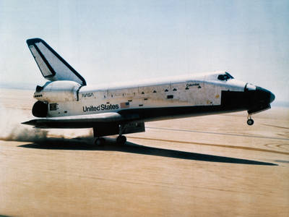
NASA Knows! Do you know what a black hole is? Do you want to find out about the International Space Station? Read about these topics and more!

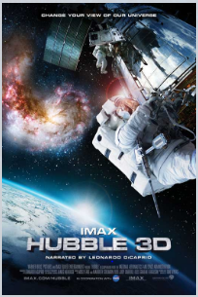
Hubble 3D An IMAX 3D camera chronicles the effort of 7 astronauts aboard the Space Shuttle Atlantis to repair the Hubble Space Telescope.

Field Trip Staff
Program Coordinator: Dr. Roger Hathaway, PiMERS Education Coordinator
Administrative Support: Mr. Joal Hathaway & Ms. Shatoya Estime
Please call 252.335.3696 or 757.418.0323 should you have questions regarding this field trip.

