ECPI University Research Field Trip
July 11, 2017

To: PiMERS Pre-College Program Participants
From: Dr. Darnell Johnson, Program Coordinator
Reason: ECPI University Technology Field Trip
Date: July 11, 2017

The agenda for the ECPI University Research Field Trip will be as follows:
Depart from the side of Dixon Hall on the ECSU campus at 8:00 am on Tuesday, July 11, 2017
Arrive at the ECPI University Research Field Trip in Virginia Beach, VA at 10:00 am

10:00 am – 12:00 am Tour the ECPI University Tech Labs
(Cybersecurity/Mechatronics/Criminal Justice/3D printing)
12:00 noon LUNCH
1:00 pm Depart for ECSU
2:30 pm Return to Dixon Hall on ECSU campus

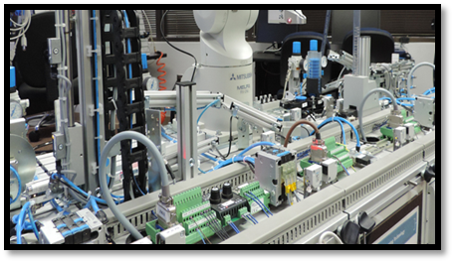
ECPI Technology Lab in Virginia Beach

Field Trip Staff
Program Coordinator: Dr. Darnell Johnson, PiMERS Education Coordinator
Administrative Assistant: Mr. Joel Hathaway
Please call 335-3696 should you have questions regarding this field trip.

