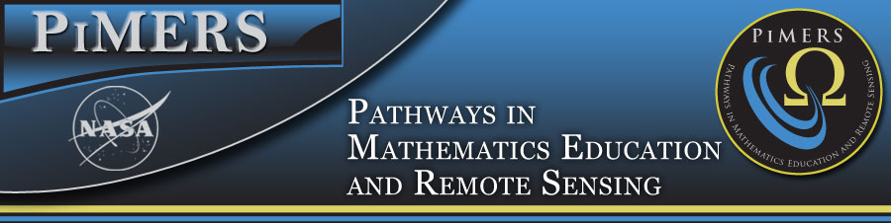
Virginia Air & Space Center Field Trip
June 20, 2018

To: PiMERS Middle School Participants
From: Roger Hathaway, Program Coordinator
Reason: Virginia Air & Space Center Field Trip
Date: June 20, 2018

The agenda for the Virginia Air & Space Center Field Trip will be as follows:
Depart from the side of Dixon Hall on the ECSU campus at 8:30 am on Wednesday, June 20, 2018
Arrive at the Virginia Air & Space Center on Settlers’ Landing in Hampton, VA at 10:00 am

10:00 am Tour the Center
12:00 noon IMAX Theater
1:00 pm Lunch
2:00 pm Depart for ECSU
3:30 pm Return to Dixon Hall on ECSU campus

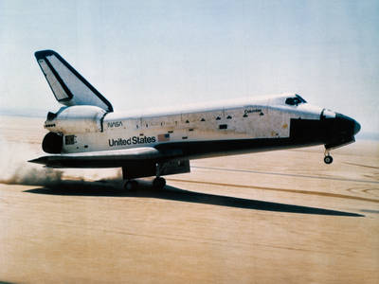
NASA Knows! Do you know what a black hole is? Do you want to find out about the International Space Station? Read about these topics and more!

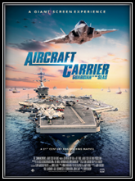
Carrier 3D The mission to protect and defend the world's oceans has become far more complex and challenging in recent years, and naval aviation has become increasingly vital to success. With RIMPAC, the world’s largest and most comprehensive international maritime training exercise providing a stunning visual context for the story, find yourself aboard the carrier alongside the 5,000 highly skilled sea and air personnel conducting flight operations in the midst of the simulated war exercises taking place there.

Field Trip Staff
Program Coordinator: Dr. Roger Hathaway, PiMERS Education Coordinator
Administrative Support: Mr. Joal Hathaway & Ms. Shatoya Estime
Please call 252.335.3696 or 757.418.0323 should you have questions regarding this field trip.

