Dismal Swamp Museum Field Trip
June 28, 2018

To: PiMERS Middle School Participants
From: Dr. Roger Hathaway, Program Coordinator
Reason: Dismal Swamp Museum Field Trip

The agenda for the Dismal Swamp Museum Field Trip will be as follows:
Depart from the front of Dixon Hall on the ECSU campus at 10:30 am on Thursday,
June 28, 2018
Arrive at the Dismal Swamp Museum in Camden, NC at 11:00 am

11:00 am – 12:00 pm Tour the Dismal Swamp Museum
12:00 noon – 12:45 pm LUNCH
12:45 - 2:00 pm Continue Tour
2:00 pm Depart for ECSU
3:00 pm Return to Dixon Hall on ECSU campus

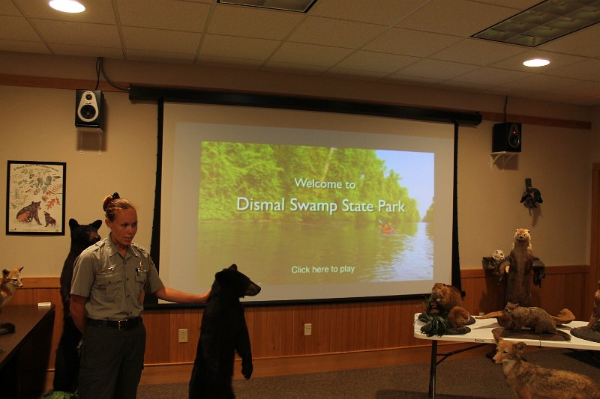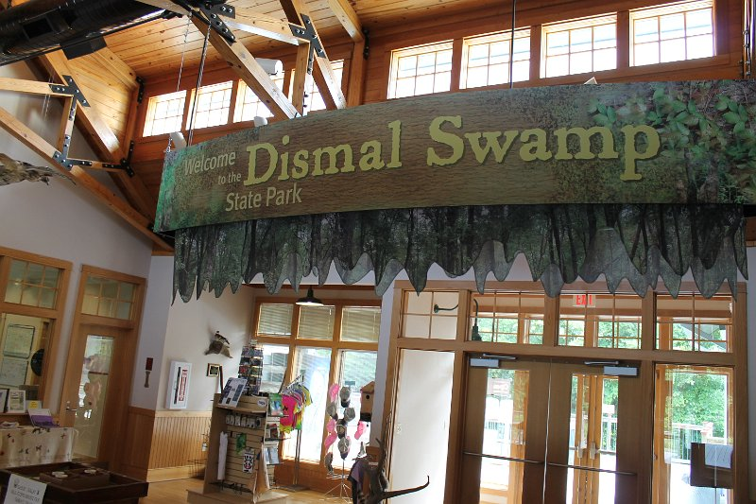

The Dismal Swamp Welcome Center is ideally located on US Hwy 17N, in South Mills, NC,
3 miles from the NC/VA border.

Field Trip Staff
Program Coordinator: Dr. Roger Hathaway, PiMERS Coordinator
Administrative Support: Mr. Joel Hathaway & Ms. Shatoya Estime
Please call 252.335.3696 or 757.418.0323 should you have questions regarding this field trip.

