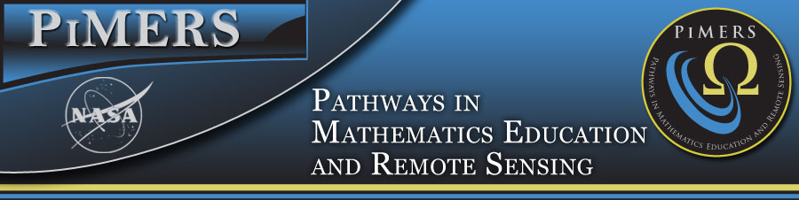
Virginia Air & Space Center Field Trip
June 21, 2017

To: PiMERS Middle School Participants
From: Dr. Darnell Johnson, Program Coordinator
Reason: Virginia Air & Space Center Field Trip
Date: June 20, 2017

The agenda for the Virginia Air & Space Center Field Trip will be as follows:
Depart from the side of Dixon Hall on the ECSU campus at 8:00 am on Wednesday, June 21, 2017
Arrive at the Virginia Air & Space Center on Settlers’ Landing in Hampton, VA at 9:00 am
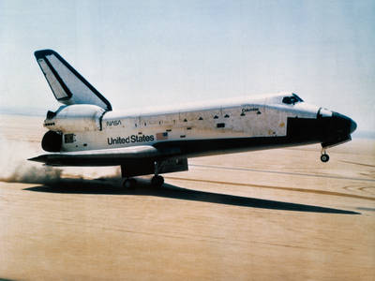
9:00 am – 11:00 am Tour the Center
12:00 noon LUNCH
1:00 pm IMAX Theater
2:00 pm Depart for ECSU
3:30 pm Return to Dixon Hall on ECSU campus

NASA Knows!
Do you know what a black hole is? Do you want to find out about the International Space Station? Read about these topics and more!

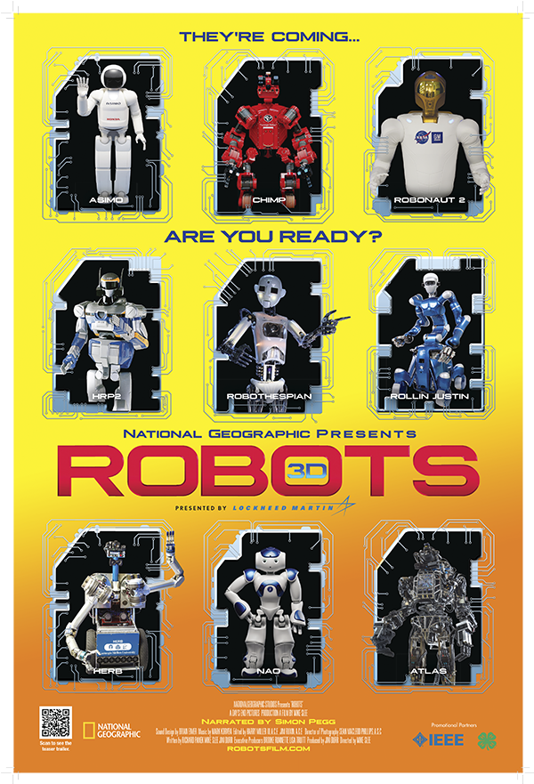
Robots 3D
Robots 3D is a sneak peek into the future at what might be possible as scientists use innovative engineering and design to make cyber characters less "humanoid" and more just plain human. Robot "actor" RoboThespian will introduce you to CHIMP, ATLAS, PR-2, Herb the Butler, ICUB, and others as he takes you on an amazing tour of what's going on in robotics labs around the world

Field Trip Staff
Program Coordinator: Dr. Darnell Johnson, PiMERS Education Coordinator
Administrative Assistant: Mr. Joel Hathaway
Please call 757-282-3409 should you have questions regarding this field trip.

