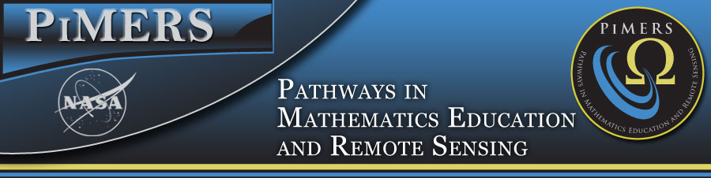

To: PiMERS Summer Middle School Researchers and Parents
From: Dr. Darnell Johnson, Program Coordinator
Date: June 19, 2017

Congratulations, your child has been chosen from a pool of fifteen candidates applying for the PiMERS Middle School Program. Students are expected to report to Room 229 in Dixon-Patterson Hall on the campus of Elizabeth City State University on Monday, June 19, 2017 at 10:00am with at least one parent or guardian. Parents must arrange transportation to and from the campus on a daily basis.

We look forward to working with each student this summer. The schedule for the program is below. Students can use the open lab periods to complete required assignments or prepare for the next day. Students will receive a stipend of $100.00 (after the completion of task sheet assignments) on the last day of the program.

Please call 757-282-3409 or email me at djohnson@cerser.ecsu.edu should you have questions.

 | 10am - noon | Noon – 1pm | 1pm – 3pm
All Students should report to 229 Dixon Hall on the Campus of ECSU each day.
Mon. June 19 | Program Opening  Dr. Linda Hayden | Lunch Seminar:  CERSER Student  Derek Morris | Digital Camera Training  Dana Chandler (Dixon Lab)
Tues. June 20 | PowerPoint Training  Jeff Wood (Dixon Lab) | Lunch Seminar:  CERSER Student  Reginald Kelley | Campus Tour:  Dr. Darnell Johnson
Wed. June 21 | Visit Virginia Air & Space Center in Hampton, VA VASC IMAX
Thurs. June 22 | Math Application Session I  Math Team | Lunch Seminar:  CERSER Student  Dana Chandler | Math Application Session II  Math Team
Friday June 23 | GPS Training-Field Work  Derek Morris-ECSU Grad Student | Lunch Seminar:  Aviation & Robotics  Orestes Gooden | Visit STEM Lab  in Dixon Hall  Orestes Gooden
Mon. June 26 | Hydrology Training  (Pharmacy Building)  Sheryl Bradford | Lunch Seminar:  CERSER Student  (Pharmacy Building) | Hydrology Training  (Pharmacy Building)  Sheryl Bradford
Tues. June 27 | Visit Dismal Swamp Museum in Camden, NC
Wed. June 28 | GLOBE Training-Math Team  (Dixon Lab & Field Work) | Lunch Seminar:  CERSER Student  Steffi Walthall | Robotics with Legos-Math Team  (Dixon Lab)
Thurs. June 29 | Robotics with Legos-Math Team  (Dixon Lab) | Lunch Seminar:  CERSER Student  Justin Dobie | Robotics with Legos-Math Team  (Dixon Lab)
Fri. June 30 | Open Lab  Task Sheets Due | Closing Program and Luncheon with Parents  Dr. Linda Hayden

Program Staff
Principal Investigator: Dr. Linda Hayden, Principal Investigator, CERSER/PiMERS
Program Coordinators: Dr. Darnell Johnson, PiMERS Coordinator
Camera/Power Point Trainer: Jeff Wood, CERSER Webmaster
GLOBE & GPS Trainer: Dana Chandler, CERSER Math Team
Hydrology Trainer: Sheryl Bradford, ECSU Safety Coordinator
Robotics Facilitator: Steffi Walthall & Lee Hayden, CERSER Math Team
Administrative Assistant: Joal Hathaway

Seminar Guest Speakers
ECSU Graduate STEM Majors
Orestes Gooden, Assistant Professor for Aviation Science

