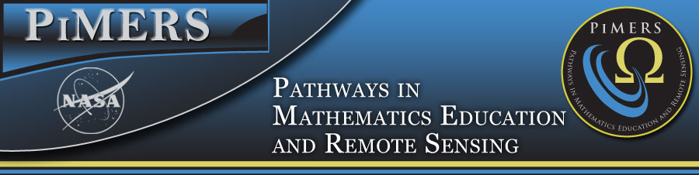
STEM Survey
This questionnaire is designed to assess your interest in a STEM discipline as a college major/career choice. It should require about 5 minutes of your time. Please respond with your first impression, without giving the statements much thought. Your answers will remain confidential.

Gender: M F Current Grade Level: 7 8

2017 PiMERS Middle School Summer Program
Th | Strongly Disagree | Disagree | Neutral | Agree | Strongly Agree
Science, Technology, Engineering, & Math (STEM) courses are exciting. | ① | ② | ③ | ④ | ⑤
I enjoyed the research experiences in the PiMERS Program. | ① | ② | ③ | ④ | ⑤
The training in PowerPoint, GPS, camera, & hydrology were exciting and helpful. | ① | ② | ③ | ④ | ⑤
I was interested in the well-informed scientists who spoke at the lunch seminars. | ① | ② | ③ | ④ | ⑤
The field trips to the Virginia Air & Space Center and ECPI University Lab were enjoyable. | ① | ② | ③ | ④ | ⑤
Participation in the PiMERS Summer Program enriched my learning experience about STEM. | ① | ② | ③ | ④ | ⑤
I would like to participate in this summer program again | ① | ② | ③ | ④ | ⑤
I feel that an understanding of engineering is useful in future careers. | ① | ② | ③ | ④ | ⑤
Obtaining good grades in all courses, especially STEM courses are important for college. | ① | ② | ③ | ④ | ⑤
The all workshop sessions made me interested in choosing a STEM career in college. | ① | ② | ③ | ④ | ⑤
I enjoy participating in science fairs, computer club, & math competitions. | ① | ② | ③ | ④ | ⑤
My family is interested in the STEM related courses I take. | ① | ② | ③ | ④ | ⑤
I believe that I will attend college after high school graduation. | ① | ② | ③ | ④ | ⑤
The PiMERS Summer Program really made me think about majoring in a STEM discipline. | ① | ② | ③ | ④ | ⑤
My K-12 education is preparing me for high school and college | ① | ② | ③ | ④ | ⑤
I really enjoyed all the use of technology during the PiMERS Summer Program. | ① | ② | ③ | ④ | ⑤
I will make it into college and major in a STEM related discipline. | ① | ② | ③ | ④ | ⑤
Having a career in science would be challenging. | ① | ② | ③ | ④ | ⑤
A career in a STEM discipline would enable me to work with others in meaningful ways. | ① | ② | ③ | ④ | ⑤
To me, a career in Science, Technology, Engineering, & Math means a lot. | ① | ② | ③ | ④ | ⑤

