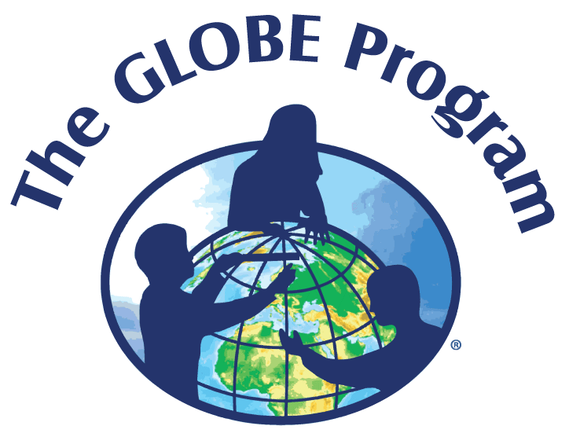

To: GLOBE Program Participants
From: Wanda L. Hathaway, Program Coordinator
Re: VA Aquarium & Marine Science Center Field Trip
Date: July 8, 2019

The agenda for the VA Aquarium & Marine Science Center field trip will be as follows:
7:30 am - Depart from Dixon-Patterson Hall, ECSU campus
9:00 am - Arrive at the Virginia Aquarium & Marine Science Center on 717 General Booth Boulevard in Virginia Beach, VA
9:00 am - Tour the Aquarium
11:00 am - LUNCH
12:15 - Departure to Dolphin Boat Trip
1:00 pm - Dolphin Watch Boat Trip
3:30 pm - Depart for ECSU
5:00 pm - Return to Dixon-Patterson Hall, ECSU campus

Virginia Aquarium
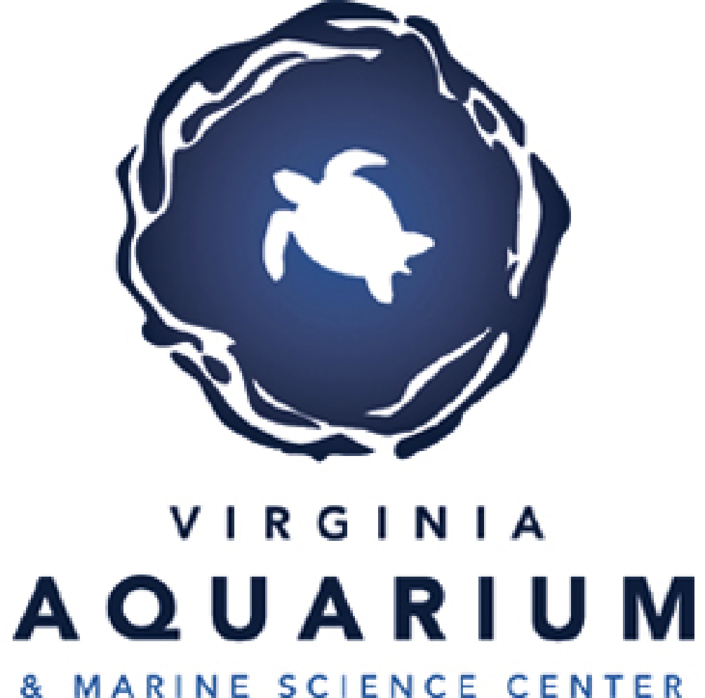
SHARKS 3D is a documentary with a strong conservation message to rehabilitate the shark’s public image and help stop the declining shark populations throughout the world. SHARKS 3D will show them as they actually are: not wicked and man-hungry creatures but wild animals that happen to be the most elaborate predators on Earth. http://www.vmsm.com.

Dolphin Watching Boat Trip
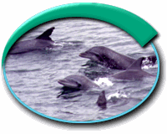
Observe bottlenose dolphins in their natural habitat aboard the beautiful 65-foot Rudee Flipper. Learn about dolphin social behaviors and the latest research studies. The 90-minute boat trips run throughout the day. Dolphin Watch trips leave from the Virginia Beach Fishing Center at Rudee Inlet.

Field Trip Staff
Dr. Linda Hayden, Principal Investigator
Program Coordinator: Mrs. Wanda L. Hathaway, CERSER Education Coordinator
Please call 335-3696/337-4113 should you have questions regarding this field trip.

