Dismal Swamp Museum Field Trip
July 5, 2019

To: GLOBE Program Participants
From: Wanda L. Hathaway, Program Coordinator
Reason: Dismal Swamp Museum Field Trip
Date: July 5, 2019

The agenda for the Dismal Swamp Museum Field Trip will be as follows:

Depart from the front of Dixon Hall on the ECSU campus at 9:00 am on Tuesday, July 5, 2019
Arrive at the Dismal Swamp Museum Field Trip in Camden, NC at 9:30 am

9:30 am – 12:00 am Tour the Dismal Swamp Museum
12:00 noon – 1:30 pm LUNCH
2:00 pm Depart for ECSU
3:00 pm Return to Dixon Hall on ECSU campus

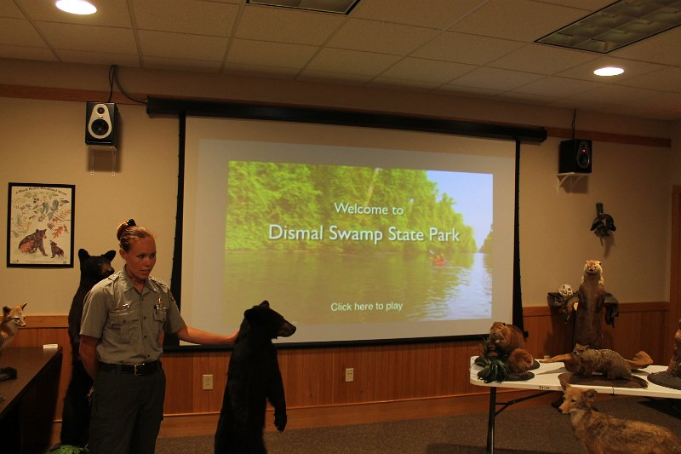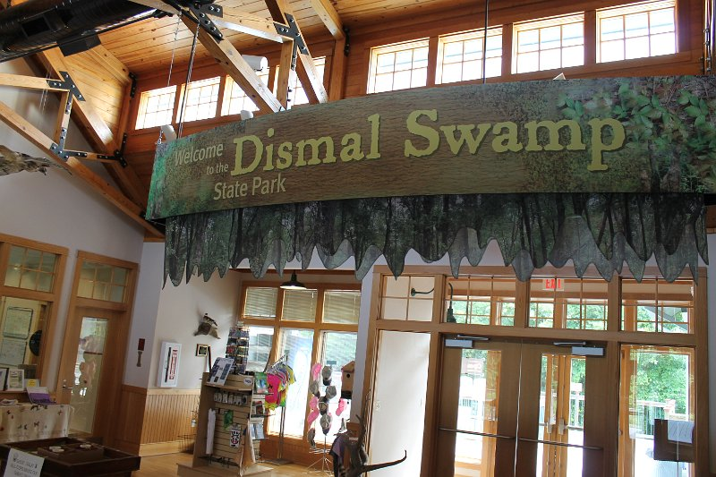

The Dismal Swamp Welcome Center is ideally located on US Hwy 17N, in South Mills, NC, 3 miles from the NC/VA border.

Field Trip Staff
Dr. Linda Hayden, Principal Investigator
Program Coordinator: Mrs. Wanda L. Hathaway, CERSER Education Coordinator
Please call 335-3696/337-4113 should you have questions regarding this field trip.

